HSP500 Wireless HotSpot Gateway with Printer
Quick Installation Guide

The HSP500 can work as a printer, it also has Printer Mode, Hotspot & Printer Mode, the difference with HSP500 is the default operation mode is “Printer Mode”.
It is designed to work with Internet Subscriber Server or Hotspot Gateway such as HSS700 and HSP607.
Package Contents
- One HSP500
- One Thermal papers (50 meter)
- One Power Adapter
- One Ethernet Cable (1.5 meter)
- Two Detachable Antenna
- One Wi-Fi Label
- One Quick Reference Sheet
If any of the above items are damaged or missing, please contact your dealer immediately.

Front Panel of HSP500

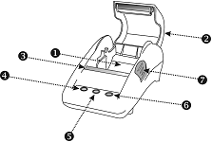

Rear Panel of HSP500

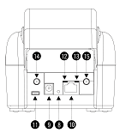

Overview
1. Paper roll housing
2. Printer Cover
3. Tear Bar, for paper cutting
4. Button A
5. Button B
6. Button C
7. Push Button, for printer cover opening
8. Reset Button
9. DC power supply connector
10. RJ45 port
11. Micro USB
12. WLAN LED:
Off: The wireless is not ready.
Green light: The wireless subscriber gateway has established a wireless connection.
Green Blinking: The wireless connection is active.
13. UPLINK LED:
Off: A port has not established any network connection.
Yellow light: A port has established a valid 10/100 Mbps network connection.
Yellow Blinking: 10/100Mbps traffic is traversing the port.
14. SMA connector
15. SMA connector

How to load paper rolls

Please follow the steps to correctly load paper rolls.

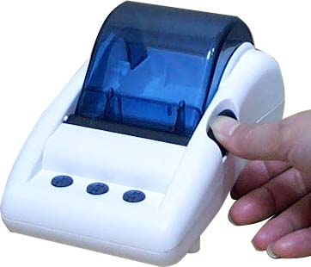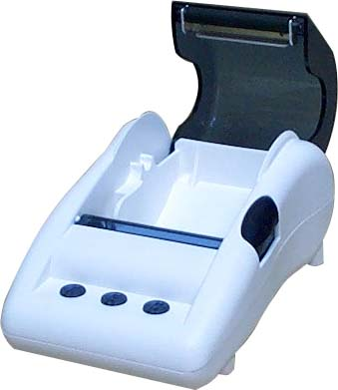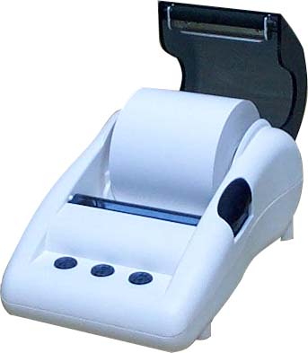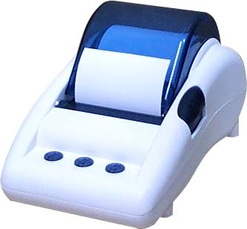

Printing a test page
After you have installed your printer, you should print a test page to make sure the printer is functioning properly.
To do this act as follows:
1.Turn the printer off.
2.Hold down the button A for approximately five seconds, and then turn the printer on.
3.The printer will print a test page.
Configure TCP/IP of your computer
For Windows User,
1. Click Start>Control Panel>Network and Internet. Then click Network and Sharing Center >
Change adapter settings. Right click on the Local Area Connection then click “Properties”.
2. Double click “Internet Protocol Version 4 (TCP/IPv4)”
3. Choose “Use the following IP address” and fill in IP address to set your PC/NB in the same IP domain as HSP500 (169.254.1.X).
4. Click “OK” to save the changes.

5. Using Ethernet cable to link your PC/NB Ethernet port and HSP500 uplink port to start next configuration of HSP500.

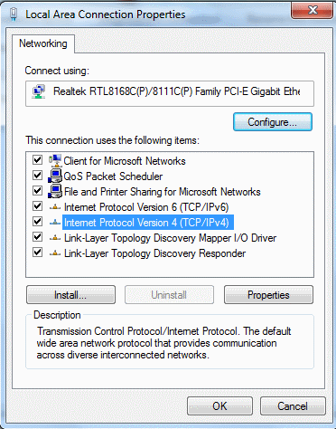
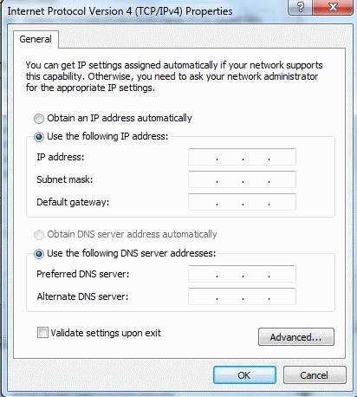

Configure the HSP500

- Start your browser and then enter the factory default IP address 169.254.1.250 in your browser’s location box. Press Enter.

- The HSP500 configuration tools menu will appear. In the Username and Password field, type in the factory default user name admin and password admin and click Login.

- Printer Setting
- Choose the “ACCOUNT GENERATOR“ and key-in the information to complete printer setting.

(2) Fill in gateway IP into “Destination IP address” column.
(3) Set Destination port number the same as gateway.
(4) Set Encryption the same status as your gateway.

Note：The same settings also have to be enabled of gateway after configuration of HSP500, please configure the same function settings of ISS or Gateway site.



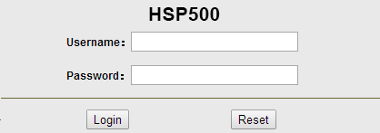

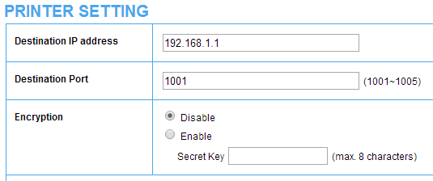

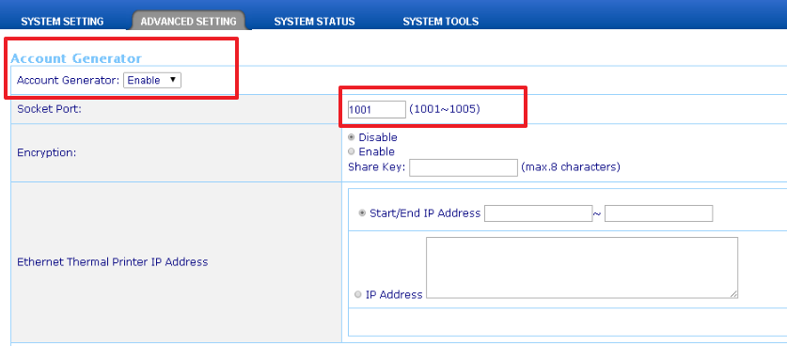

For detail setting of HSS700 and HSP607, please refer the user manual of HSS700 and HSP607.
4. Interface Setting
To make the printer setting easier, you could set your printer as static IP (default is DHCP IP client).
(1) Choose “INTERFACE SETTING” then select the “Static IP” under “Ethernet Interface“.
(2) Fill in the IP Address, Subnet Mask and Gateway IP address of printer in the column. Then click “Apply“ to save the change.

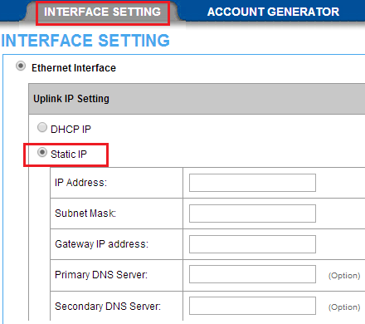

Hardware Setting

The configuration of HSP500 is done. The last thing you need to do is changing the hardware setting of HSP500.
- Using Ethernet cable to link HSP500 uplink port and the LAN port of internet subscriber server/hotspot gateway. (e.g. HSS700).
- Then add the IP address of HSP500 into gateway.
The Printer mode setting is completed. You could print the username and password by a single click on HSP500.

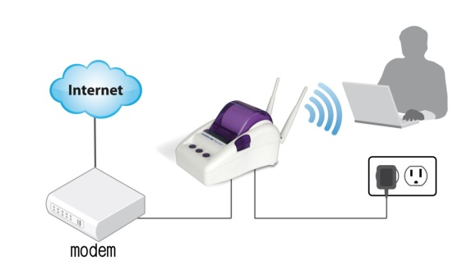
HSP607, HSS700

