
HSP500
Wireless HotSpot Gateway with Printer
USER MANUAL

Copyright Notice

Copyright © 2014 Xentino Technologies Corp. All rights reserved. No part of this document may be copied, reproduced, or transmitted by any means, for any purpose without prior written permission.

Disclaimer

We shall not be liable for technical or editorial errors or omissions contained herein; nor for incidental or consequential damages resulting from furnishing this material, or the performance or use of this product. We reserve the right to change the product specification without notice. Information in this document may change without notice.

Trademarks

Microsoft Win98, Windows 2000, WinXP, Win Vista and Win7 are registered trademarks of Microsoft Corporation.

Xentino are registered trademarks of Xentino Technologies Corporation.

General: All other brand and product names mentioned herein may be registered trademarks of their respective owners. Customers should ensure that their use of this product does not infringe upon any patent rights. Trademarks mentioned in this publication are used for identification purposes only and are properties of their respective companies.

Contents
1. Introduction 5
1­1 Package Contents 6
1­2 Features 6
1­3 Precautions 7
1­4 Outlook 7
1­4­1 Printing a test page 10
1­4­2 How to load paper rolls 10
1­5 Technical Specifications 11
1­5­1 Hardware Specifications 11
1­5­2 Software Specifications 12
2. Installation 15
2­1 Connecting the Antennas 15
2­2 Installation Requirements 15
2­3 Getting Start 17
3. Configuring the HSP500 19
3­1 Setting Wizard 19
3­2 Advanced Setup 34
3­2­1 AUTHENTICATION 35
3‐2‐1‐1 Authentication 35
3‐2‐2‐2 RADIUS 37
3­2­2 BILLING 39
3‐2‐2‐1 Billing 39
3‐2‐2‐2 Accounting 42
3‐2‐2‐3 Credit Card 50
3­2­3 MANAGEMENT 53
3‐2‐3‐1 Syslog 53
3‐2‐3‐2 Session Trace 59
3‐2‐3‐3 Bandwidth 61
3‐2‐3‐4 SNMP 62
3­2­4 SECURITY 63
3‐2‐4‐1 Pass Through 63
3‐2‐4‐2 Filtering 65
3‐2‐4‐3 Secure Remote 67
3­2­5 SYSTEM 68
3‐2‐5‐1 System 68
3-2-5-2 WAN/LAN 71
3‐2‐5‐3 Server 73
3‐2‐5‐4 Customization 76
3‐2‐5‐5 Portal Page 85
3‐2‐5‐6 Advertisement 86
3‐2‐5‐7 Walled Garden 87
3‐2‐5‐8 DDNS 88
3‐2‐5‐9 Wireless 90
3‐2‐5‐10 USB 93
3­3 System Status 94
3­3­1 System 95
3­3­2 Account List 96
3­3­3 Account Log 97
3­3­4 Current User 98
3­3­5 DHCP Clients 99
3­3­6 Session List 99
3­4 System Tools 100
3­4­1 Configuration 101
3­4­2 Firmware Upgrade 102
3­4­3 Boot Code 105
3­4­4 Controller Board Firmware 105
3­4­5 System Account 106
3­4­6 SSL Certificate 110
3­4­7 Ping Command 111
3­4­8 Mode Setting 111
3­4­9 Restart 112
3­4­10 Logout 112
4. QR Code Service 113
4­1 QR code setting 113
4­2 Additional information for QR code use 114
4­3 Use QR code to access the Internet 115
5. Personal ID Recognition 118
5.1 Personal ID Recognition Setting 118
Appendix A Signal Connection Arrangements 122
Appendix B Regulations/EMI Compliance 123
LIMITED WARRANTY 125

1. Introduction

The HSP500 is a compact intelligent gateway. It provides Plug’ Play Internet access, advanced security and network management.

The HSP500 is designed for service providers, system integrator or hotspot venue operator without backend‐RADIUS‐Server to have integrated solution for rapid deployment, which can start hotspot service quickly and easily and enhance service performance.

The HSP500 is an ideal solution for hotel lobbies, coffee bars, airport lounges, conference facilities and other sites that commonly host business travelers, and offers instant high‐speed Internet connections. With its IP Plug and Play technology, it accepts any client configuration login, when client open browser the HSP500 immediately recognizes new end‐user and redirects their browser to customized Web pages. There’s no need for end‐user to change any of their default network (Static IP), e‐mail (SMTP Server behind firewall), or browser settings (HTTP Proxy) or load any special software to access hotspot service. It’s completely Plug’ Play with any browser.

The HSP500 provides QR code service. You can install any QR code APP to your mobile device, and then scan QR code on the ticket to get access of the Internet! You could save the time to key the account and the password.

1­1 Package Contents

Please inspect your package. The following items should be included:

HSP500
- One HSP500
- One Thermal papers (50 meter)
- One Power Adapter
- One Ethernet Cable (1.5 meter)
- One Quick Installation Guide
- Two Detachable Antennas
- One Product CD
- One Wi-Fi Label

If any of the above items are damaged or missing, please contact your dealer immediately.

1­2 Features

- Wireless data rates up to 300 Mbps
- Supports up to 30 simultaneous Users
- IP Plug and Play (iPnP)
- Comprehensive security
64/128-bit WEP encryption
WPA encryption
WPA2 Encryption
IP/URL filtering
- Intelligent Management
- Built-in AAA (Authentication/Accounting/Authorization) and Billing mechanism
- Internet access via QR code scanning

Note: The "iPnP" Function only can be used with TCP/IP‐based Network.

1­3 Precautions

- Never remove or open the cover. You may suffer serious injury if you touch these parts.
- Never install the system in the wet locations.
- Use only the original fitting AC power adapter otherwise there is a danger of severe electrical shock.
- Avoid exposing the HSP500 to direct sunlight or another heat source.
- Choose a well‐ventilated area to position your HSP500.

1­4 Outlook

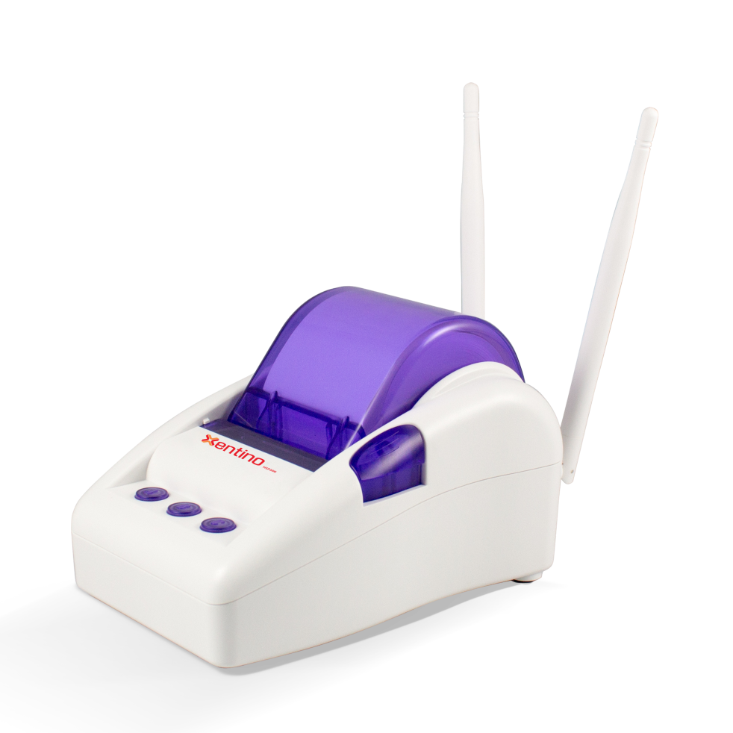

Figure 1‐4‐1 HSP500

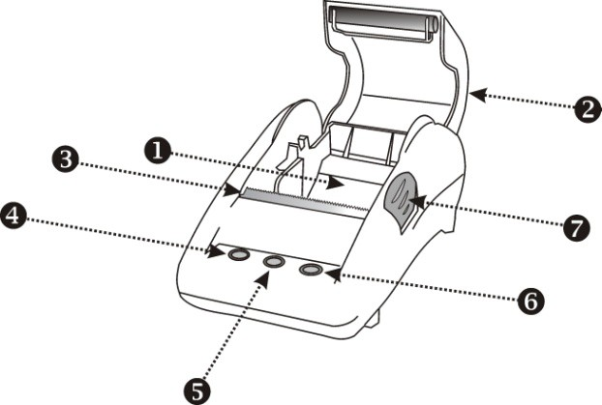

Figure 1‐4‐2 Front Panel

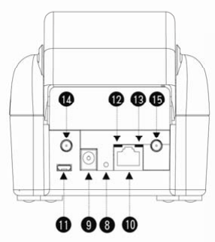

Figure 1‐4‐3 Rear Panel

1. Paper roll housing
2. Printer Cover
3. Tear Bar, for paper cutting
4. Button A
5. Button B
6. Button C
7. Push Button, for printer cover opening
8. Reset Button
9. DC power supply connector
10. RJ45 port
11. Micro USB connector
12. WLAN LED (Green)
13. UPLINK LED(Yellow)
14. SMA connector
15. SMA connector

- WLAN LED:
Off: The wireless is not ready.
Green light: The HSP500 has established a valid wireless connection. Green Blinking: The wireless connection is active.

- UPLINK LED:
Off: A port has not established any network connection.
Yellow light: A port has established a valid 10/100 Mbps network connection.
Yellow Blinking: 10/100 Mbps traffic is traversing the port.
- Reset Button: The HSP500 has a reset button at the rear panel of the device. Use this function to reset the system back to factory defaults.
- Power Jack: Used to connect the external power supply with the HSP500.

1­4­1 Printing a test page

After you have installed your printer, you should print a test page to make sure the printer is functioning properly. To do this act as follows:

1. Turn the printer off.

2. Hold down the button A for approximately five seconds, and then turn the printer on.

3. The printer will print a test page.

1­4­2 How to load paper rolls

Please follow the steps to correctly load paper rolls.

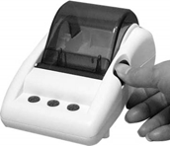
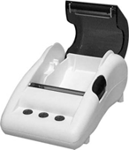
1 2

3 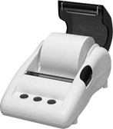 4 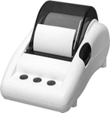

Figure 1‐4‐4 Paper rolls loading

1­5 Technical Specifications

1­5­1 Hardware Specifications

Network Specification
- IEEE802.3 10BaseT Ethernet
- IEEE802.3u 100BaseTX Fast Ethernet
- IEEE802.11b/g/n Wireless LAN
- ANSI/IEEE 802.3 NWay auto‐negotiation
- Wi‐Fi Compatible

Connectors
- One WAN Port (10BaseT/100BaseTX Auto cross‐over)
- One Micro USB connector

Encryption
- WEP (Wired Equivalent Privacy) 64/128‐bit RC4
- WPA (Wi‐Fi Protected Access)
- WPA2 (Wi‐Fi Protected Access)

External Antenna Type
- Dual detachable diversity antenna with reverse SMA

LED Indicators
- One POWER LED
- One WAN 10/100M Link/Activity LED
- One Wireless Link/Activity LED
- One System LED

Power Requirement
- External Power Adapter
- Input: 100‐240 VAC, 50/60 Hz
- Output: 12V, 1.5A

Environment Conditions
- Operating Temperature: 0 to 50°C

- Storage Temperature: ‐10 to 60°C
- Operating Humidity: 20~80% non‐condensing
- Storage Humidity: 20% to 90% non‐condensing

Certifications
- FCC part 15 Class B, CE , C‐Tick , VCCI

Dimension
- Size: 109×155×90 (W×D×H )mm
- Weight: About 340g (Net)

Printer Tray
- Push button: push to open printer cover
- Tear bar: cuts receipt paper
- Button A: flashing when printer cover is opened
- Paper roll housing: put paper roll here

Paper Roll and Printing
- Paper width: 58 (+0/‐1)mm
- Paper length: 50M (max.)
- Paper thickness: 65 um
- Paper roll outside diameter: 63 (+2/‐2) mm
- Paper roll inside diameter: 12 (+0.5/‐0) mm
- Paper Detection: Photo interrupter
- Printing width: 48 mm
- Printing Method: Direct thermal
- Printing Speed: 25.4 mm/ sec
- Dot resolution (dots/ mm): 8 (203 dpi)
- Thermal head service life: 1 pulses or 50Km

1­5­2 Software Specifications

Networking
- IEEE802.3 10BaseT Ethernet
- IEEE802.3u 100BaseTX Fast Ethernet
- IEEE802.11b Wireless LAN
- IEEE802.11g Wireless LAN
- IEEE802.11n Wireless LAN

- Supports 30 Simultaneous Users
- IP Plug and Play (iPnP)
- HTTP Proxy Support
- WEP64/128bit
- WPA-PSK (TKIP)
- WPA2-PSK(AES)
- WPA/WPA2 Mix mode
- SMTP Server Redirection
- DHCP Server(RFC 2131)
- DHCP Relay(RFC 1542)
- Static IP WAN Client
- DHCP WAN Client
- PPPoE WAN Client(RFC 2516)
- PPTP WAN Client
- NAT(RFC 1631)
- IP Routing
- NTP (Network Time Protocol) Support
- Local Account: 256
- Max Session Number: up to 16384

Marketing Cooperation
- Advertisement URL link
- Walled garden
- Customizable log‐on and log‐off pages
- Portal Page

User Accounting and Authentication
- Built‐in Authentication
- Web‐based Authentication
- RADIUS AAA Support (RFC 2865, 2866)
- Secondary RADIUS
- User Authentication and Accounting
- Logout Window Timer Control

Security and Firewall
- Layer 2 Isolation Security
- SSL User Login page/ Configuration Page

- SSL Administration
- VPN Pass through (IPSec/PPTP)
- Customize SSL Certificate
- Pass Through IP/MAC/URL Address
- Restricted Destination Filtering IP/URL
- VPN (IPSec/PPTP) Pass through
- PPTP VPN Client
- WEP
- WPA
- WPA2
- WPA/WPA2 Mix mode

Management
- Web‐based Management Tool
- Firmware Upgrade via HTTP/TFTP
- Wizard setup for step‐by‐step Configuration
- Backup/Restore/Factory Default Setting
- Remote Authorized Management
- Real‐time Session List
- Syslog (System/Subscriber/LAN device)
- E‐mail logs
- SNMP v1/v2 (MIB II, Private MIB)
- System Information Table
- Status Report (Daily/Monthly/System/Network)
- SSL certificate upload

2. Installation

2­1 Connecting the Antennas

The HSP500 provides two antenna connectors on the rear of the unit.

2­2 Installation Requirements

Before installing the HSP500, make sure your network meets the following requirements.

System Requirements
The HSP500 requires one of the following types of software:

- Windows 98 Second Edition/NT/2000/XP/Vista
- Red Hat Linux 7.3 or later version
- MAC OS X 10.2.4 or later version
- Any TCP/IP‐enabled systems like Mac OS and UNIX (TCP/IP protocol installed)
- Standard phone line for xDSL modem Or Coaxial cable for Cable modem
- Web Browser Software (Microsoft I.E 5.0 or later version or Netscape Navigator 5.0 or later version)
- One computer with an installed 10Mbps, 100Mbps or 10/100Mbps Ethernet card
- UTP network Cable with a RJ‐45 connection (Package contents)

Note: Prepare twisted‐pair cables with RJ‐45 plugs. Use Cat.5 cable for all connections. Make sure each cable not exceed 328 feet (Approximately 100 meters).

ISP Requirements
Verify whether your ISP use fixed or dynamic IP. If it is a fixed IP, be sure to get the IP from your ISP. For dynamic IP, which is mostly used, the PC will get the IP automatically whenever it hooks up on the modem.

Dynamic IP
- Dynamic IP Setting

Fixed IP
- Your fixed IP address for the HSP500
- Your subnet mask for the HSP500
- Your default gateway IP address
- Your DNS IP address

PPPoE
- Your user name and password from your ISP

PPTP
- PPTP Server IP Address from your ISP
- PPTP Local IP address from your ISP.
- PPTP Local IP subnet mask from your ISP.
- Your user name from your ISP
- Your password from your ISP
- Your PC Requirements

The Static IP settings for the PC
- Your PC’s fixed IP address
- Your PC’s subnet mask
- Your PC’s default gateway IP address
- Your PC’s primary DNS IP address

Note:
1. The gateway’s default IP address setting is “10.59.1.1”.
2. The gateway’s default subnet mask setting is “255.255.255.0”.

The Dynamic IP settings for the PC
We recommend that you leave your IP settings as automatically assigned. By default, the HSP500 is a DHCP server, and it will give your PC the necessary IP settings.

2­3 Getting Start

HSP500 Connection
- Connect the DC power adapter to the HSP500 and plug it into a power socket.
- Connect HSP500 and xDSL modem with an Ethernet Cable.
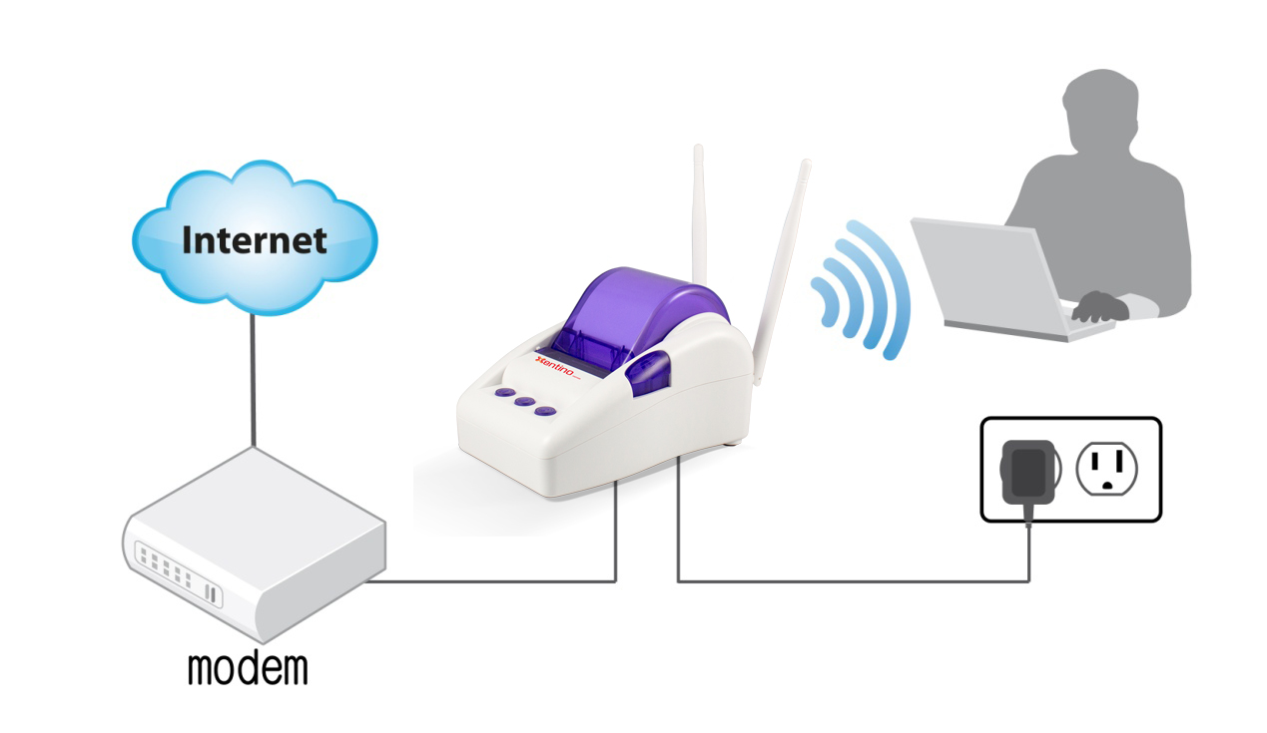
Figure 2-3-1 HSP500 Connection

Configure TCP/IP of your computer
For Windows user,
- Click Start > Control Panel, click Switch to Classic View and double click on Network Connections.
- Right click on the Local Area Connection and click Properties.
- Double click Internet Protocol (TCP/IP).
- Choose Obtain an IP address automatically.
- Click OK to close the Internet Protocol (TCP/IP) Properties and click OK again to close the Local Area Connection.

Figure 2-3-2 TCP/IP Setting

3. Configuring the HSP500

3­1 Setting Wizard

Step 1: The ESSID’s name by default is related to the last 4 numbers of WLAN MAC. If the WLAN MAC is “00-90-0E-00-12-34”, the default is “Xentino-1234_1”.
Please search ESSID “Xentino-1234_1” and connect it.

Step 2: Start your browser, and then enter the factory default IP address 10.59.1.1 in your browser’s location box. Press Enter.

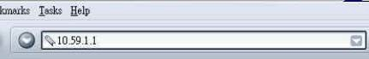
Figure 3‐1‐1 Web Browser Location Field (Factory Default)

Step 3: The HSP500 configuration tools menu will appear. In the Username and Password field, type the factory default user name admin and password admin and click Login. If you are first time setting the system, the wizard setup screen will appear. You will be guided, step‐by‐step, through a basic setup procedure.

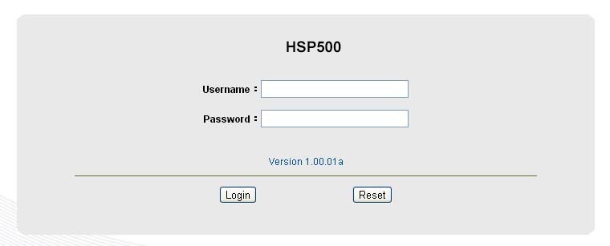

Figure 3‐1‐2 Configuration Tools Menu

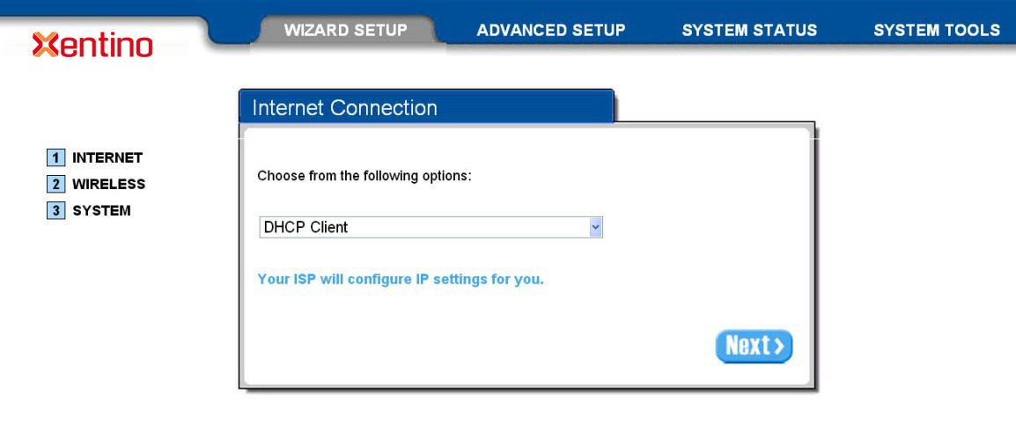
Figure 3‐1‐3 Wizard Setup Screen

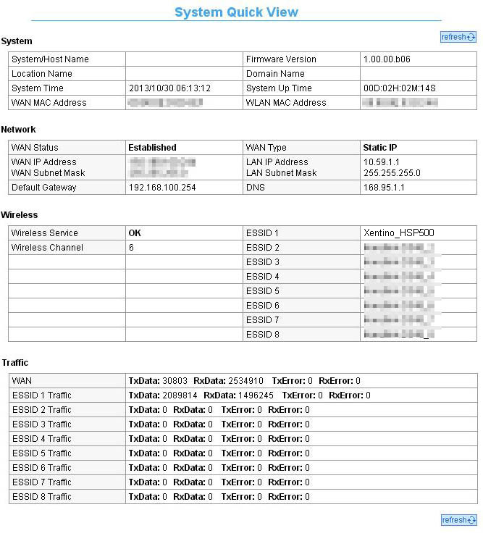

Figure 3‐1‐4 System Quick View

Step 4: Internet Connection Setting

Select the appropriate Internet connection type to connect to your ISP.

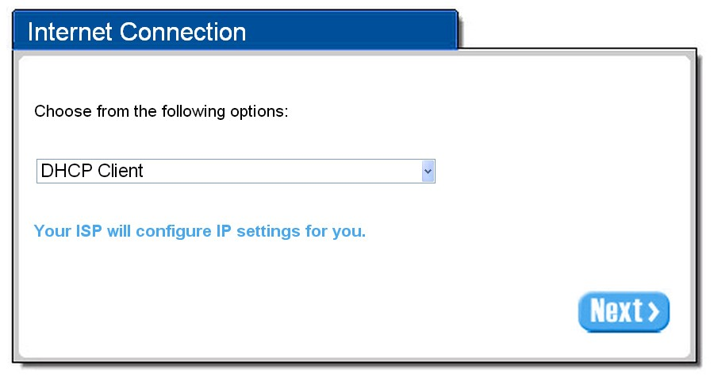

Figure 3‐1‐5 Internet Connection Setting Screen

DHCP Client
The device can work as a DHCP client. This allows the device to obtain the IP address and other TCP/IP settings from your ISP. If your xDSL/Cable comes with this feature, please enable Use DHCP Client.

Figure 3‐1‐6 Internet Connection Setting Screen

Static IP Setting
If Static IP Setting is selected, then this screen will appear. Enter the IP address information provided by your ISP.
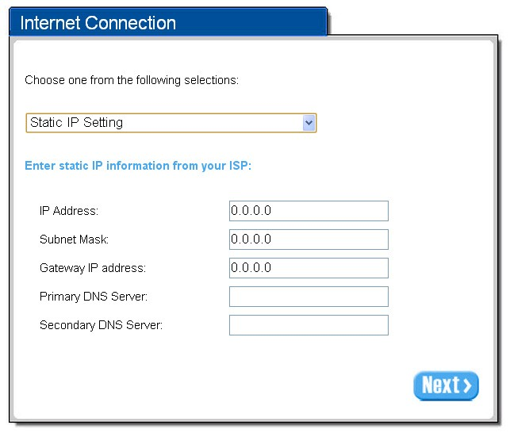

Figure 3‐1‐7 Internet Connection Setting Screen—Static IP Setting

Item | Default | Description
IP Address | 0.0.0.0 | Enter the IP address provided by your ISP.
Subnet Mask | 0.0.0.0 | Enter the subnet mask for the IP address.
Gateway IP Address | 0.0.0.0 | Enter the Gateway IP Address provided by your ISP.
Primary DNS Server | Empty | Enter the primary DNS server IP address for the xDSL/Cable connection  (provided by your ISP).
Secondary DNS Server | Empty | Enter the secondary DNS server IP address for the xDSL/Cable connection  (provided by your ISP). If the primary DNS Server IP were not available, meanwhile, Secondary DNS Server IP would start in the same time.

PPPoE (Point‐to‐Point Protocol over Ethernet)
If “PPPoE” is selected, then this screen will appear. Enter the username, password and other major fields.

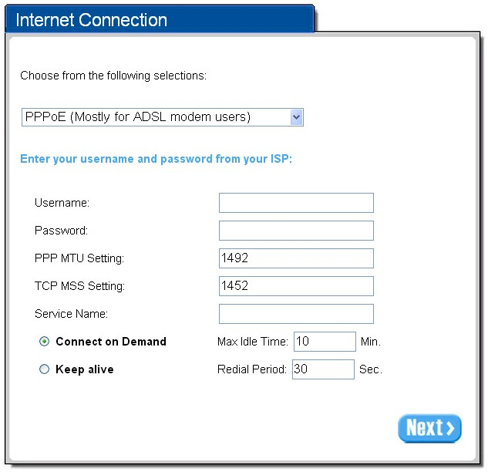

Figure 3‐1‐8 Internet Connection Setting Screen—PPPoE Setting

Item | Default | Description
Username | Empty | Enter the user name provided by your ISP. The user name can consist of up  to 80 alphanumeric characters and is case sensitive.
Password | Empty | Enter the user password provided by your ISP. The password can consist of  up to 80 alphanumeric characters and is case sensitive.
PPP MTU Setting | 1492 | MTU (Maximum Transfer Unit) specifies maximum transmission unit size.
TCP MSS Setting | 1452 | MSS (Maximum Segment Size) specifies maximum segment size.
Service Name | Empty | Enter the service name provided by your ISP. The service name can consist  of up to 64 alphanumeric characters and is case sensitive.
Connect on Demand and Max Idle Time
Connect on  Demand | Enable | You can configure your HSP500 to cut your connection with your ISP after a specified period of time (Max Idle Time). If you have been disconnected due to inactivity, Connect on Demand enables your HSP500 to automatically re-establish your connection as soon as you attempt to access the Internet again. If you wish to activate Connect on Demand, click the radio button. If you want your Internet
Max Idle Time | 10 Minutes

 |  | connection to remain, click the radio button of keep alive. The Max Idle Time maximum value is 65535 minutes.
Keep alive and Redial Period
Keep alive | Disable | This option keeps your PPPoE enabled Internet access connected indefinitely, even when it sits idle. The Redial Period maximum value is 65535 seconds.
Redial Period | 30 Seconds

PPTP Client (Point‐to‐Point Tunneling Protocol)
If PPTP Setting is selected, then this screen will appear. Please enter the IP address, Username and Password provided by your ISP.

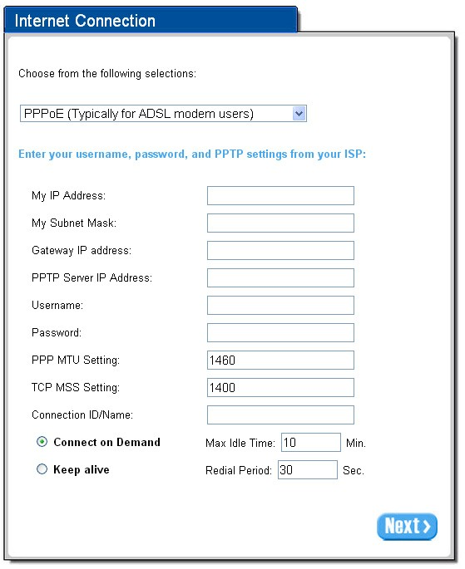

Figure 3‐1‐9 Internet Connection Setting Screen—PPPoE Setting

Item | Default | Description
Username | Empty | Enter the user name provided by your ISP. The user name can consist of up  to 80 alphanumeric characters and is case sensitive.
Password | Empty | Enter the user password provided by your ISP. The password can consist of  up to 80 alphanumeric characters and is case sensitive.
PPP MTU Setting | 1492 | MTU (Maximum Transfer Unit) specifies maximum transmission unit size.
TCP MSS Setting | 1452 | MSS (Maximum Segment Size) specifies maximum segment size.
Service Name | Empty | Enter the service name provided by your ISP. The service name can consist  of up to 64 alphanumeric characters and is case sensitive.
Connect on Demand and Max Idle Time
Connect on Demand | Enable | You can configure your HSP500 to cut your connection with your ISP after  a specified period of time (Max Idle Time).  If you have been disconnected due to inactivity, Connect on Demand enables your HSP500 to automatically re-establish your connection as soon as you attempt to access the Internet again. If you wish to activate Connect on Demand, click the radio button. If you want your Internet connection to remain, click the radio button of keep alive. The Max Idle Time maximum value is 65535 minutes.
Max Idle Time | 10  Minutes
Keep alive and Redial Period
Keep alive | Disable | This option keeps your PPPoE enabled Internet access connected indefinitely, even when it sits idle. The Redial Period maximum value is 65535 seconds.
Redial Period | 30  Seconds

Step 5: Wireless Setting
This page allows you to choose Country, Channel ID and 802.11 Mode for wireless connection.

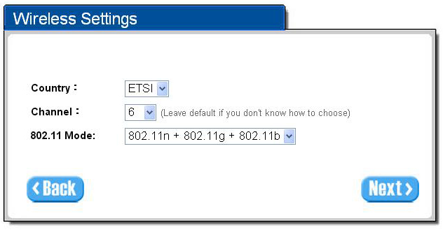

Figure 3‐1‐10 Wireless Setting Screen

Item | Default | Description
Country | ETSI | Enter the Country for wireless connection.
Channel | 6 | Enter the channel ID for wireless connection.
802.11 Mode | 802. 11n + 802.11g + 802.11b | Enter the 802.11 Mode for wireless connection.

Step 6: Authentication Setting

This page allows you to choose whether the users need to be authenticated before the Internet access. If users need the account and password to get access of Wi-Fi, please choose Yes.
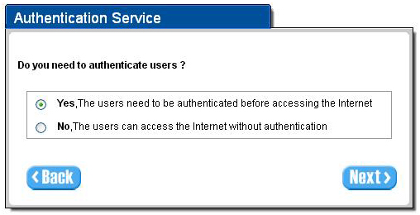
Figure 3-1-11 Authentication Service Setting Screen

Step 7: Billing Profile Setting
This page allows you to set your service and price plan. If you would like to provide “FREE” Wi-Fi for users, please activate “No Billing Mode” the price and the tax won’t be showed on the ticket. The billing type could be set by time based or by volume based.
Time Base Profile
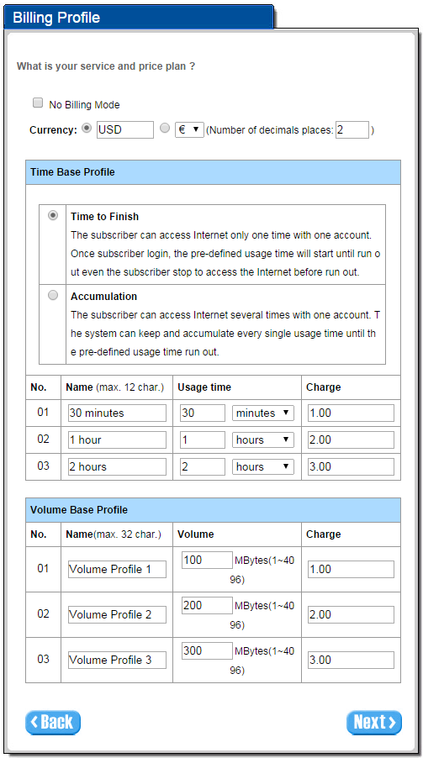
Figure 3-1-11 Billing Profile Setting

Item | Default | Description
No Billing Mode | Disabled | If you would like to provide FREE Wi-Fi for users, please activate“No Billing Mode”the price and the tax won’t be showed on the ticket.
Currency | USD | The administrator can decide the currency printed out on the ticket.
Service and Price Plan | Time to Finish | Choose your service and price plan.
Time Base Profile  01/02/03 | You could set the profile name, usage time and charge here. You could set 3 different profiles in this step.

Volume Based Profile
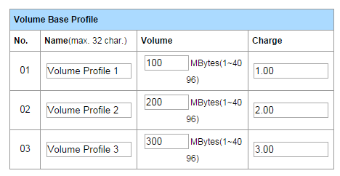
Figure 3-1-13 Billing Profile Setting – Volume base

Item | Default | Description
Volume Base Profile  01/02/03 | You could set the profile name, volume and charge here. You could set 3 different profiles in this step.

Step 8: Accounting Setting
Following the Billing Profile Setting, the page allows to set the billing profiles for each button of the printer.
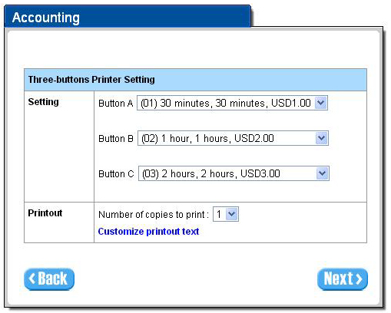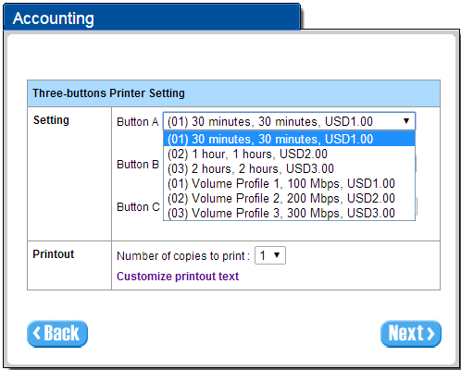
Figure 3-1-14 Accounting Setting
Item | Default | Description
Setting
Button A/Button B/Button C | You could choose the billing profile via the dropdown list for each button on the printer.
Printout
Numbers of copies to print | 1 | The numbers of the same printed tickets. You can reserve the copies.
Customize printout ticket |  | You can customize the printout text for the ticket. If you want to know more, please refer to Error! Reference source not found. Error! Reference source not found. / Account Printout.

Step 9: Firmware Upgrade Notice Setting
If you would like to receive the information about firmware upgrade, please activate it and leave your email.
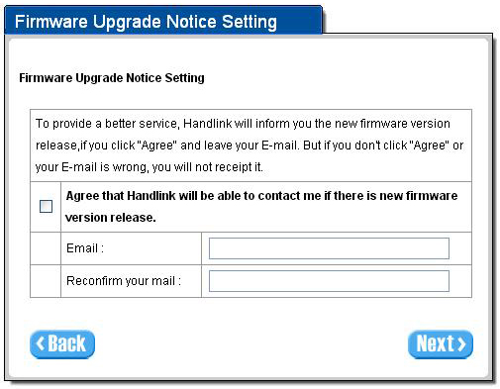
Figure 3-1-15 Firmware Upgrade Notice Setting

Step 10: System Setting
System Setting: The HSP500 allows changing the administrator’s Username and Password, and system time setting.
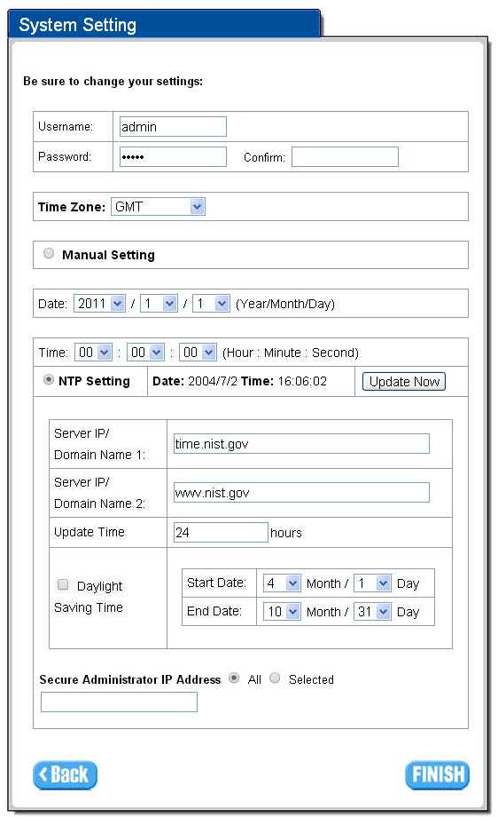
Figure 3-1-16 System Setting Screen
Item | Default | Description
Username | admin | Enter the user name. The user name can consist of up to 80 alphanumeric characters and is case sensitive.
Password | admin | Enter the user password. The password can consist of up to 80 alphanumeric characters and is case sensitive.
Time Zone | GMT | Enter the Time Zone for the system.
Manual Setting | YYYY/MM/DD HH:MM:SS | Click Manual Setting to set the system date and time.
NTP Setting |  | Click Update button to correct the system date and time.
Secure Administrator IP Address | All | This function allows remote user to management the device. You can specify one or any IP addresses for remote control the system.
Click FINISH button to save the settings then the system will restart.
Note:
- This Web agent is best viewed with IE 5.0 or Netscape 6.0 and above browsers.
- Username and Password can consist of up to 20 alphanumeric characters and are case sensitive.
- If for some reason your password is lost or you cannot gain access to the HSP500 Configuration Program, please press the reset button to load the device to manufacturer defaults.
- If the administrator doesn’t send packet in 5 minutes (default), the HSP500 will logout automatically.
- Proxy needs to set disable first when the administrator accesses admin UI.

3­2 Advanced Setup

The Advanced Setting enables you to configure advanced settings related to accessing the Internet, including,

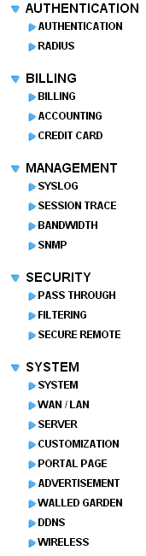
AUTHENTICATION
- AUTHENTICATION
- RADIUS

BILLING
- BILLING
- ACCOUNTING
- CREDIT CARD

MANAGEMENT
- SYSLOG
- SESSION TRACE
- BANDWIDTH
- SNMP

SECURITY
- PASS THROUGH
- FILTERING
- SECURE REMOTE

SYSTEM
- SYSTEM
- WAN / LAN
- SERVER
- CUSTOMIZATION
- PORTAL PAGE
- ADVERTISEMENT
- WALLED GARDEN
- DDNS
- WIRELESS

Figure 3‐2‐1 Advanced Setting Item

Note: After change the settings of device, please click Apply button to save the new settings.

3­2­1 AUTHENTICATION

3‐2‐1‐1 Authentication

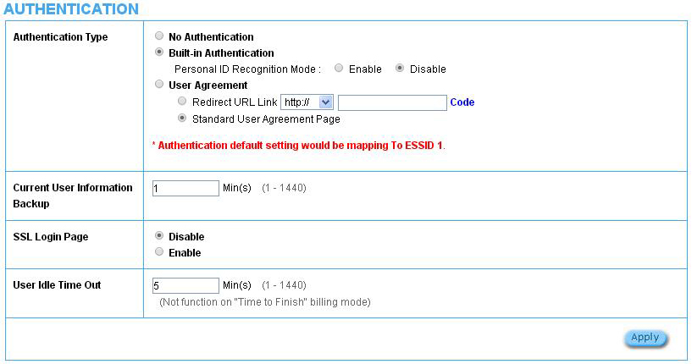

Figure 3‐2‐2 Authentication

Item | Default | Description
Authentication Type | Built-in Authentication | Option: No Authentication, Built-in Authentication or User Agreement.  No Authentication  Subscriber can direct access the Internet without enter username and password.  Built-in Authentication  HSP500 provides “Built-in Authentication” for service provider to build up an Internet service without any extra authentication software. If “Built-in Authentication” is selected, service provider can generate the subscriber account inside the device, and the system will authenticate the subscriber login according to the generated account.  Personal ID Recognition mode  Some countries or areas will ask Wi-Fi users to offer personal ID recognition according to the law for the Internet crime investigation. If you would like to activate PIR function, please refer to Chapter 5 Personal ID Recognition. The default is Disable.  User Agreement  Subscriber must accept the service usage agreement before they can access the Internet.
Redirect Login Page URL | Empty | The input format can be http://www.yahoo.com. The maximum character of the URL Link is 200.
Code | Copy and paste the following HTML Code into your home page to produce redirect subscriber login page.

Copy and paste the following HTML Code into your home page to produce user
agreement login page.

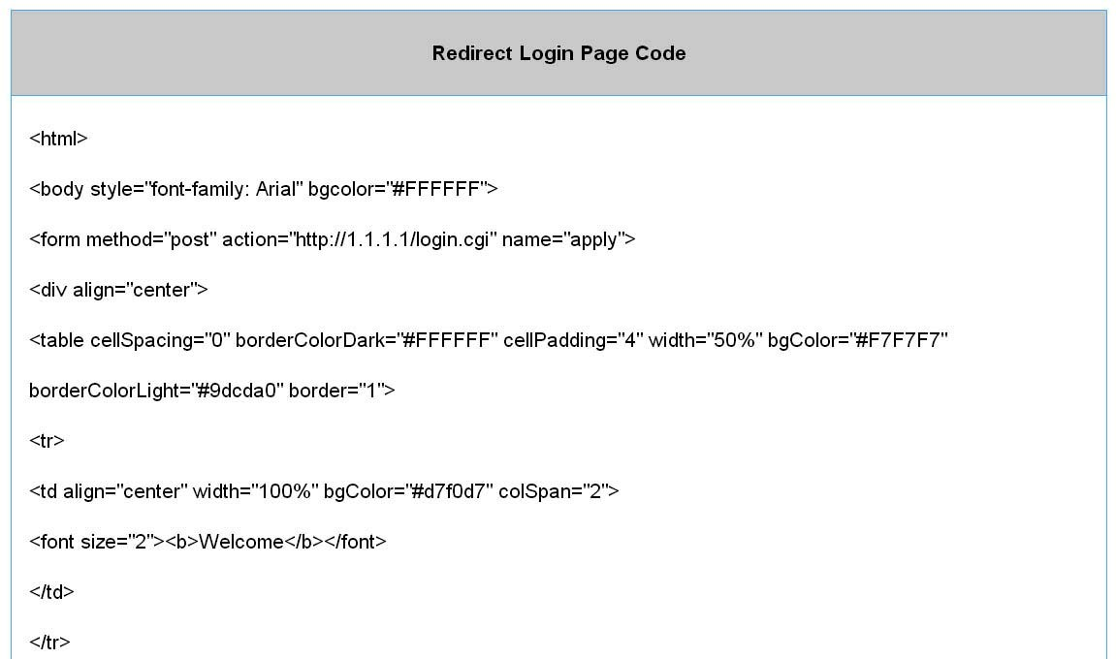

Figure 3‐2‐3 Preview Redirect Login Page Code

Item | Default | Description
Current User Information Backup | 1 Min(s) | The system provides automatically backup account information and unused account to flash ROM. This function allow administrator to adjust the backup time. The default value is 1 minute. The Current User  Information Backup valid range is 1 to 1440.
SSL Login Page | Disable | Enables or disables SSL security of login page.
User Idle Time Out | 5 Minutes | The user idle time out valid range is 1-1440.

Click Apply button to save the new settings.

3‐2‐2‐2 RADIUS

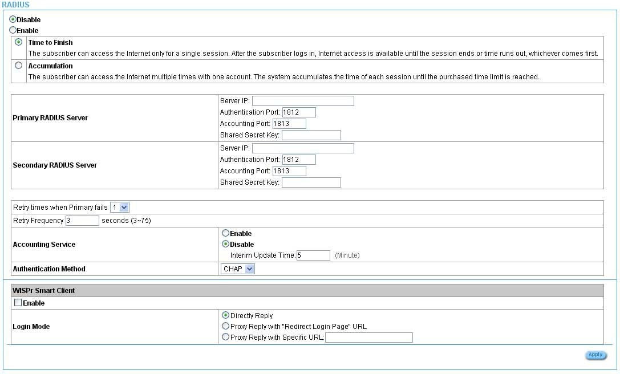

Figure 3‐2‐4 Authentication Setting Screen

Item | Default | Description
RADIUS Authentication | Disable | Disable (RADIUS Disable)  Subscriber can direct access the Internet without enter username and password.  Enable (RADIUS Authentication)  HSP500 provides “RADIUS Authentication” for service provider to build up an Internet service with RADIUS server. If RADIUS Authentication is enabled, all subscribers’ authentication will send to RADIUS Server by RADIUS protocol (RFC 2865, 2866).
Time to Finish/  Accumulation | Enable | Service provider provides two different accounting calculate for the  Internet service.
Primary RADIUS Server
Server IP | Empty | Enter the IP address of RADIUS server.
Authentication Port | 1812 | Enter the authentication port number; the authentication port number  must match with the RADIUS server setting. The allowed numbers  are from 0 to 65535.

Accounting Port | 1813 | Enter the accounting port number; the accounting port number must match with the RADIUS server setting. The allowed numbers are from  0 to 65535.
Share Secret Key | Empty | The share secret key, the key number also has to match with the  Server setting. Up to 64 characters are allowed.
Secondary RADIUS Server
Server IP | Empty | Enter the IP address of RADIUS server.
Authentication Port | 1812 | Enter the authentication port number; the authentication port number must match with the secondary RADIUS server setting. The allowed numbers are from 0 to 65535.
Accounting Port | 1813 | Enter the accounting port number; the accounting port number must match with the secondary RADIUS server setting. The allowed numbers are from 0 to 65535.
Share Secret Key | Empty | The share secret key, the key number also has to match with the  secondary RADIUS Server setting. Up to 64 characters are allowed.
Retry times when  Primary fail | 1 | Specify the retry times when primary fail.
Retry Frequency ~  Seconds | 3 | The field default value is 3 seconds.
Accounting Service | Disable | Enables or disables the accounting service.
Interim Update Time | 5 Minutes | Specify the interim update time.
Authentication Method | CHAP | CHAP Enter the authentication method of RADIUS server.
WISPr Smart Client
Enable | Disable | Enables or disables WISPr Smart Client roaming function.
Login Mode | Directly Reply | Options: Directly Reply, Proxy Reply with “Redirect Login Page” URL  and Proxy Reply with Specific URL. The login mode information for the IPASS GIS connection. (Provided by your ISP).

3­2­2 BILLING

3‐2‐2‐1 Billing

The function is used to setup a billing profile. A billing profile is a description of how you want to charge your customer.

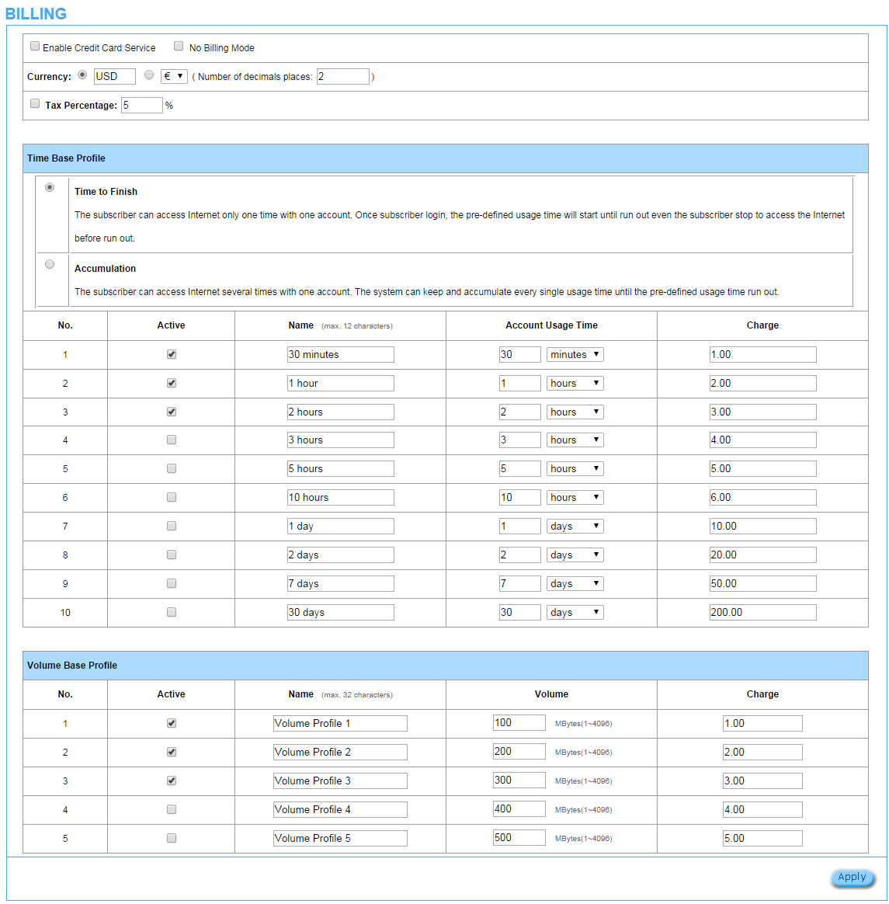

Figure 3‐2‐5 Billing Setting Screen

Item | Default | Description
Enable Credit Card Service | Disable | Enables or disables the credit card service. Before you enable credit card service, make sure that your credit service is configured to work and the currency is American dollars. You must be converting all prices on your billing page into American dollars (U.S. dollars). For details, see section 3-2-2-3 Credit Card. The credit card function only supports the American dollars.
No Billing Mode | Disable | If you would like to provide FREE Wi-Fi for users, please activate“No Billing Mode”the price and the tax won’t be showed on the ticket.
Currency | USD | Enter the appropriate currency unit or currency symbol.
Number of decimals places | 2 | Enter the number. The field maximum value is 3.
Tax Percentage | Disable | This check box is used to indicate the taxable status of the account.
Tax Percentage | 5% | Enter the tax rate (i.e. a 5% sales tax is entered as 5).
Time Base Profile
Time to Finish | Enable | The subscriber can access Internet only one time with one account. Once subscriber login, the pre-defined usage time will start until run out even the subscriber stop to access the Internet before run out.
Accumulation | Disable | The subscriber can access Internet many times with one account. The system can keep and accumulate every single usage time until the pre-defined usage time run out.
You are able to set up to 10 records of time base profile in UI.
Active | - | Click on check box, active or inactive the billing profile.
Name | - | It is the name of billing profile. The maximum allowed characters length is 12.
Account Usage time | - | The duration of the billing period. When this period expires, user account will be discontinued.
Charge | - | Enter the unit rate amount (i.e. 35.00) that most of your accounts are charged for one day of service.
Volume Base Profile
You are able to set up to 5 records of volume base profile in UI.
Active | - | Click on check box, to active or inactive the billing profile.
Name | - | It is the name of billing profile. The maximum allowed characters length is 12.
Account Usage time | - | Setting the volume of the account. When this volume is run out, user account will be discontinued.
Charge | - | Enter the unit rate amount.

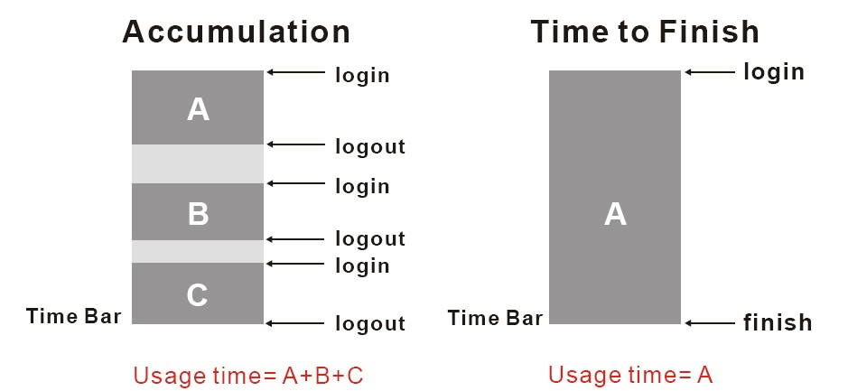

Figure 3‐2‐6 Accumulation and Time to Finish

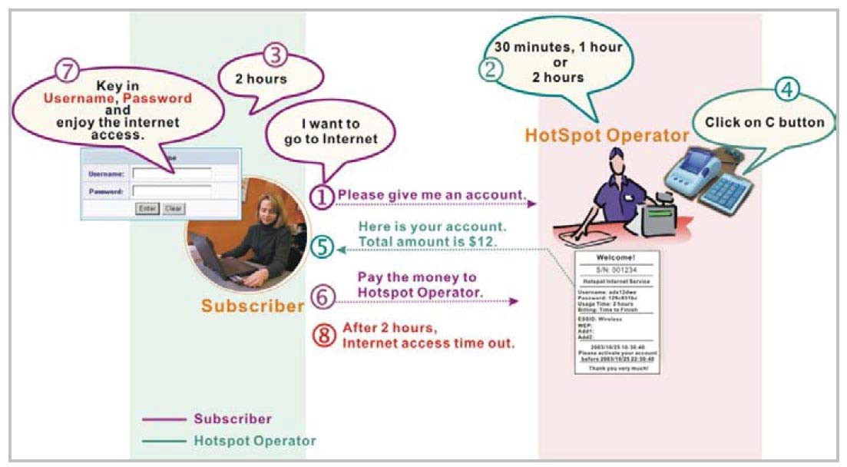

Figure 3‐2‐7 Pre‐paid Procedure Diagram

3‐2‐2‐2 Accounting

This function allow service provider to generate the subscriber accounts.

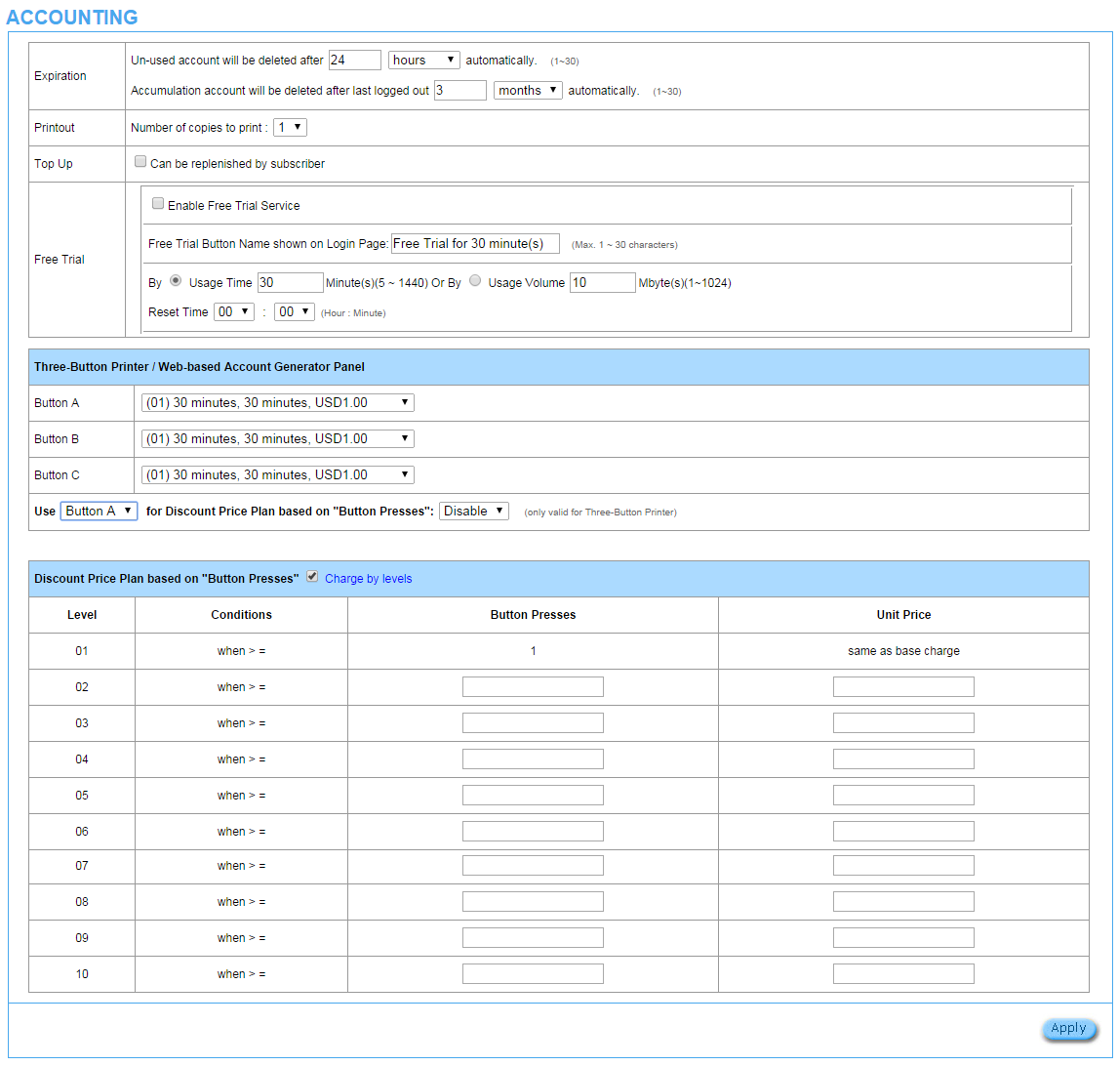

Figure 3‐2‐8 Accounting Setting Screen

Item | Default | Description
Expiration
Un-used account will be deleted  after ~hours automatically | 24 hours | Enter the number of hours/minutes/days. The field maximum  value is 30 hours/minutes/days.
Accumulation account will be  deleted after last logged in ~ | 3 months | Enter the number and select time unit from list box. The field  maximum value is 30 month/ days/ hours.
Printout
Number of copies to print | 1 | The system allows you to print all your bills. Select one number of  copies by clicking in the list box.
Top Up
Can be replenished by  subscriber |  | Click the check box to enable Top Up function.

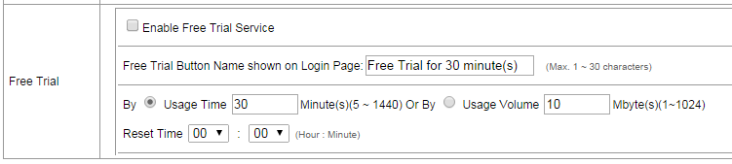

Figure 0-1 Accounting Setting Screen_Free Trial

Item | Default | Description
Free Trial
Enable Free Trial Service | Disable | You could provide free trial to users by enable this function.
Free Trial Button Name shown on Login Page | Free Trial for 30 minute(s) | You could customize the text that shown on user login page. The maximum allowed characters length is 30.
Free Trial base | By Usage time | You could set the free trial to be based by time or by volume and you could also define the usage of free trial.
Reset Time | 00:00 | The gratuitous usage amount of “free Trial” is on a periodic time basis. The “Reset Time” defines the periodic cycle time. Based on the configuration, HSP500 grants users the gratuitous usage amount (time or volume) on each periodic cycle time.

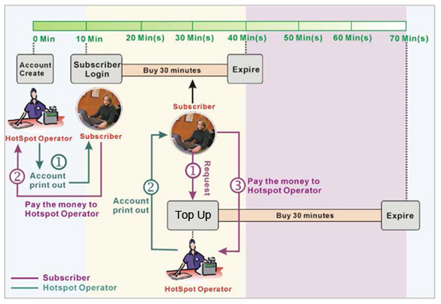
Figure 3‐2‐10 Account Process DiagramCan be replenished by subscriber=Enable

Item | Default | Description
Button A~C |  | Define each button’s billing profile. Select one billing profile  by clicking in the list box.
Use ~ for Discount  Price Plan based on  “Button Presses” | Button A, Disable | Select one button (A~C) by clicking in the list box to assign the base charge and select enable to active the discount price plan.

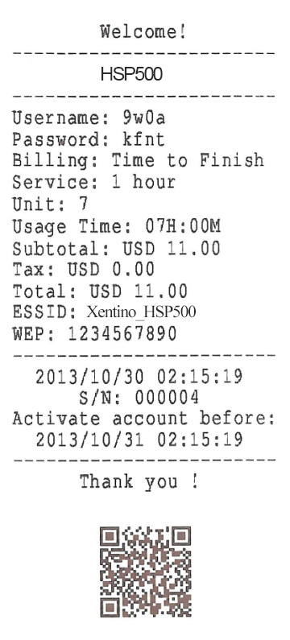
Figure 0-2 Account Generator Printer (Time to Finish)
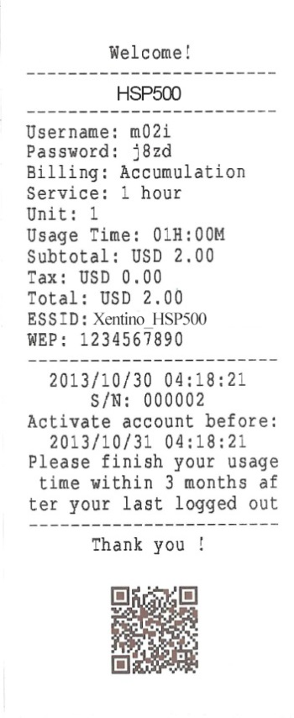
Figure 0-3 Account Generator Printer (Accumulation)

Example: If press 7 times

- Discount Price Plan based on “Button Presses” is disabled.
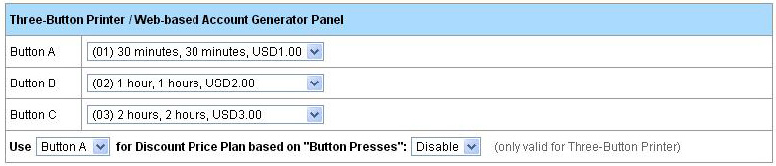

Figure 3‐2‐13 Example 1

Amount: 7 x $2.00= $14.00

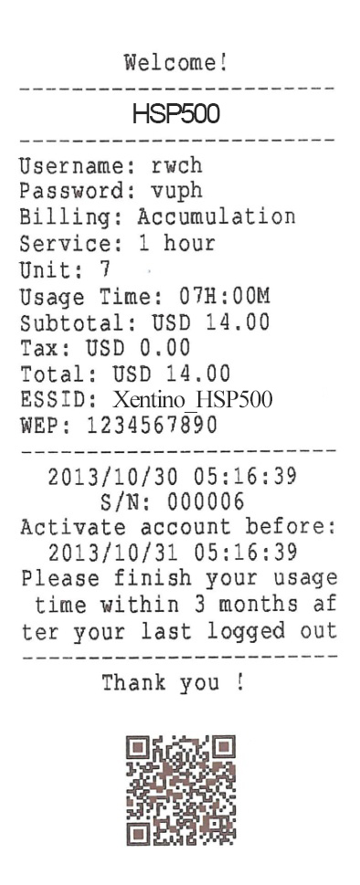

Figure 3‐2‐14 Account Printout

- Discount Price Plan based on “Button Presses” is enabled.
- The Charge by level is disabled.

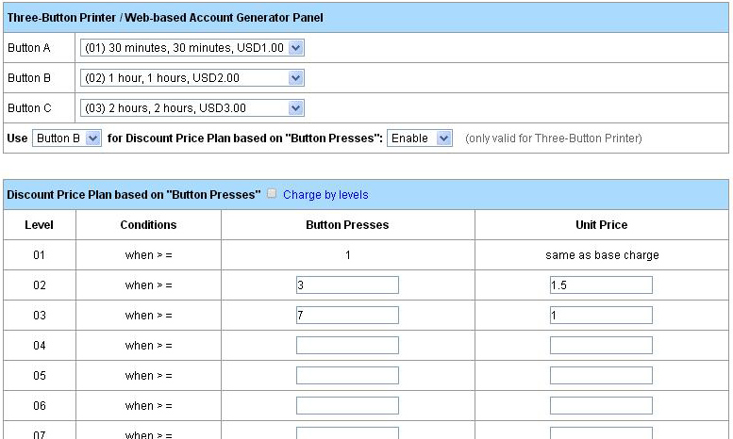

Figure 3‐2‐15 Example 2

Amount: 7 x $ 1 = $ 7.00

Below is an example of the account printout.

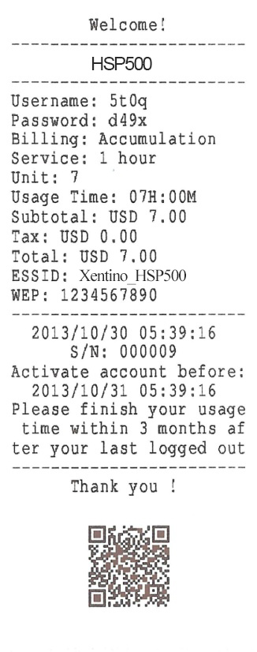
Figure 3‐2‐16 Account Printout

- Discount Price Plan based on “Button Presses” is enabled.
- Charge by level is enabled.

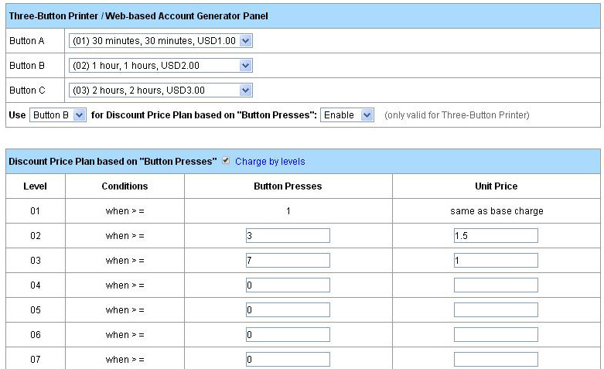

Figure 3‐2‐17 Example 3

Amount: 2 x $2.00 + 4 x$ 1.50+1x$1= $11.00

Below is an example of the account printout.

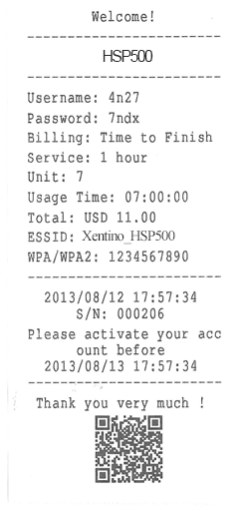
Figure 3‐2‐18 Account Printout

- Discount Price Plan based on “Button Presses”

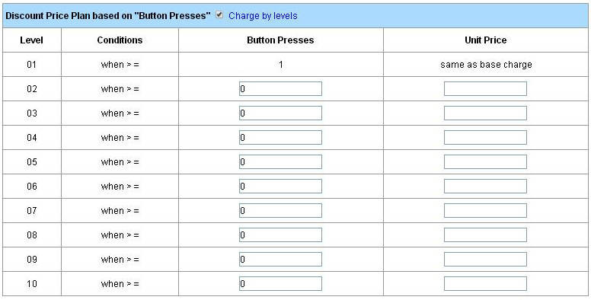

Figure 3‐2‐19 Discount Price Plan Setting Screen

Item | Default | Description
Charge by levels | Enable | Enables or disables the charge by levels function.
Level | 1‐10 | This field displays the level number of charge rate.
Conditions | When>= | The discount condition
Button Presses | - | Enter the times of pressing button
Unit Price | - | Enter the amount of charge level

Click Apply button to save the new settings and the success dialog box appears. Click on Back to return to Accounting setting screen.

3‐2‐2‐3 Credit Card

HSP500 provides three credit card services (Authorize.net, iValidate.net, Secure Pay and Paypal) that allow service provider to authorize, process, and manage credit transactions directly from Internet.

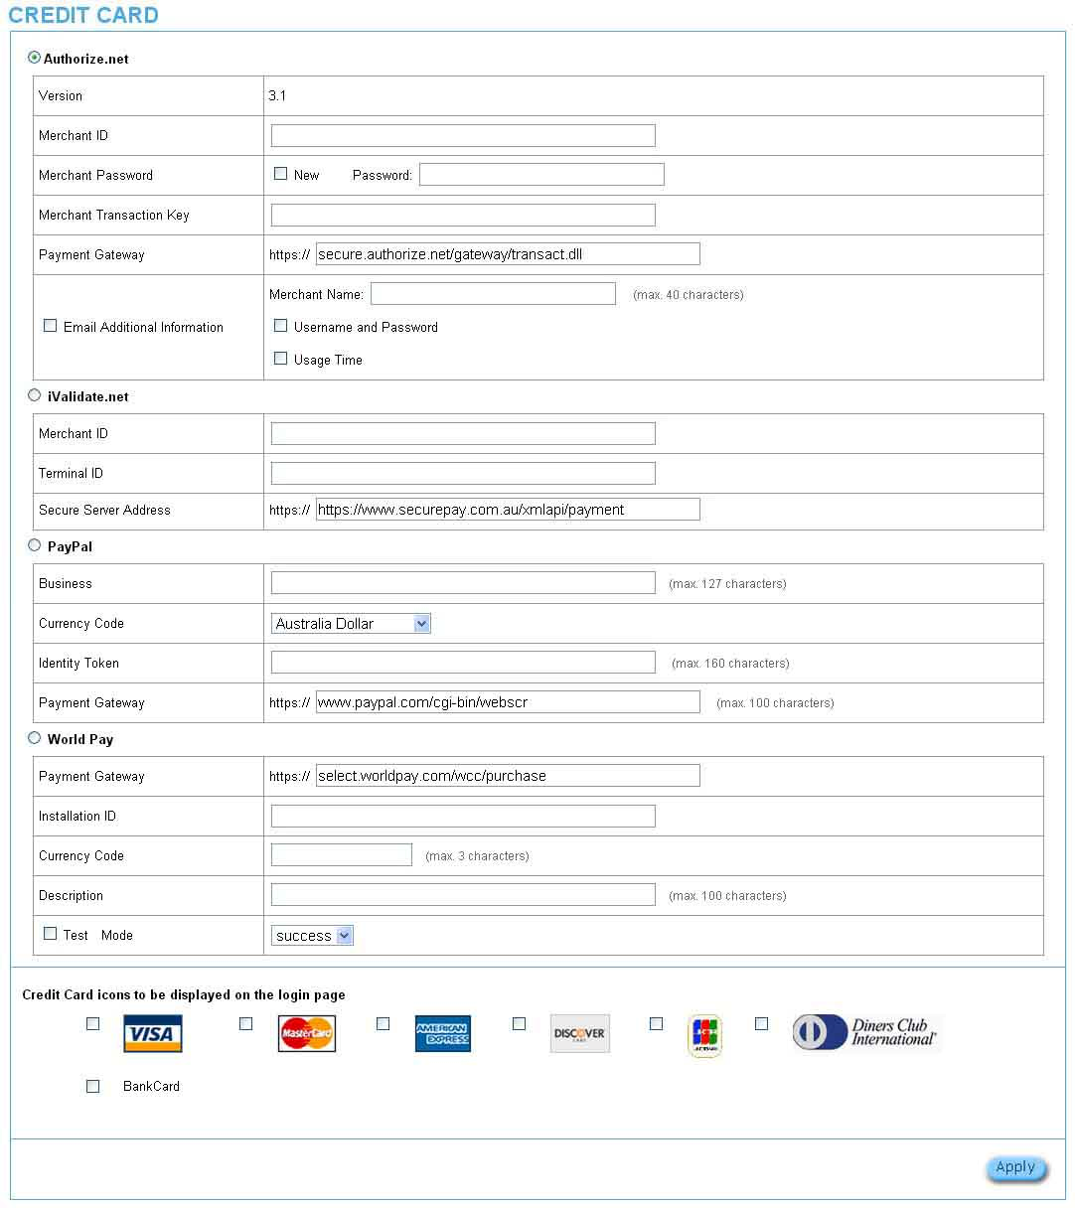

Figure 3‐2‐20 Credit Card Setting Screen

Item | Default | Description
Authorize.net
Version | 3.1 | This field displays the merchant version.
Merchant ID | Empty | Enter your Merchant ID. This is a Merchant Identification Number that you’re received from your Merchant Provider. The maximum character of the Merchant ID is 50.
Merchant Password | This is a Merchant password that you’re received from your Merchant Provider.
Need | Disable | If your Merchant Provider need password to authorize, click  the check box to enable this function.
Password | Empty | Enter your Merchant password.
Merchant Transaction Key | Empty | The Merchant Transaction Key can be obtained directly from “Authorize.net”. The Merchant Transaction Key is similar to a password and is used by the Payment Gateway to authenticate transactions. The maximum character of the Merchant Transaction Key is 50.
Payment Gateway | https://secure.authorize.net/gateway/transact.dll | Enter the address of Payment Gateway.
Email Additional Information | The Email Additional Information included subscriber username and password would be sent to subscriber.
Email Additional Information | Disable | Indicates whether Email additional information should be sent to the subscriber (customer).
Merchant Name | Empty | Enter the merchant’s company name. The maximum allowed characters length is 40.
Username and Password Enable/Disable | Disable | The Email Additional Information included subscriber username and password would be sent to subscriber.
Usage Time Enable/Disable | Disable | The Email Additional Information included subscriber usage time would be sent to the subscriber.
iValidate.net
Merchant ID | Empty | Enter your Merchant ID. This is a Merchant Identification Number that you’re received from your Merchant Provider. The maximum character of the Merchant ID is 20.
Device ID | Empty | Enter your Device ID. This is a Device Identification Number that you’re received from your Merchant Provider. The maximum character of the Device ID is 20.
Secure Server Address | https://www.vious.net/merchant/processcc.asp | Enter the secure server address.
Secure Pay
Merchant ID | Empty | Enter your Merchant ID. This is a Merchant Identification Number that you’re received from your Merchant Provider. The maximum character of the Merchant ID is 7.
Secure Pay Address | https://www.securepay.com.au/securepay/payments/process2.asp | Enter the address of SecurePay Payment Gateway.
Paypal
Business | Empty | Enter your Merchant PayPal account. This is a Merchant Identification account that you’re register on PayPal. The maximum character of the Business is 127.
Currency Code | Australia dollar | To Drop-down the list. It’s includes Australia dollar, Canadian Dollar, Euro, Pound Sterling, Japanese Yen , U.S. Dollars, Czech Koruna, Danish Kroner, Hong Kong Dollars, Hungarian Forint, New Zealand Dollars, Norwegian Kroner, Polish Zloty, Singapore Dollars, Swedish Kronor, Swiss Francs.
Identity Token | Empty | Enter the Identities token form merchants profile in the Paypal site. The maximum character of the Identity Token is 160.
Payment Gateway | https://www.paypal/cgi-bin/webscr | Enter the address of Payment Gateway.  The maximum character of the payment gateway is 100.
World Pay
Payment Gateway | select.worldpay.com/wcc/purchase | Enter the payment gateway address.
Installation ID | Empty | The unique reference number, assigned by WorldPay, for a particular Select installation. This is the number you send to WorldPay in your payment form. You will probably have at least two of these; one for the live installation and one for testing.
Currency Code | Empty | Enter the currency code
Description | Empty | Enter a description of payment page
Test Mode | Disable, Success | Enables or disables test mode function.  Select test mode by clicking in the list box.  Success─to make a successful test transaction.  Fail─for a failed transaction.
Credit Card icons to be displayed on the login page |  | Click on check box to display credit card icon on the login page.

Click Apply button to save the new settings and the success dialog box appears. Click on Back to return to Accounting setting screen.
Note: Please leave the Administrator’s Email address in Advanced/Syslog/Email portion.

3­2­3 MANAGEMENT

3‐2‐3‐1 Syslog

The function allows the device to transmit event messages to your syslog server or your email address for monitoring and troubleshooting.

Syslog Setting
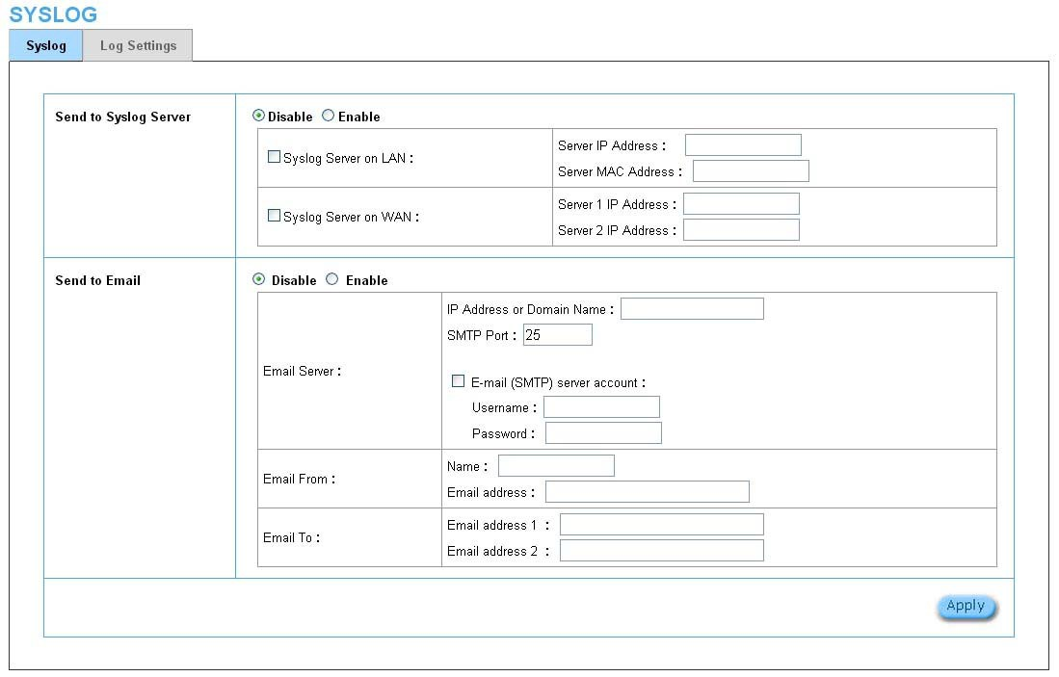

Figure 3‐2‐21 Syslog Setting Screen

Item | Default | Description
Send to Syslog Server | Disable | Enables or disables the syslog server function.
Syslog on LAN
Server IP Address | Empty | Enter syslog server’s IP address. The HSP500 will send all of its logs to  the specified syslog server.
Server MAC Address | Empty | Enter the syslog server’s MAC address. The HSP500 will send all of its  logs to the specified syslog server.

Item | Default |  | Description
Syslog on WAN
Server 1 IP Address | Empty | Enter IP address of first syslog server.
Server 2 IP Address | Empty | Enter IP address of second syslog server.
Send to Email | Disable | Enables or disables the send to e-mail function.
E-mail Server
IP Address or Domain Name | Empty | Enter the SMTP server IP address or domain name. The  maximum allowed characters length is 50.
SMTP Port | 25 | The SMTP port allowed range is 25 or 2500 to 2599.
E-mail (SMTP) Server needs to check my account | Disable | If your SMTP server requires authentication before accepting e-mail, click on check box. These values (username and password) are supplied by your network administrator, SMTP  server provider or ISP.
Username | Empty | Enter the username for the SMTP server. The maximum allowed  characters length is 64.
Password | Empty | Enter the password for the SMTP server
Email From
Name | Empty | Enter the name you would like to appear in the “message from”  field of your outgoing message. The maximum allowed characters length is 20.
Email Address | Empty | Enter your e-mail address. This is the address others will use to  send email to Email Address 1/Email Address 2.
Email To
Email Address 1 | Empty | Enter your first e-mail address to receive the logs.
Email Address 2 | Empty | Enter your second e-mail address to receive the logs.

Click Apply button to save the new settings and the success dialog box appears. Click on Back to return to Syslog setting screen.

Note：Support encryption web mail (Yahoo!, Gmail, Outlook.com) send and receive DUT log.

Log Categories

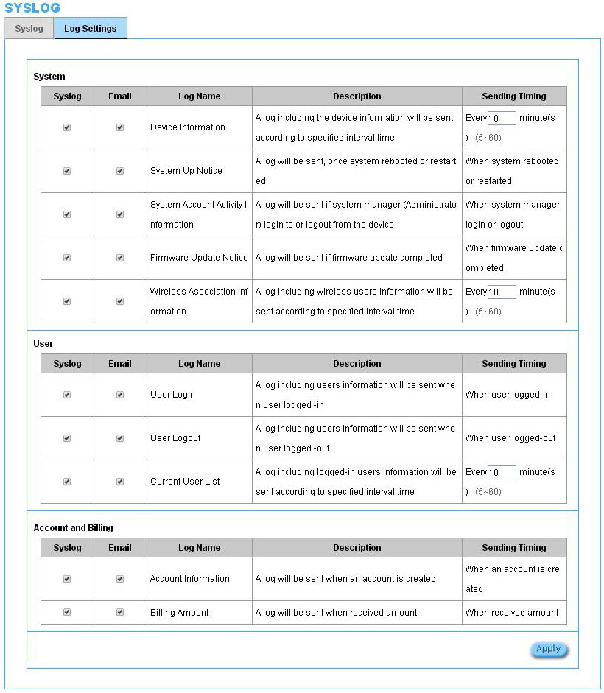

Figure 3‐2‐22 Log Settings Screen

Item | Default | Description
System
Device Information | Every 10 minute(s) | The range is 5~60 minutes. The log included system information would be sent according to specified interval time.  Format：  PRODUCT=HSP500 :VER=2.00.00;LOGNAME=DVI;  DATE=07Mar26;TIME=11:30:00;  WANMAC=09-00-0e-00-00-01;LANMAC=09-00-0e-00-00-02;  WLANMAC=09-00-0e-00-00-03;  IP_ADDRESS=210.66.37.21;  SYS_UP_TIME=14D23H34M21S;WANTXOK=99999;  WANRXOK=99999;WANTXERROR=99999;WANRXERROR=99999;  LANTXOK=99999;LANRXOK=99999;LANTXERROR=99999;  LANRXERROR=99999;WIRELESSTXOK=99999;WIRELESSRXOK=99999;  WIRELESSTXERROR=99999;WIRELESSRXERROR=99999;  WAN_QUALITY=5;
System Up Notice | When system rebooted or restarted | If device have been rebooted or restarted, the log would be sent.  Format：  PRODUCT=HSP500 ;VER=2.00.00;LOGNAME=SUN;  DATE=07Mar26;TIME=15:23:32;  WANMAC=09-00-0e-00-00-01;LANMAC=09-00-0e-00-00-02;  WLANMAC=09-00-0e-00-00-03;  IP_ADDRESS=210.66.37.21;  SYS_NAME=Cafehotspot;LOCATION=East;CITY=Taipei;  COUNTRY=Taiwan; FIRMWARE=v1.01.02;MESSAGE=System_Up;  Message = System_Reboot
System Account Activity Information | When system manager login or logout | A log will be sent if system manager (Administrator) login  to or logout from the device  Format：  PRODUCT=HSP500 ;VER=2.00.00;LOGNAME=SUN;  DATE=07Mar26;TIME=15:23:32;  WANMAC=09-00-0e-00-00-01;LANMAC=09-00-0e-00-00-02;  WLANMAC=09-00-0e-00-00-03;  IP_ADDRESS=210.66.37.21;  SYS_NAME=Cafehotspot;LOCATION=East;CITY=Taipei;  COUNTRY=Taiwan;  FIRMWARE=v1.01.02;MESSAGE=System_Up;  Account Name = Admin | Supervisor | Operator  Status= Login | Logout | Idle_Time_Out
Firmware Update Notice | When firmware update completed | A log will be sent if firmware update completed  Format:  PRODUCT=HSP500 ;VER=2.00.00;LOGNAME=FUN;  DATE=07Mar26;TIME=15:23:32;  WANMAC=09-00-0e-00-00-01;LANMAC=09-00-0e-00-00-02;  WLANMAC=09-00-0e-00-00-03;  IP_ADDRESS=210.66.37.21;  MESSAGE=Success;OLD_FRIMWARE=v1.00.01;  NEW_FIRMWARE=v1.00.02  Message = Success | Fail
Wireless Association Information | Every 10 minute(s) | The range is range 5~60 minutes. A log including wireless users information will be sent according to specified interval time.  Format:  PRODUCT=HSP500 ;VER=2.00.00;LOGNAME=WAI;  DATE=07Mar26;TIME=15:23:32;  WANMAC=09-00-0e-00-00-01;LANMAC=09-00-0e-00-00-02;  WLANMAC=09-00-0e-00-00-03;  IP_ADDRESS=210.66.37.21;  USER_NUM=15;SEQ=1-5;USER_MAC=02-34-3e-01-00;
User
User Login | When user logged-in | A log including users information will be sent when user logged–in  Format:  PRODUCT=HSP500 ;VER=2.00.00;LOGNAME=ULI;DATE=07Mar26;  TIME=15:23:32;WANMAC=09-00-0e-00-00-01;  LANMAC=09-00-0e-00-00-02; WLANMAC=09-00-0e-00-00-03;  IP_ADDRESS=210.66.37.21;USER_NAME=asdfg12;USER_IP=10.59.1.1;  USER_MAC=02-34-3e-01-00;INTERFACE=Ethernet;  USER_TYPE=Dynamic;  User Type = Dynamic / Super / User Agreement / Radius / No-Auth
User Login | When user logged-in | When User Replenish login format:  PRODUCT=HSP500 ;VER=2.00.00;LOGNAME=URP;DATE=07Mar26;  TIME=15:23:32; WANMAC=09-00-0e-00-00-01;  LANMAC=09-00-0e-00-00-02; WLANMAC=09-00-0e-00-00-03;  IP_ADDRESS=210.66.37.21;USER_NAME=asdfg12;  REP_USER_NAME=kifm2fs3;USER_IP=10.59.1.1;  USER_MAC=02-34-3e-01-00; INTERFACE=Ethernet;  USER_TYPE=Dynamic; USED_TIME=24:00:00;TIME_LEFT=24:00:00  User Type = Dynamic / Radius
User Logout | When user  logged-out | A log including users information will be sent when user  logged –out  Format:  PRODUCT=HSP500 ;VER=2.00.00;LOGNAME=ULO;DATE=07Mar26;  TIME=15:23:32;WANMAC=09-00-0e-00-00-01;  LANMAC=09-00-0e-00-00-02; WLANMAC=09-00-0e-00-00-03;  IP_ADDRESS=210.66.37.21;USER_NAME=asdfg12;USER_IP=10.59.1.1;  USER_MAC=02-34-3e-01-00;INTERFACE=Ethernet;  USER_TYPE=Dynamic;RXDATA=1234; TXDATA=1234;  USED_TIME=24:00:00;LOGOUT_TYPE=Time_Up;TIME_LEFT=24:00:00  User Type = Dynamic / Super / User Agreement / Radius / No-Auth
Current User List | Every 10 minute(s) | The range is Range 5~60 minutes. A log including logged-in users information will be sent according to specified interval time  Format:  PRODUCT=HSP500 ;VER=2.00.00;LOGNAME=CUL;DATE=07Mar26;  TIME=15:23:32;WANMAC=09-00-0e-00-00-01;  LANMAC=09-00-0e-00-00-02; WLANMAC=09-00-0e-00-00-03;  IP_ADDRESS=210.66.37.21;USER_NUM=0;SEQ=1-5;  USER_NAME=asdfg12,USER_IP=10.59.1.2,USER_MAC=02-34-3e-01-00,  INTERFACE=Ethernet,USER_TYPE=Dynamic,RXDATA=1234,  TXDATA=1234,USED_TIME=24:00:00,SESSION=100,WLAN_SIG=N/A;  USER_NAME=dk6uf2eg,USER_IP=10.59.1.3,USER_MAC=02-34-3e-01-02,  INTERFACE=Wireless,USER_TYPE=Dynamic,RXDATA=1234,  TXDATA=1234,USED_TIME=24:00:00,SESSION=100,WLAN_SIG=100%;  User Type = Dynamic / Super / User Agreement / Radius / No-Auth  User Name = If the type of user is Super/User Agreement/No-Auth , the  username=****
Account and Billing
Account Information | When an account is created | A log will be sent when an account is created  Format:  PRODUCT=HSP500 ;VER=2.00.00;LOGNAME=ACI;DATE=07Mar26;  TIME=15:23:32;WANMAC=09-00-0e-00-00-01;  LANMAC=09-00-0e-00-00-02; WLANMAC=09-00-0e-00-00-03;  IP_ADDRESS=210.66.37.21;USER_NAME=asdfg12;  ACCOUNT_TYPE=TimetoFinish; ACCOUNT_SERIAL=000002;  ACCOUNT_PRICE= USD20.00; ACCOUNT_USAGE_TIME=10:59:59;  BILLING_INDEX=1;BILLING_UNIT=2;  Account Type = TimeToFinish / Accumulation / PostPaid  Account Price = Currencyxx.xx  Currency = AUD | CHF | EUR | GBP | JPY | RIY | USD
Billing Amount | When received  amount | A log will be sent when received amount  Format:  PRODUCT=HSP500 ;VER=2.00.00;LOGNAME=BLA; DATE=07Mar26;  TIME=15:23:32;WANMAC=09-00-0e-00-00-01;  LANMAC=09-00-0e-00-00-02; WLANMAC=09-00-0e-00-00-03;  IP_ADDRESS=210.66.37.21;USER_NAME=username; BILL_TYPE=Cash,  BILL_AMOUNT= USD50.00  Billing Type= Cash | Credit_Card； Billing Amount = xx.xx  Currency = AUD | CHF | EUR | GBP | JPY | RIY | USD……

Click Apply button to save the new settings and the success dialog box appears. Click on Back to return to Logs setting screen.

3‐2‐3‐2 Session Trace

Session Trace is an intelligent function to help service provider to trace every user’s access behavior. When “session trace” is enable , the system will collect information such like destination IP, destination port, source IP, source MAC, source port by every user and send the collected information in text format file to specified TFTP server or Email Server.

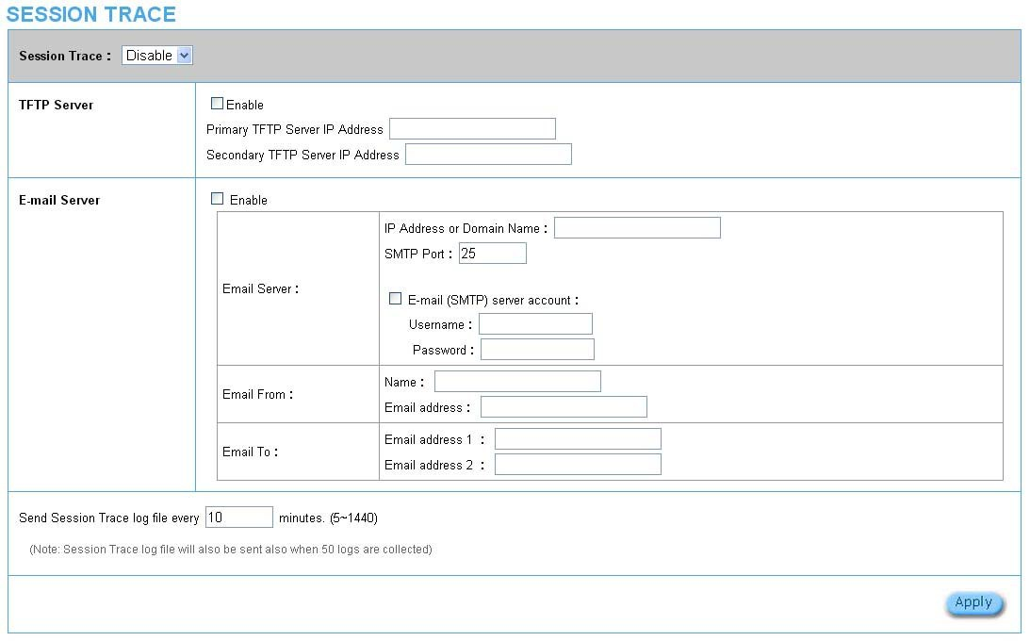

Figure 3‐2‐23 Session Trace Setting Screen

Item | Default | Description
TFTP Server
Session Trace | Disable | Disables or enables session trace function.
Primary TFTP Server IP  Address | Empty | Enter the IP address of the primary TFTP server.
Secondary TFTP Server IP  Address | Empty | Enter the IP address of the second TFTP server.
Send Session Trace log file  every~ minutes. | 10 minutes | The field means to send the session trace log file every interval  minutes. The value range is 5 to 1440 (minutes).
Send to Email | Disable | Enables or disables the send to e-mail function.
E-mail Server
IP Address or Domain Name | Empty | Enter the SMTP server IP address or domain name. The  maximum allowed characters length is 50.
SMTP Port | Empty | The SMTP port allowed range is 25 or 2500 to 2599.
E-mail (SMTP) Server needs to check my account | Disable | If your SMTP server requires authentication before accepting e-mail, click on check box. These values (username and password) are supplied by your network administrator, SMTP server provider or ISP.
Username | Empty | Enter the username for the SMTP server. The maximum allowed  characters length is 64.
Password | Empty | Enter the password for the SMTP server
Email From
Name | Empty | Enter the name you would like to appear in the “message from”  field of your outgoing message. The maximum allowed characters length is 20.
Email Address | Empty | Enter your e-mail address. This is the address others will use to  send email to Email Address 1/Email Address 2.
Email To
Email Address 1 | Empty | Enter your first e-mail address to receive the logs.
Email Address 2 | Empty | Enter your second e-mail address to receive the logs.

3‐2‐3‐3 Bandwidth

The function enables administrator to limit bandwidth usage on a per user basis (MAC address). That prevents users from consuming a disproportionately large amount of bandwidth so every user gets a fair share of the available bandwidth.

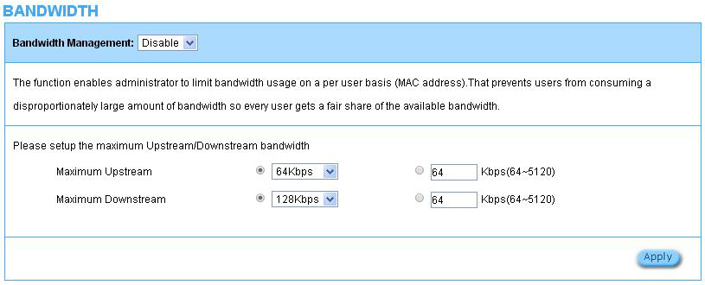

Figure 3‐2‐24 Bandwidth Setting Screen

Item | Default | Description
Bandwidth | Disable | Enables or disables Bandwidth Management.
Maximum Upstream | 64Kbps | Specify the amount of upstream bandwidth.
Maximum Downstream | 128Kbps | Specify the amount of downstream bandwidth.

3‐2‐3‐4 SNMP

The SNMP Agent Configuration screen enables you to access to your device via Simple Network Management Protocol. If you are not familiar with SNMP, please consult your Network Administrator or consult SNMP reference material. You must first enable SNMP on the SNMP Agent Configuration screen.

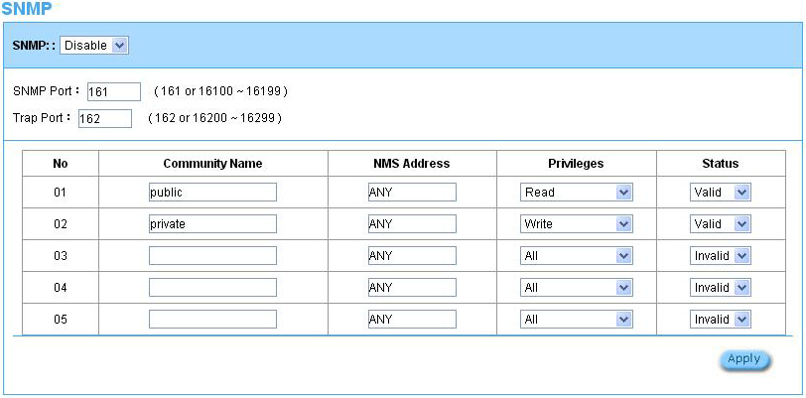

Figure 3‐2‐25 SNMP Setting Screen

Item | Default | Description
SNMP | Disable | Disables or enables the SNMP management.
SNMP Port | 161 | If the SNMP enables, also allowed to specific the SNMP port number via NAT. The allowed SNMP port numbers are 161(default), 16100-16199 and Trap port numbers are 162 (default), 16200-16299. This Port setting is useful for remote control via NAT network.
Trap Port | 162
Configuration
Community Name | public/private | Every unit with SNMP enable must be configured to recognize one or more community names up to 20 characters. The default setting for the community of entry 1 is “public” and for the entry 2 is “private” and others are empty.
NMS Address | ANY | The address of the NMS. The default settings for the NMS Networking are  “ANY”.
Privileges | Read/Write | Choose “Read”, “Write”, “Trap Recipients” and “All” for different privileges.  The default setting of the entry 2 is “write” and others are “read”.
Status | Valid/Invalid | Chosen “Valid” or “Invalid”. The default setting of entry 1, 2 are valid and  others are invalid.

3­2­4 SECURITY

3‐2‐4‐1 Pass Through

This function allow administrator to set some special devices pass through the HSP500 system. Because some network devices might be constructed under the HSP500. However these devices needn’t be checked and authorized. The HSP500 provides a pass through list and the administrator can control which devices can be pass through with authentication.

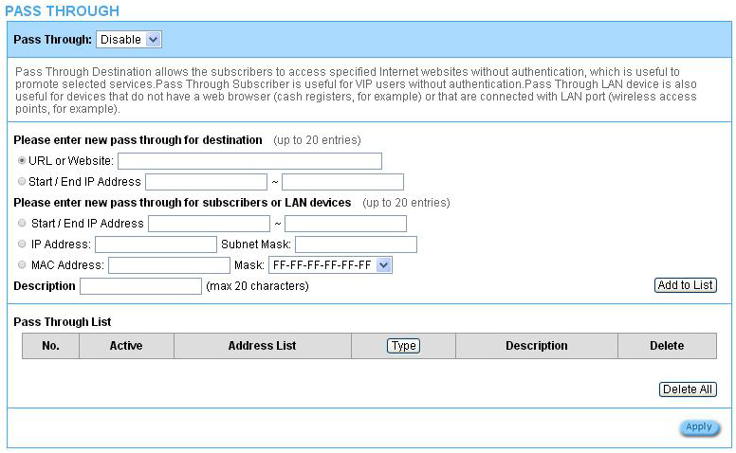

Figure 3‐2‐26 Pass through Setting Screen

Item | Default | Description
Pass Through | Disable | Enables or disables the pass through function.
Destination URL/IP Address Pass Through
URL or Website | Empty | Enter the URL Page; please use this format such like “http://www.yahoo.com”. The maximum character of the URL Page is 50.  Note:  1. Please add www.apple.com into PASS THROUGH list in HSP500. (iOS 6 device and later is required.)  2. Please add go.redirectingat.com for certain QR code apps.

Start / End IP Address | Empty | Enter the start / end IP address of you wants pass through.
Subscriber IP/MAC Address or LAN Device Pass Through
Start / End IP Address | Empty | Enter the start / end IP address of you wants pass through.
IP Address | Empty | Enter the IP address of you wants pass through.
Subnet Mask | Empty | Enter the subnet mask of you wants pass through.
MAC Address | Empty | Enter the MAC address of you wants pass through.
Mask | Empty | Enter the subnet mask of you wants pass through.
Pass Through List | Display the pass through Information of HSP500.
No. | - | The index number of pass through address.
Active | Disable | Click on check box, active or inactive the pass through address.
Address List | - | Display the pass through address(s).
Type | - | Display the type of pass through address.
Delete | Disable | Select the check boxes and click ‘Delete’ to delete the pass through  address(s).

Click Add to List button to add a new entry. Click Apply button to save the new settings. Click Delete All & Apply button to delete all entries.

Note: The priority of "pass through" is higher than "Filtering".

3‐2‐4‐2 Filtering

Filtering allows the system administrator to have a list of restricted destinations, which is useful to block specified Internet websites or Intranet areas.

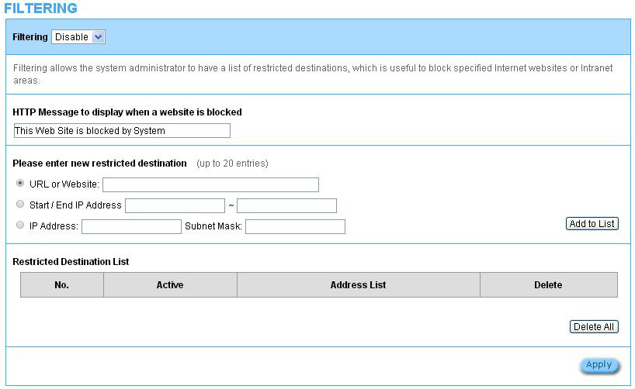

Figure 3‐2‐27 Filtering Setting Screen

Item | Default | Description
Filtering | Disable | Enables or disables filtering function.
HTTP Message to display  when a website is blocked | The Web Site is  blocked by System | Enter the http message. The maximum character of the HTTP  message is 200.
Restrict Destination
URL or Website | Empty | Enter the URL Page of you wants to filter; please use this format such like “http://www.yahoo.com”. The maximum  character of the URL Page is 50.
Start IP Address | Empty | Enter the start IP address of you wants to filter.
IP Address | Empty | Enter the destination IP address of you wants to filter.
Subnet Mask | Empty | Enter the destination subnet mask.
No | ‐ | The index number of filtering address.
Active | Disable | Click on check box, active or inactive the filtering address.

Address List | ‐ | Display the filtering address(s).
Delete | Disable | Select the check boxes and click ‘Delete’ to delete the filtering  address(s).

Click Add to List button to add a new entry. Click Apply button to save the new settings.
Click Delete All & Apply button to delete all entries.

3‐2‐4‐3 Secure Remote

This feature allows you to create a secure connection to a remote site or back end system with VPN PPTP Client. If “Secure Remote” is enabled, the RADIUS packet/ syslog will be transferred to this secure connection.

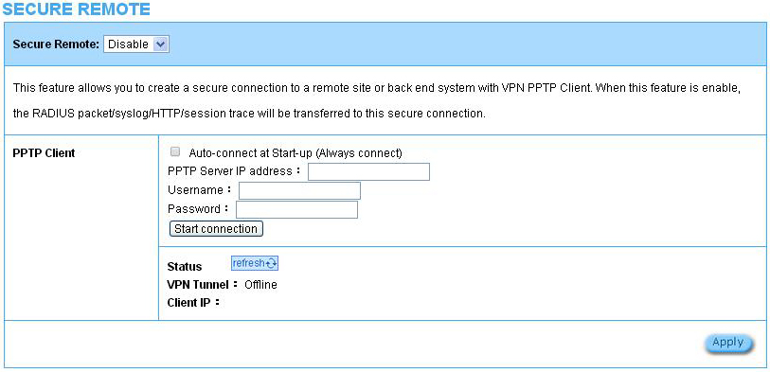

Figure 3‐2‐28 Secure Remote Setting Screen

Item | Default | Description
Auto-connect at Start-up  (Always connect) | Disable | Enable the check box to automatically establish the PPTP  connection.
PPTP Server IP address | Empty | Enter the PPTP server IP address provided by your ISP.
Username | Empty | Enter the user name provided by your ISP. The user name can  consist of up to 80 alphanumeric characters and is case sensitive.
Password | Empty | Enter the user password provided by your ISP. The password can consist of up to 80 alphanumeric characters and is case sensitive.
Start / stop connection | Click on Start/Stop connection button to start/stop PPTP connection.
VPN Tunnel | Display the status.
Client IP | Display the IP address.

Click refresh button to delete all entries.

3­2­5 SYSTEM

3‐2‐5‐1 System

Define the HSP500 System configuration.

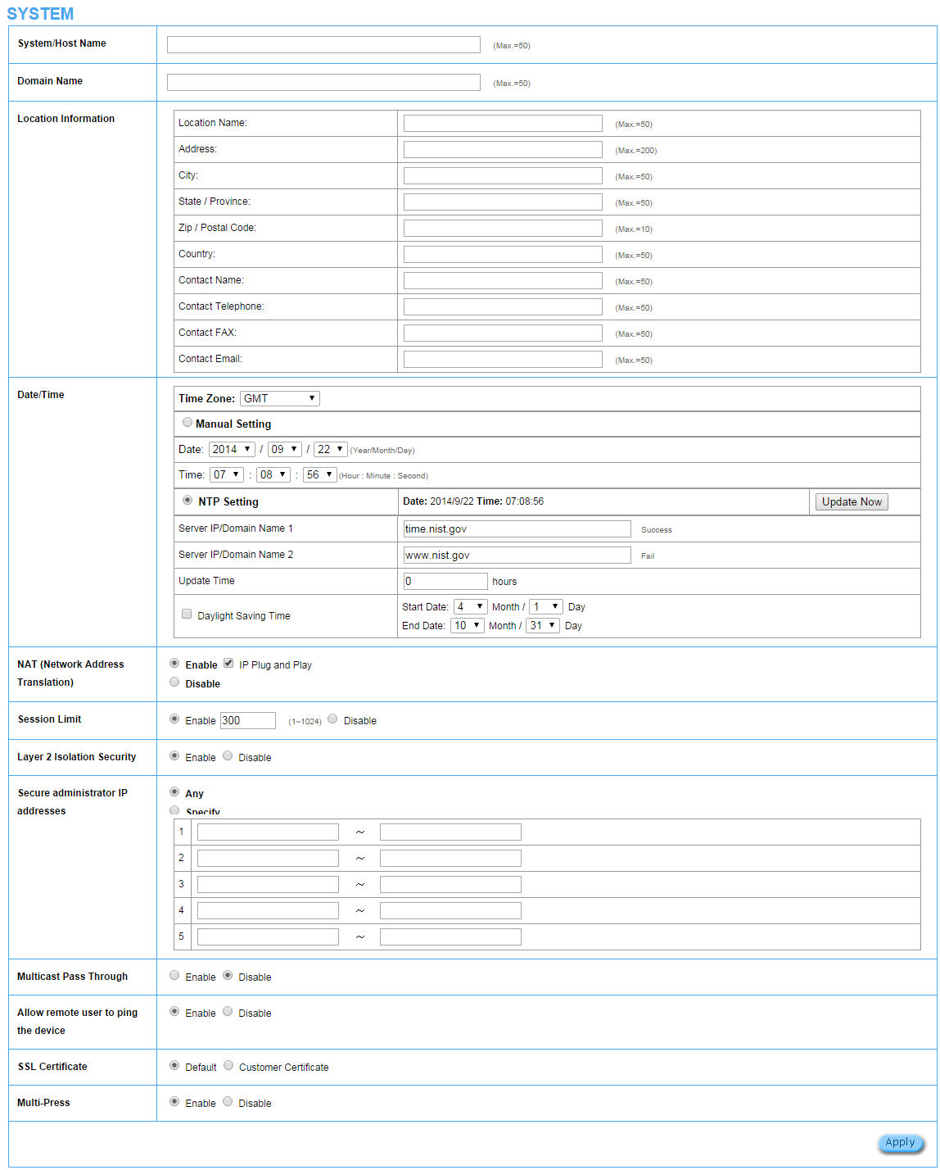

Figure 3‐2‐29 System Setting Screen

Item | Default | Description
System/Host Name | Empty | The system name can consist of up to 50 alphanumeric characters.
Domain Name | Empty | The Domain name can consist of up to 50 alphanumeric characters.
Location Information | Empty | Enter your location information.
Date/Time
Time Zone | GMT | Select the appropriate time zone for your location.
Manual Setting | Click Manual Setting to set the system date and time.
Date | Year/Month/Day | Enter the Date for the system.
Time | Hour:Minute:Second | Enter the Time for the system.
NTP Setting | Enable | Enables or disables NTP (Network Time Protocol) Time Server. Network Time Protocol can be utilized to synchronize the time on devices across a network. A NTP Time Server is utilized to obtain the correct time from a time source and adjust the local time.
Server IP/Domain Name | Empty | Enter the IP address/domain name of NTP server. The maximum allowed characters length is 100.
Update Time | 0 hours | Enter the number of hours for update time.
Daylight Saving Time | Disable | Enables or disables Daylight Saving Time (DST).
Daylight Saving Time | Month/Day | Set the Daylight Saving Time (DST) on the HSP500 . Adjust the begin time and end time.
NAT (Network Address Translation)
NAT | Enable | Enables or disables NAT Address Translation function.
User Session Limited | Enable,300 | Enables or disables user session limit function. This feature provides you an ability to control a number of sessions allowed for particulars user(s) at the one time.
IP Plug and Play (iPnP Technology) | Enable | Enables or disables plug & play function. When enabled, the user needn’t change their network configuration to access the Internet.
Layer 2 Isolation Security | Enable | If enable plug and play is selected, you can enable Layer 2 Isolation Security function. When the “Layer 2 Isolation Security” enabled, everyone cannot communicate with each other.
Secure administrator IP Addresses | Any | Options: Any and Specify. Administrator can specify 5 IP addresses or a range to allow remote control access from network.
Multicast Pass Through | Disable | This function allows for multiple transmissions to specific recipients at same time.
Allow remote user to ping the device | Enable | This function allows remote user to ping the HSP500 through Internet. Ping is normally used to test the physical connection between two devices, to ensure that everything is working correctly.
SSL Certificate | Disable | Option: default or customize certificate, These are two ways to create a certificate, one is purchase a certificate from a certificate authority (Ex. Verisign or Thawte), and another is creating a self-certificate (For example: Uses OpenSSL tool).
Multi-Press | Enable | If the Multi-Press is enabled, the unit on the ticket will equal to the times of press at one time. So the venue could control the unit on each ticket by Multi press function.  If the Multi-Press is disabled, The unit on ticket will not be affected by the times of button pressed. It means no matter how many times the button has been pressed at one time, the unit on the ticket will stay as 1.

Click Apply button to save the new settings.

3-2-5-2 WAN/LAN

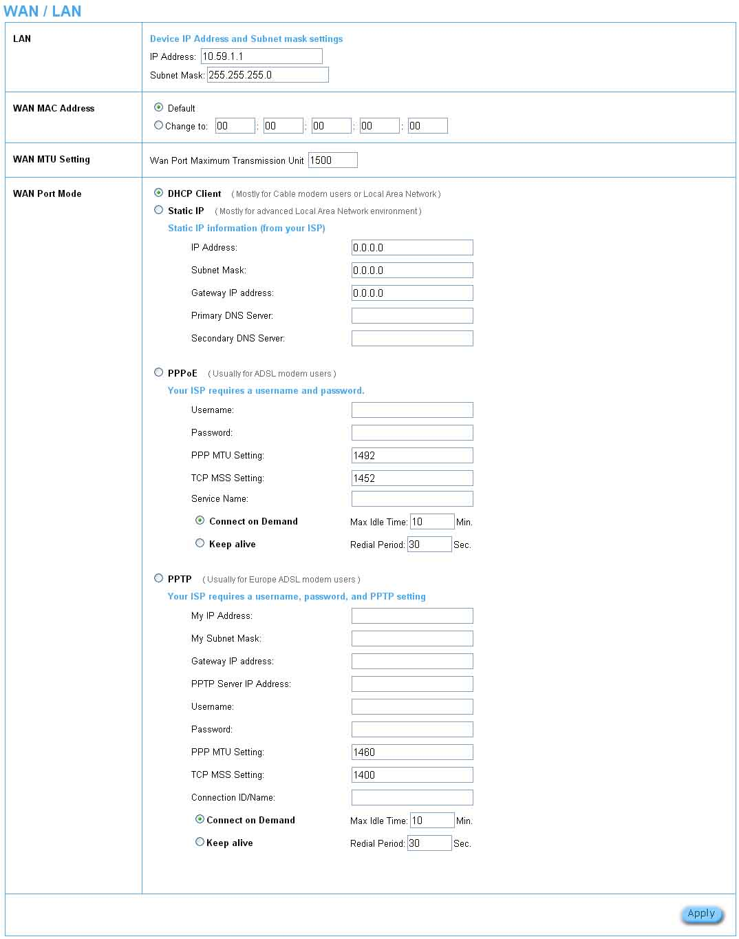

Figure 3-2-30 WAN/LAN Setting Screen

Item | Default | Description
LAN
IP Address | 10.59.1.1 | The internal LAN IP address of your HSP500.
Subnet Mask | 255.255.255.0 | Enter the subnet mask for the IP address.
WAN MAC Address
IP Address | The default MAC address is set to the WAN physical interface on device.
DHCP Client | The device can work as a DHCP client. This allows the device to obtain the IP address and other TCP/IP settings from your ISP. If your xDSL/Cable comes with this feature, please enable Use DHCP Client.
Static IP
IP Address | Enter the IP address for the xDSL/Cable connection (provided by your ISP).
Subnet Mask | Enter the subnet mask for the IP address.
Gateway IP Gateway | Enter the Gateway IP address for the xDSL/Cable connection (provided by your ISP).
Primary DNS Server | A primary DNS server IP address for the xDSL/Cable connection (provided by your ISP).
Secondary DNS Server | A secondary DNS server IP address for the xDSL/Cable connection (provided by your ISP). If the primary DNS Server IP were not available, meanwhile, Secondary DNS Server IP would start in the same time.
PPPoE
User Name | Empty | Enter your PPPoE account name. The user name can consist of up to 80 alphanumeric characters and is case sensitive.
Password | Empty | Enter your PPPoE password. The password can consist of up to 80 alphanumeric characters and is case sensitive.
PPP MTU Setting | 1492 | MTU (Maximum Transfer Unit) specifies maximum transmission unit size.
TCP MSS Setting | 1452 | MSS (Maximum Segment Size) specifies maximum segment size.
Service Name | Empty | Enter the service name provided by your ISP. The service name can consist of up to 64 alphanumeric characters and is case sensitive.
Connect on Demand | Enable | You can configure your HSP500 to cut your connection with your ISP after a specified period of time (Max Idle Time). If you have been disconnected due to inactivity, Connect on Demand enables your HSP500 to automatically re-establish your connection as soon as you attempt to access the Internet again. If you wish to activate Connect on Demand, click the radio button. If you want your Internet connection to remain, click the radio button of keep alive. The Max Idle Time maximum value is 65535 minutes.
Max Idle Time | 10 Minutes
Keep alive | Disable | This option keeps your PPPoE enabled Internet access connected indefinitely, even when it sits idle. The Redial Period maximum value is 65535 seconds.
Redial Period | 30 Seconds

3‐2‐5‐3 Server

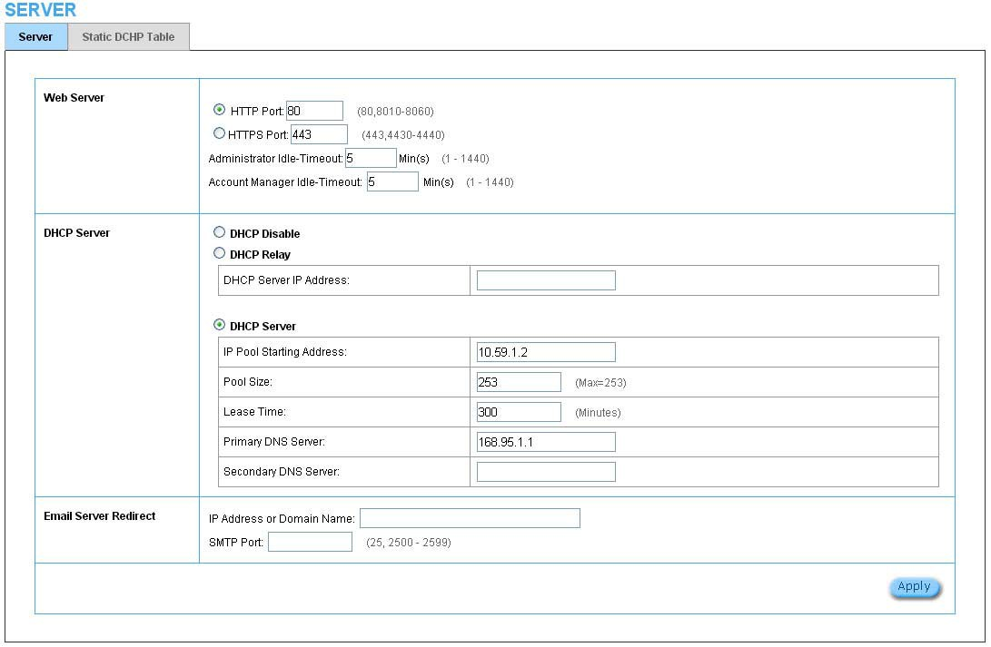
Server

Figure 3‐2‐31 Server Setting Screen

Item | Default | Description
Web Server
HTTP Port | 80 | Enter the HTTP port number. The HTTP port allowed range is 80 or  8010 to 8060. For access the HSP500 system under NAT, please tab the “http://HTTP Port IP Address: Port Number”.
HTTPS Port | 443 | Enter the HTTPS port number. The HTTPS port allowed range is 443 or  4430 to 4440. For access the HSP500 system, please tab the  “https://HTTPS Port IP Address: Port Number”.
Administrator Idle-Timeout | 5 Minutes | The idle time out valid range is 1-1440. If the idle time out is set as 5 minutes, it means if the administrator doesn’t send packet in 5 minutes,  the administrator will logout automatically.

DHCP Server | Enable | There are three types of DHCP Services.  DHCP Disable—Disable the DHCP server function. DHCP Relay—Enable DHCP Relay function.  DHCP Server—Enable DHCP server function.
DHCP Relay | To route DHCP through an external server, the administrator needs to enable the  DHCP relay and assign a valid DHCP server IP address.
DHCP Server IP Address | Empty | Enter the IP address of DHCP server.
DHCP Server | The HSP500's DHCP server is turned on and running by default when you install it in  your network.
DHCP Pool Starting  Address | 10.59.1.2 | Enter the DHCP Pool Starting IP address.
Pool Size | 253 | The DHCP pool size range is 1 to 512.
Lease Time | 300  Minutes | The DHCP lease time. The DHCP lease time range is 1 to 71582788  minutes.
Primary DNS Server | 168.95.1.1 | Enter the IP address of the network’s primary DNS server.
Secondary DNS Server | Empty | Enter the IP address of a second DNS server on the network.
Email Server Redirect | To prevent some subscriber’s original Email server may protect by firewall or NAT network. HSP500 provides an extra Email server parameter to forward the subscriber’s Email. The HSP500 not only forwards the subscribers’ E-mail via other E-mail server but also changes the SMTP header. The recipient of your E-mail sees the message as if you sent it from your local Internet Service Provide, not form the hotel or other place.  Note: Before setting this sever, please make sure the e-mail sever relay function is  opened. It must not exceed 50 characters.
IP Address or Domain  Name | Empty | Enter the E-mail server IP address or domain name.
SMTP Port | 25 | Enter the SMTP port number for mail server. The SMTP port allowed  range is 25 or 2500 to 2599.

Click Apply button to save the new settings.

Static DHCP
This function allows subscriber to assign IP address on the LAN to specific individual computers based on their MAC Address.

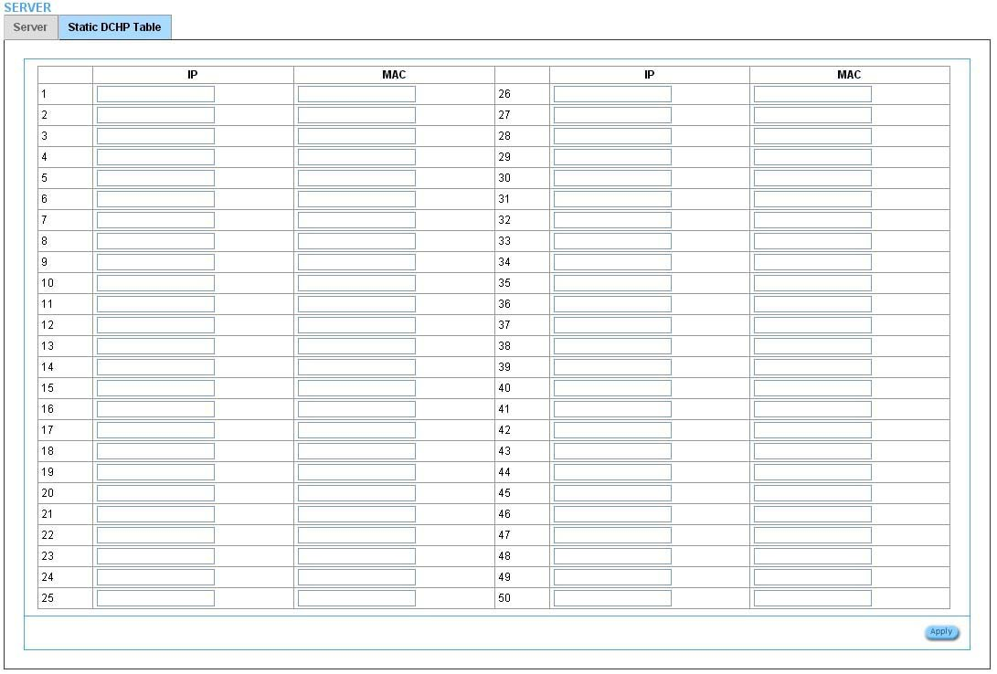

Figure 3‐2‐32 Server Setting Screen

Item | Default | Description
IP Address | Empty | Enter the IP address that subscriber want to assign to the computer on LAN with the  MAC address the subscriber will also specify.
MAC Address | Empty | Enter the MAC address of a computer on your LAN.

Click Apply button to save the new settings.

3‐2‐5‐4 Customization

Login Page
The HSP500 provides three different login page formats, including standard, redirect, advanced and frame format.

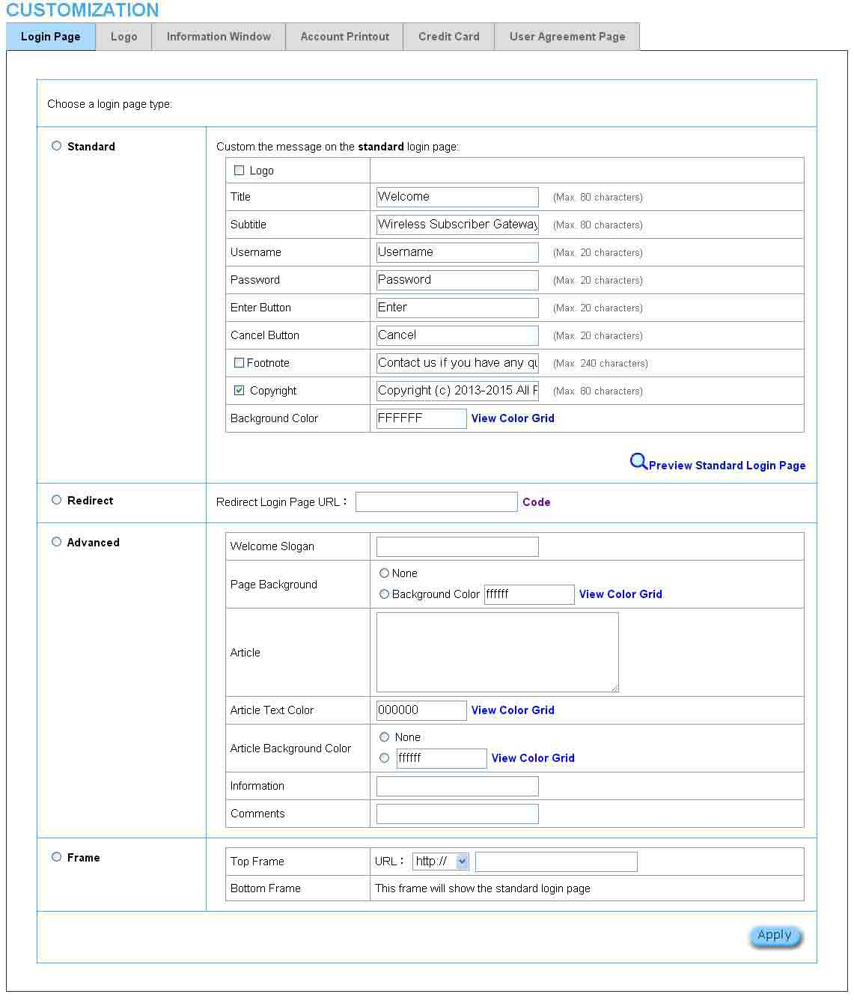

Figure 3‐2‐33 Customization Setting Screen

Item | Default |  | Description
Standard | For some service providers, they may hope to have a customize subscriber’s login page to the users. This function helps them to realize the ideal. The page elements are including login page title, background color, subtitle etc.
Logo | Disable | Select the check box to display service provider’s logo.
Title | Welcome | Enter the title name of subscriber login page. The maximum  allowed characters length is 80.
Subtitle | Hot Spot Internet Service | Enter the subtitle name of subscriber login page. The maximum allowed characters length is 80.
Footnote | Disable | Allow the administrator to input the footnote such like “Pleas  Contact to our Customer Service Center, EXT 141”. The maximum character of the footnote is 240.
Copyright | Enable | The copyright is allowed the administrator to input a paragraph in the subscriber login page for copyright information. The maximum character of the copyright is 80.
Background Color | FFFFFF | The background text color can be specified color. For the specified text color format please views the color grid. The allowed format is Hexadecimal.
Figure 0-4 Login Page Screen
Redirect | This allow service provider to redirect the subscriber’s browser to a specified home page.
Copy and paste the following HTML Code into your home page to produce redirect subscriber login page.
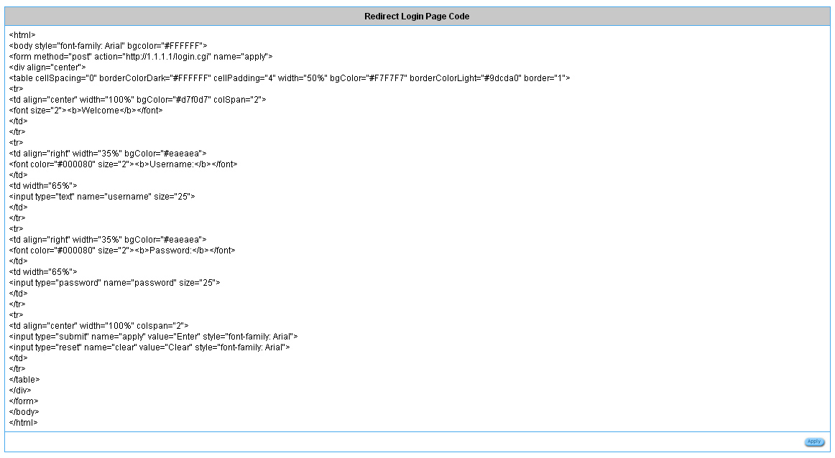
Figure 0-5 Preview Redirect Login Page Code
Advanced | This function allow user to design login page of HSP500 .
Welcome Slogan | Welcome | The maximum allowed characters length is 80.
Page Background | None | The page background can be none or specified color. For the background color format please views the color grid. The allowed format is Hexadecimal.
Article | Empty | The article is allowed the administrator to input a paragraph in the subscriber login page for advisement or announcement. The maximum character of the article is 1024.
Article Text Color | 000000 | The article text color can be specified color. For the specified text color format please views the color grid. The allowed format is Hexadecimal.
Article Background  Color | None | The article background can be specified color. For the background color format please views the color grid. The allowed format is Hexadecimal.
Information | Empty | Allow the administrator to input the text information such like address, telephone number and fax information. The maximum character of the information is 80.
Comments | Empty | Allow the administrator to input the text comments such like “Please Contact to our Customer Service Center, EXT 141”. The maximum character of the comment is 80.
Frame | If “Frame” is selected the subscriber login page will be separate into Top Frame and Bottom Frame.  Bottom Frame is a default format for username and password input, Top Frame is allowed to be specified a URL to link.
Top Frame URL Link | Empty | The input format can be http://www.yahoo.com. The maximum character of the URL Link is 200.
Bottom Frame | - | This frame will show the standard login page.
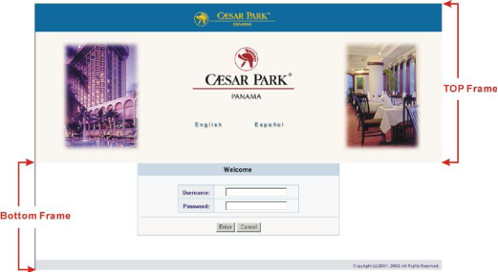
Figure 0-6 Example-Login Page Screen

Logo
This function allows service provider to upload the customer’s logo image file which can be shown on the standard login page.

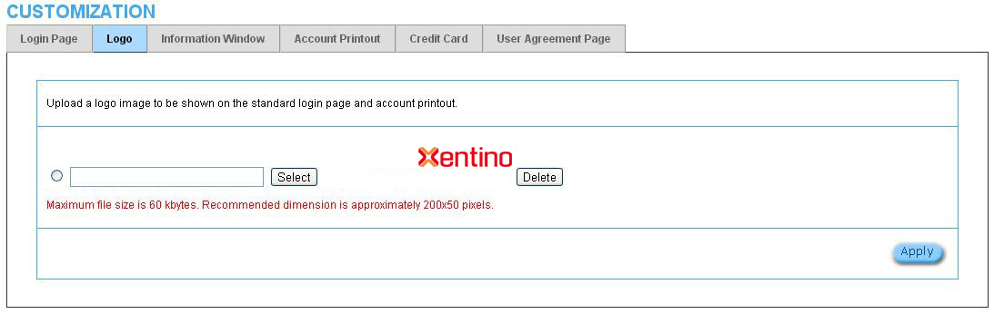

Figure 3‐2‐37 Logo Setting Screen

Item | Default | Description
File Path | Empty | Enter the file pathname of the logo file in the File Path field.

Click Apply button to save the logo file to system.
Click Delete button to delete the logo file.
Information Window
This function allow service provider can decide whether they want an “Information Window” pop‐up on subscriber PC when authenticate successful or not and specified text of information window. Subscriber can type “http://1.1.1.1/info” to open the information window again or enter “http://1.1.1.1/logout” to logout immediately if accumulation billing selected.

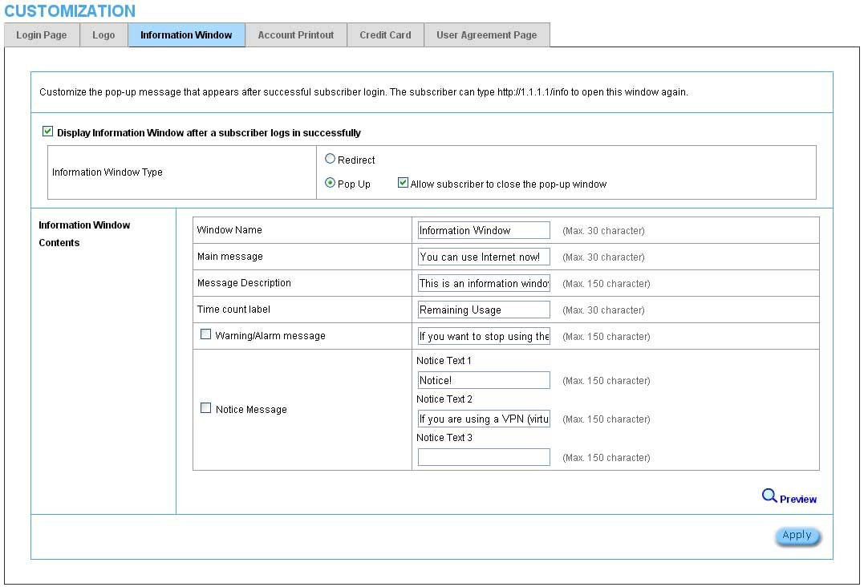

Figure 3‐2‐38 Example‐Login Page Screen

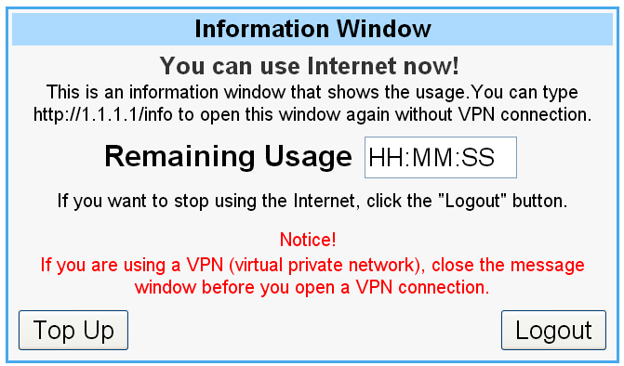
Window Name
Main message
Message Description
Time count label
Warning/Alarm message
Notice Message

Figure 0-7 Information Window

Billing Type=Time to Finish
Can be topped up by subscriber=Enable

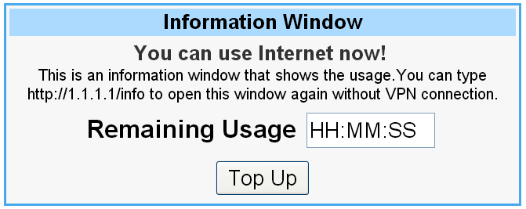
Figure 0-8 Information Window

Billing Type=Accumulation
Can be topped up by subscriber=Disable

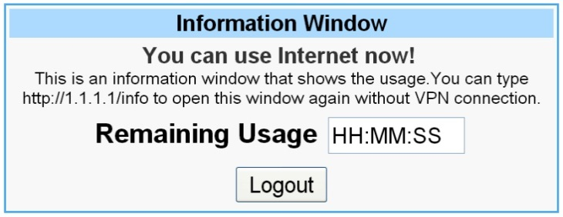
Figure 0-9 Information Window

Billing Type=Accumulation
Can be topped up by subscriber=Enable
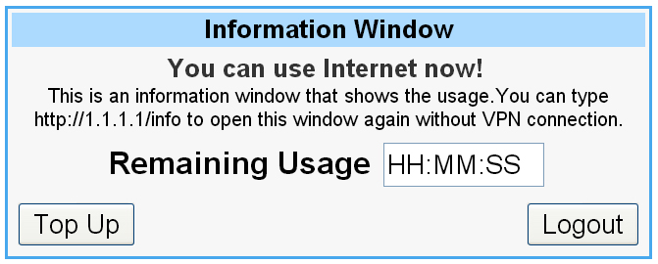
Figure 0-10 Information Window
Account Printout
This function allow service provider to specified text of account printout.
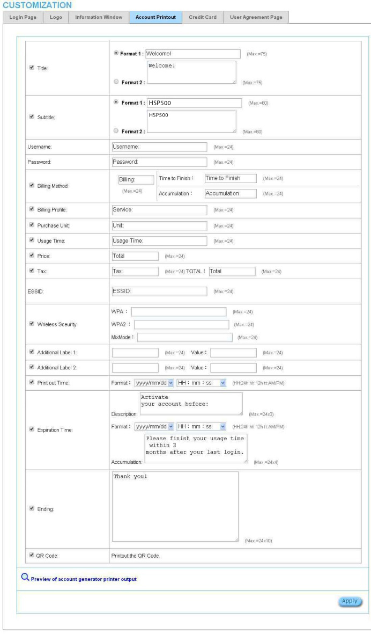
Figure 0-11 Account Printout Customization Setting Screen
Note: If you don’t print out QR code on the ticket, please disable “QR Code”.

Credit Card

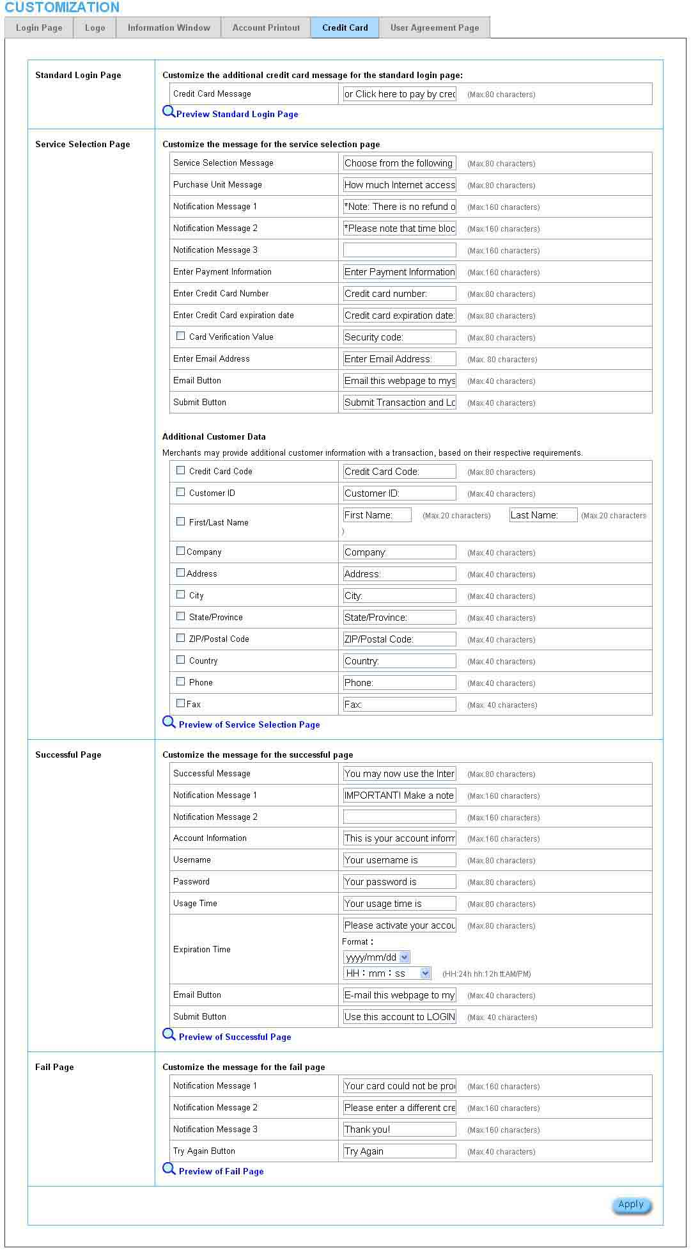
Figure 0-12 Credit Customization Setting Screen

Item | Description
Standard Login Page | This function allow service provider to customize the additional credit card message  for the standard login page.
Service Selection Page | This function allow service provider to customize the additional credit card message  for the standard login page.
Fail Page | This function allow service provider to customize the message for the fail page.

Click Apply button, the success dialog box appears. Click on Back to return to Credit
Card Customization setting screen.

User Agreement Page
This function allow user to design user agreement page of Internet Subscriber
Server.

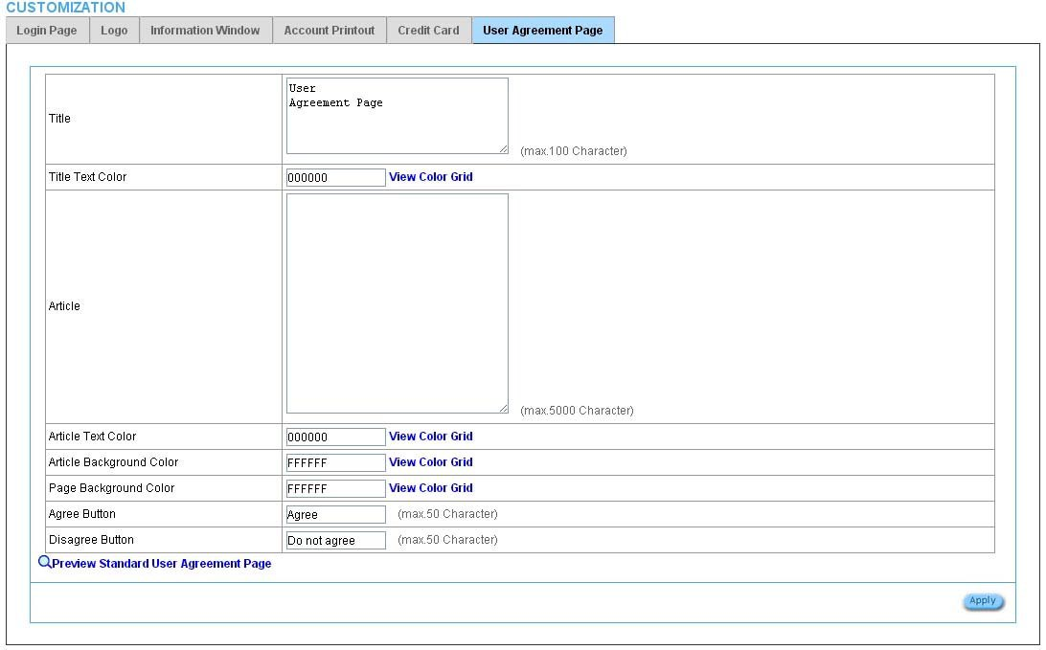

Figure 3‐2‐45 User Agreement Page Setting Screen

3‐2‐5‐5 Portal Page

This feature allows redirecting subscriber’s browser to a specified portal page after successful login.

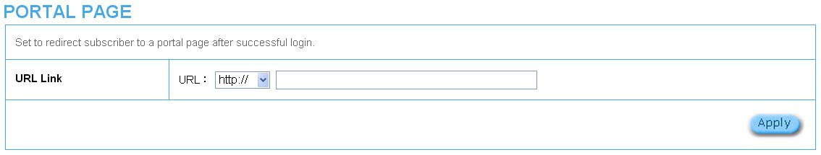

Figure 3‐2‐46 Portal Page Setting Screen

Item | Default | Description
URL Link | Empty | Enter the URL Link page. The input format can be “http://www.yahoo.com”. The maximum  character of the URL Link is 200.

Click Apply button, the success dialog box appears. Click on Back to return to Portal
Page setting screen.

3‐2‐5‐6 Advertisement

The system allow service provider to input 5 URL links for advertisement link purpose.

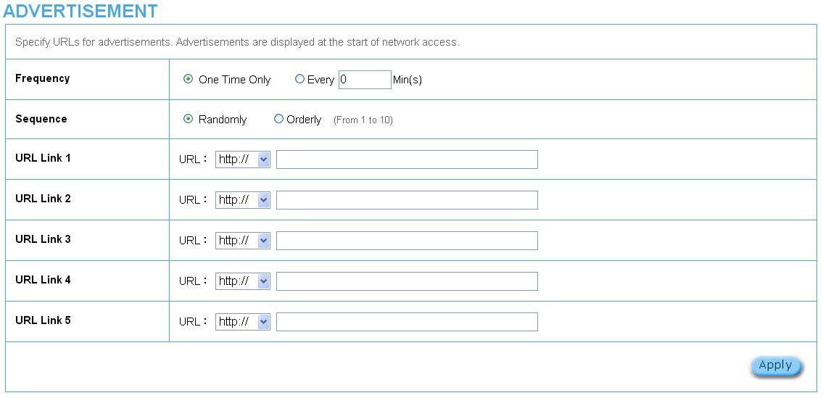

Figure 3‐2‐47 Advertisement URL Link Setting Screen

Item | Default | Description
Frequency | One Time Only | One Time Only—One Time Only means to send the advertisement link once after the subscriber Login.  Every~Min(s)—The field means to send the advertisement link every  interval minutes. The value range is 1 to 60 (minutes).
Sequence | Randomly | Randomly—Display the advertisement page in the random order. From 1 to  10 —Display the advertisement page in the order as setting.
URL Link 1~5 | Empty | This function allows the administrator to input ten different websites in the table for advertisement. And these 5 websites will display to the subscribers at random when the subscribers login in the HSP500 system. The input format can be “http://www.yahoo.com”. The maximum character of the URL Link # is 200.

Click Apply button, the success dialog box appears. Click on Back to return to
Advertisement URL Link setting screen.

3‐2‐5‐7 Walled Garden

We prepare ten URL links that allows subscriber to access the specific Web pages even they didn’t have a username or password. It’s free trying and can use for advertisement.

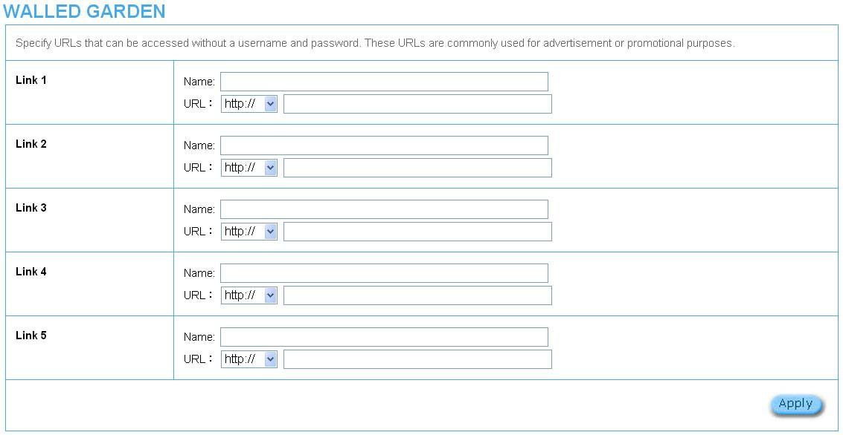

Figure 3‐2‐48 Walled Garden Setting Screen

Item | Description
Name | The name is allowed user to set the prompt string in user customize login page. The maximum  allowed characters length is 80.
URL 1~5 | The input format can be “http://www.yahoo.com”. The maximum character of the Link# is 200.

Click Apply button, the success dialog box appears. Click on Back to return to Walled
Garden setting screen.

3‐2‐5‐8 DDNS

The DDNS service (Dynamic Domain Name Service), an IP Registry provides a public central database where information such as email addresses, host names, IP addresses etc. can be stored and retrieved. This solves the problems if your DNS server uses an IP associated with dynamic IP addresses. When the ISP assigns the HSP500 a new IP, the HSP500 must inform the DDNS server the change of this IP so that the server can update its IP‐to‐DNS entry. Once the IP‐to‐DNS table in the DDNS server is updated, the DNS name for your web server (i.e., xyz.dyndns.org) is still usable.

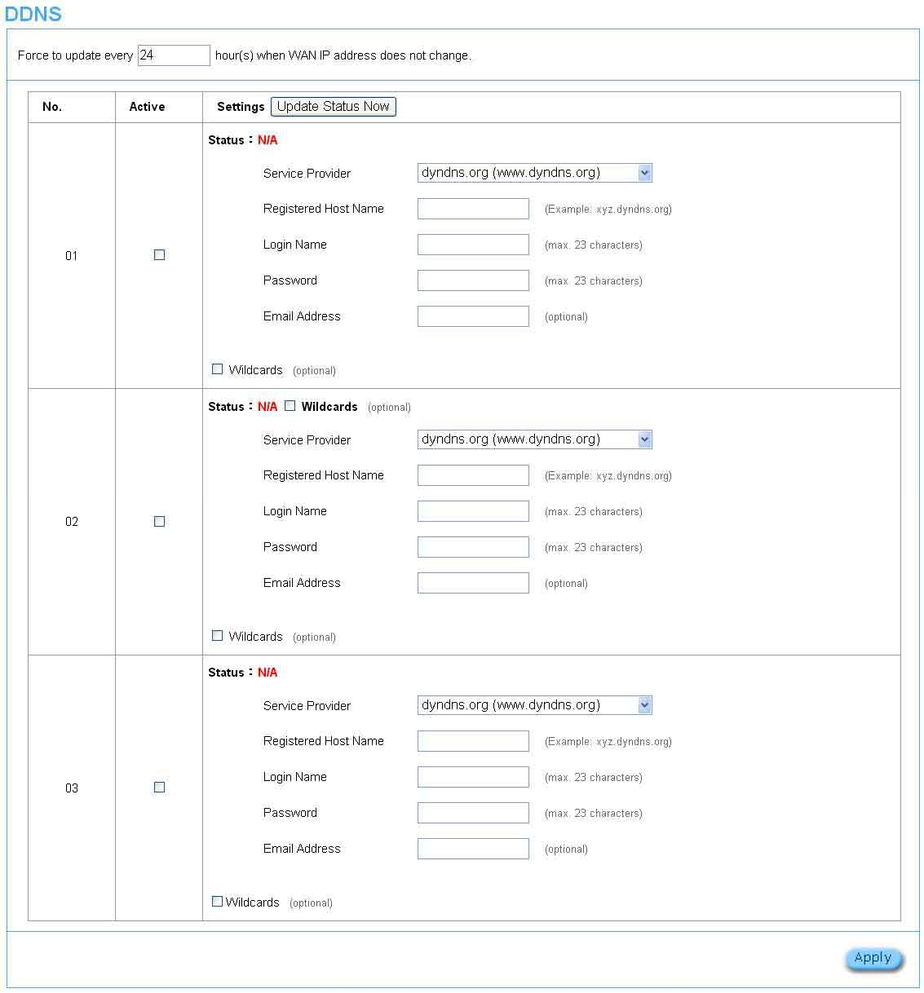

Figure 3‐2‐49 DDNS Setting Screen

Item | Default | Description
Force to update every~day(s) when  WAN IP address keeps no change | 1 day | Enter a number in the field to set the force update  interval (in days).
No | 01~03 | The index number of a DDNS account.
Active | Disable | Click on check box, active or inactive the DDNS  record.
Update Status Now | Click the Update Status Now button to do manual update.
Settings | Enter the account information of DDNS Server.
Status | YY/MM/DD HH:MM:SS | Display the update date, time and status. The Status area shows the update time and current state of the DDNS Client.  N/A—DDNS Client service not installed.  Update Successfully—DDNS Client service installed;  service running.  Update Fail—DDNS Client service installed; service not running.
Service Provider | Dyndns.org  (www.dyndns.org) | Select a DDNS service provider by clicking in the list box.  Note: Before configuring the DDNS settings, you have to register a dynamic domain at one of the dynamic  domain service providers’ list box.
Registered Host Name | Empty | Enter the host name of DDNS server. The maximum  character of the registered host name is 100.
Login Name | Empty | Enter the user name of DDNS server.
Password | Empty | Enter the user password of DDNS server.
Email Address | Empty | Enter your email address. The DDNS Server will  e-mail you important information once your Internet  Name has been successfully registered.
Wildcards (optional) | Disable | Enable this function to be able to use  *.mydomain.dyndns.org and not only mydomain.dyndns.org.
Click Apply button, the success dialog box appears. Click on Back to return to DDNS
setting screen.

3‐2‐5‐9 Wireless

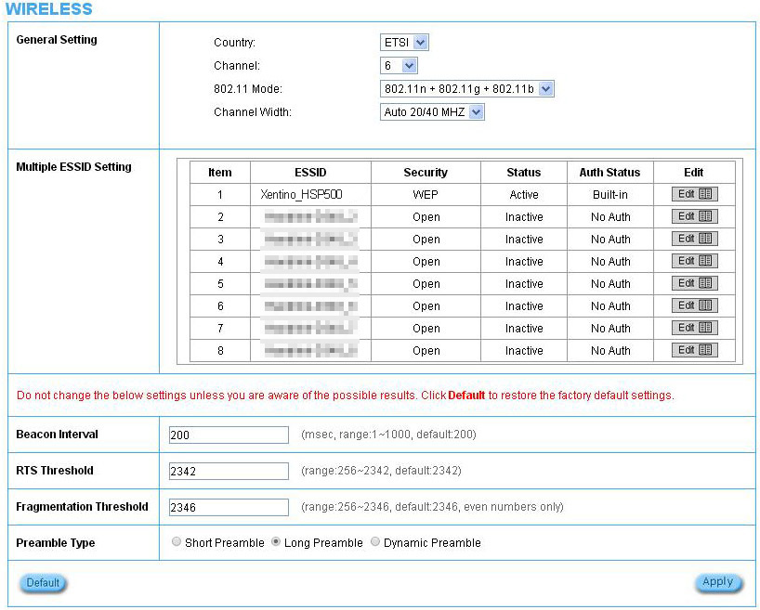

Figure 3‐2‐50 Wireless Setting Screen

Item | Default | Description
General Settings
Country | ETSI | Enter the Country for wireless connection.
Channel | 6 | Select the channel ID for wireless connection.
802.11 Mode | 802. 11n + 802.11g + 802.11b | Enter the 802.11 Mode for wireless connection.
Channel Width | Auto 20/40 MHZ | Select the Channel Width for wireless connection.
Multiple ESSID Setting | Click Edit button for each of 8 ESSID setting.
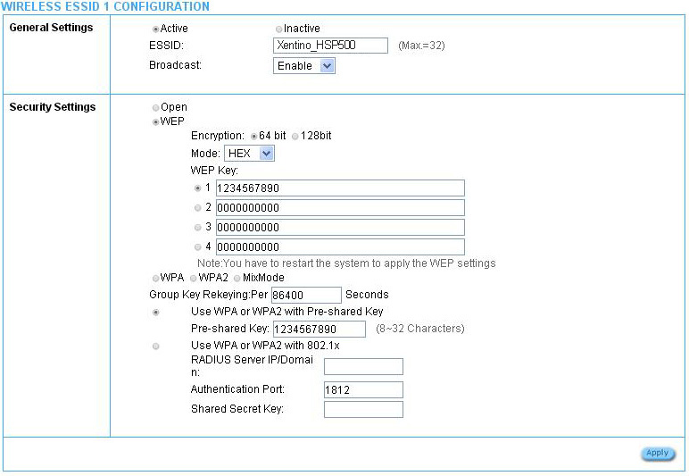
Figure 0-13 ESSID Setting Screen
General Settings
ESSID status | Active (ESSID1) | ESSID1 is active, and others are inactive by default.
ESSID name | The ESSID’s name by default is related to the last 4 numbers of WLAN MAC. If the WLAN MAC is“00-90-0E-00-12-34”, the default is“Xentino-1234_1". It is case sensitive and must not exceed 32 characters.
Broadcast | Enable | This allows you to show or hide the ESSID name when users search the Wi-Fi signal.
Security Settings
Security | Open | Select Open to allow wireless station to communicate with the device without any data encryption. Select WPA / WPA2 / MixMode for data encryption.
Group Key Re-Keying | 86400 Seconds | Enter a number in the field to set the force re-keying interval.
Use WPA or WPA2 with  Pre-shared Key | Disable
Pre-Shared Key | Empty | Enter a pre-shared key from 8 to 63 case sensitive ASCII characters.
Use WPA or WPA2 with 802.1x | Disable
RADIUS Server IP/Domain | Empty | Enter the RADIUS server IP address or domain name. The maximum allowed characters length is 15.
Authentication Port | 1812 | Enter the authentication port number. The allowed numbers are from 0 to 65535.
Share Secret Key | Empty | Enter the RADIUS secret key
Beacon Interval | 200 | This value valid range is 1 to 1000 indicates the frequency interval of the beacon.
RTS Threshold | 2347 | This value valid range is 256-2342. This setting determines the packet size at which the HSP500 issues a request to send (RTS) before sending the packet. A low RTS Threshold setting can be useful in areas where many client devices are associating with the HSP500 , or in areas where the clients are far apart and can detect only the HSP500 and not each other.
Fragmentation  Threshold | 2432 | This setting determines the size at which packets are fragmented. Enter a setting ranging from 256 to 2432 bytes. Use a low setting in areas where communication is poor or where there is a great deal of radio interference.
Preamble Type | Long Preamble | The preamble type is a section of data at the head of a packet that contains information the HSP500 and client devices need when sending and receiving packets. The setting menu allows you to select a long, short or dynamic preamble type.

Click Apply button, the restart dialog box appears. Click on Apply to restart the system.

Click Default button to load the default manufacturer configuration to the system. All this page (Wireless) configuration setup will be replaced by default settings.

3‐2‐5‐10 USB

The HSP500 plugged in a USB to Ethernet adapter can expand the HSP500 Wi-Fi signal range. The administrator can connect HSP500 USB port to another AP/router Ethernet port with a USB 2.0 to RJ45 Ethernet network adapter. After the activation, the administrator can change the ESSID.
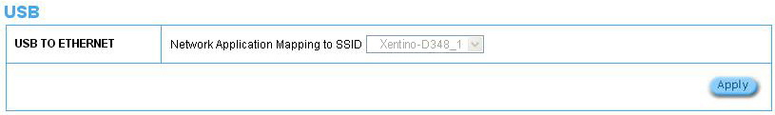
Figure 0-14 USB Setting Screen

3­3 System Status

Display HSP500 system basic status, including,

1. System
2. Account List
3. Account Log
4. Current User
5. DHCP Clients
6. Session List

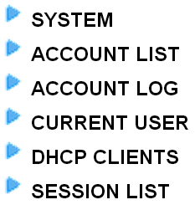
Figure 3‐3‐1 System Status Item Screen

3­3­1 System

The System Information Menu displays current system basic information including the service connection message, host name, LAN, WAN, DHCP Configuration, DNS, E‐mail Redirection, SSL Certificate, network traffic Information and the system firmware version number.
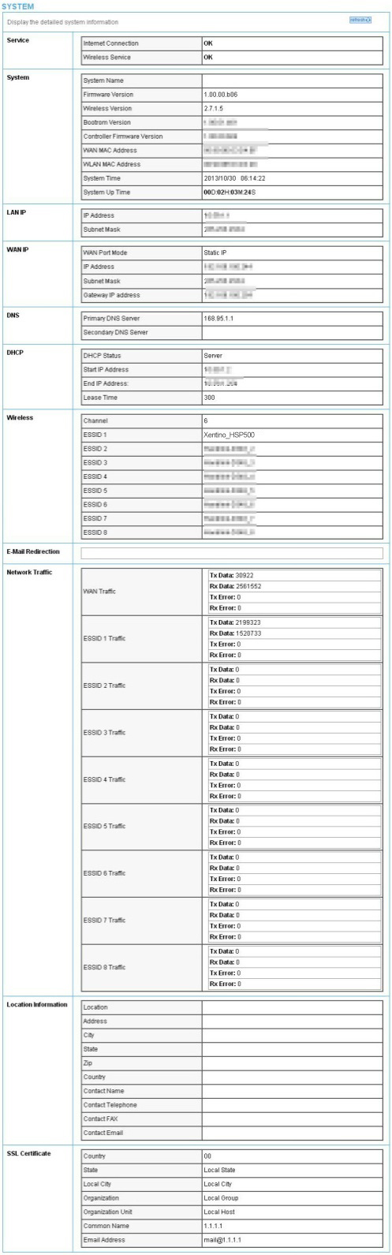

Figure 3‐3‐2 System Status Screen

3­3­2 Account List

You can display a list of all the account information on this device. This table includes the username, password, usage time, time created, login time, expiration time and status.

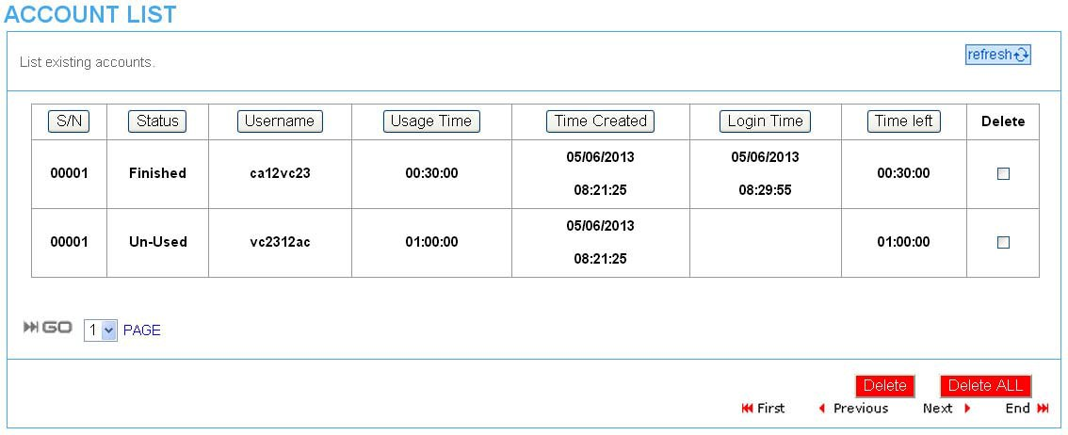

Figure 3‐3‐3 Account List

Click refresh button to update the account list page.

Click the column button (S/N, Status, Username, ….,etc.) to sort the column in ascending/descending order.

Select the check boxes and click Delete to delete the accounts. Click Delete ALL button to delete all accounts in account list.

Note: This page will refresh automatically every 5 minutes.

3­3­3 Account Log

The account log shows the accounts’ log information.

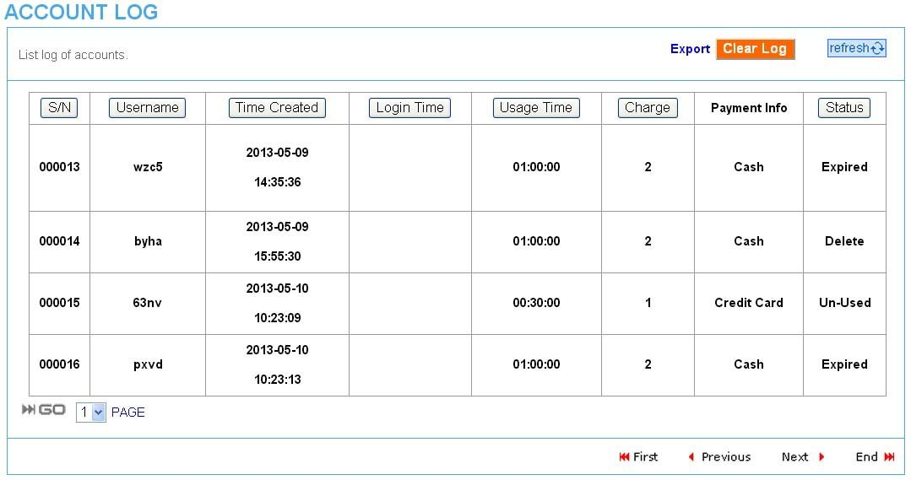

Figure 3‐3‐4 Account Log

Click Export to export the account logs to a text file format. (export.log) Click Clear Log button to remove all account log entries.
Click refresh button to update the account log page.

Click the column button (S/N, Username, Time Created, …,etc.) to sort the column in ascending/descending order.

3­3­4 Current User

Display the current logged‐in subscribers’ status. It allow service provider to disconnect any subscribers.

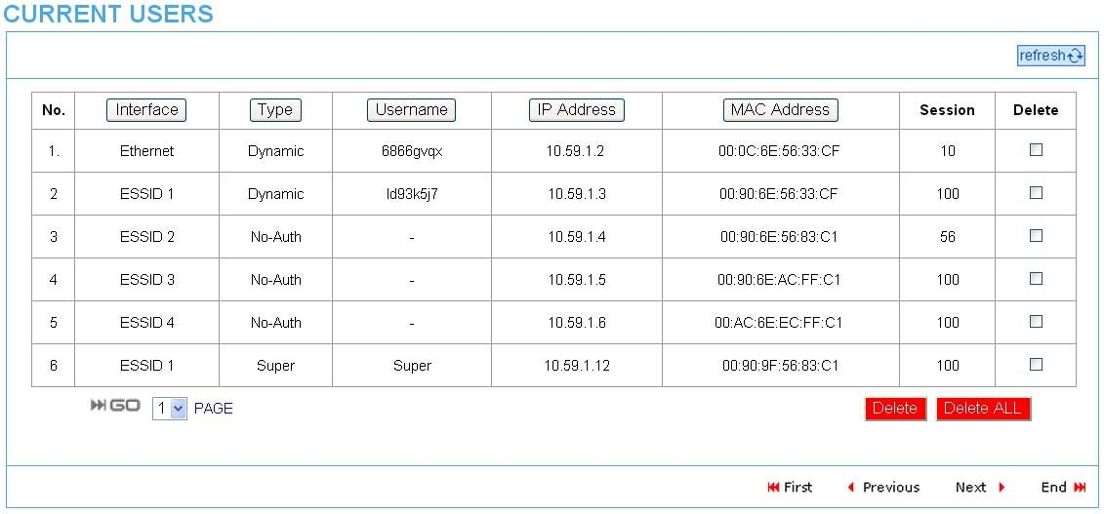

Figure 3‐3‐5 Current User List

Click refresh button to update the current user list page.

Click the column button (Interface, Type, Username, IP Address, …, etc.) to sort the column in ascending/descending order.

Select the check boxes and click ‘Delete’ to delete accounts. Click Delete ALL to delete all accounts in current user list.

3­3­5 DHCP Clients

The DHCP client table shows the current DHCP users on the LAN.

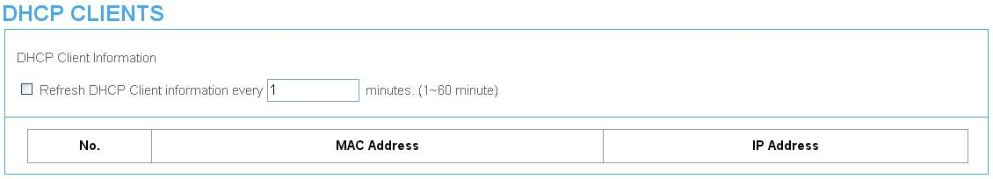

Figure 3‐3‐6 Current User Screen

3­3­6 Session List

The remote site administrator could monitor the real time usage status of HSP500
via this page.

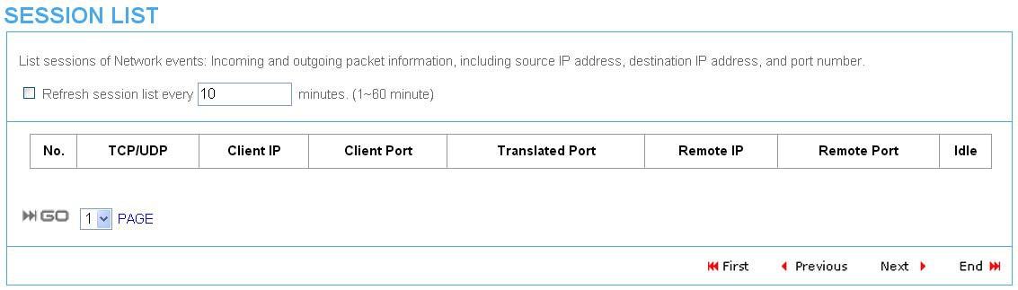

Figure 3‐3‐7 Session List Screen

3­4 System Tools

This allows service provider or administrator to process Firmware upgrade, change password and backup or restore configuration.

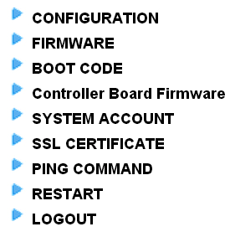
1. Configuration
2. Firmware
3. Boot Code
4. Controller Board Firmware
5. System Account
6. SSL Certificate
7. Ping Command
8. Restart
9. Logout

Figure 3‐4‐1 System Tools Item

3­4­1 Configuration

Use the Configuration item to save, restore or reset configuration parameters of the
HSP500.

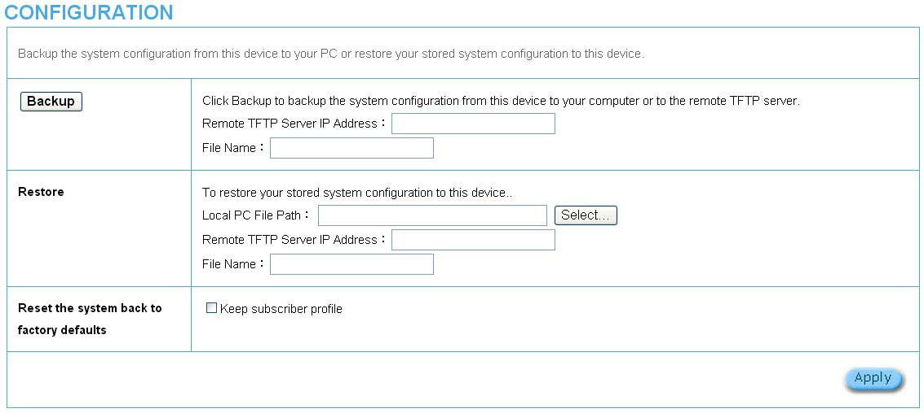

Figure 3‐4‐2 Configuration Setting Screen

Item | Default | Description
Backup | Click it to save the system configuration to your computer. (export.cfg)
Remote TFTP Server IP  Address | Empty | Enter the IP address of TFTP Server.
File Name | Empty | Enter the file name in the File Name field.
Restore | Click it to restore your system configuration.
Local PC File Path | Empty | Enter the file pathname of the system configuration file in the Local PC  File Path field.
Remote TFTP Server IP  Address | Empty | Enter the IP address of TFTP Server.
File Name | Empty | Enter the file name in the File Name field.
Reset the system back  to factory defaults | Erase all setting and back to factory setting.
Keep subscriber profile | Disable | Click the keep subscriber profile to change all the parameters into factory  setting but still reserve the subscriber profiles.

3­4­2 Firmware Upgrade

The Firmware Upgrade menu loads updated firmware to be permanent in flash ROM. The download file should be a binary file from factory; otherwise the agent will not accept it. After downloading the new firmware, the agent will automatically restart it.

Manual Firmware Upgrade

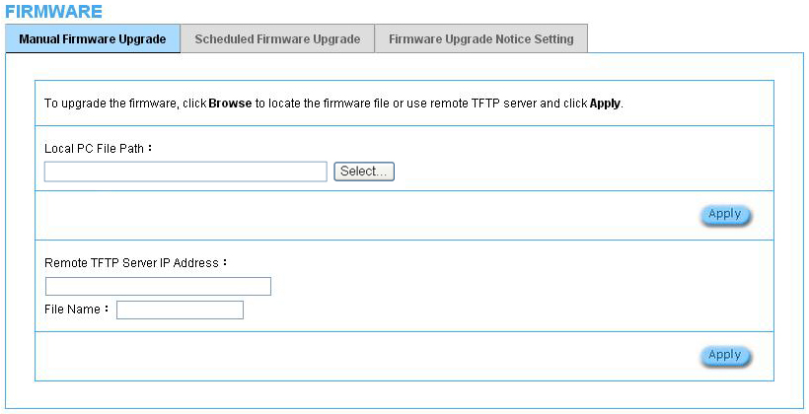

Figure 3‐4‐3 Manual Firmware Upgrade Setting Screen

Item | Default | Description
This allow administrator to upgrade the firmware via HTTP.
Local PC File Path | Empty | Enter the file name and location in the Local PC File Path field.
This allows administrator use TFTP server to upgrade firmware.
Remote TFTP Server IP Address | Empty | Enter the IP address of TFTP Server.
File Name | Empty | Enter the file name in the File Name field.

Note:

1. Before downloading the new firmware, users must save the configuration file for restore configuration parameters of the device.

2. Do not turn the power off during the upgrade process. This will damage the unit.

Scheduled Firmware Upgrade
Scheduled Firmware Upgrade is a program that enables an automatic upgrade to the latest firmware version through the TFTP server.
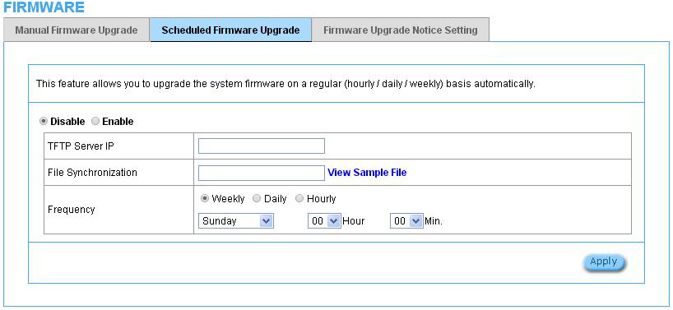

Figure 3‐4‐4 Scheduled Firmware Upgrade Setting Screen

Item | Default | Description
Disable/Enable | Disables or enables the scheduled firmware upgrade function.
TFTP Server IP | Empty | Enter the IP address of TFTP Server.
File Synchronization | Empty | Enter the file name and location in the File  Synchronization field.
View Sample File | Click the button to display synchronization file example.
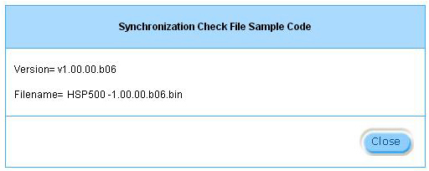

Figure 3‐4‐5 Synchronization File Sample Code
Frequency | Weekly | Set the firmware upgrade time. The default value is  “Weekly”.
Note: Do not turn the power off during the upgrade process. This will damage the unit.

Firmware Upgrade Notice Setting
If you would like to receive the information about firmware upgrade, please activate it and leave your email. You should enable “Agree that Xentino will be able to contact me if there is new firmware version release.” before filling in the email address.
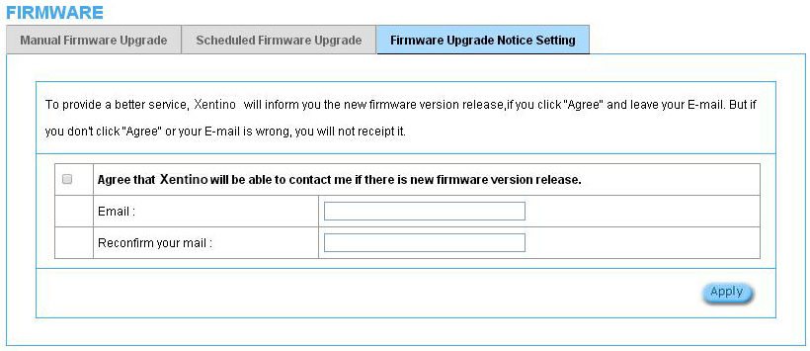
Figure 0-1 Synchronization File Sample Code

Item | Default | Description
Email | Empty | Enter the email address for firmware upgrade information.
Reconfirm your mail | Empty | Re-enter the email address.

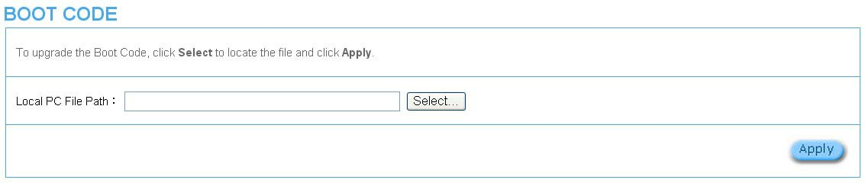
3­4­3 Boot Code

Figure 3‐4‐7 Boot Code Upgrade Setting Screen

3­4­4 Controller Board Firmware

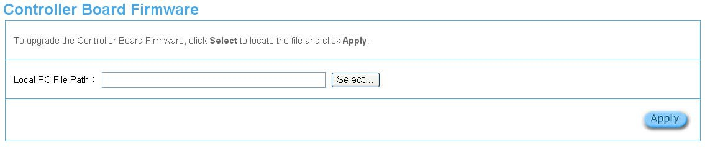
Figure 3‐4‐8 Controller Board Firmware Upgrade Setting Screen

3­4­5 System Account

Use the System Account screen to change the system accounts.

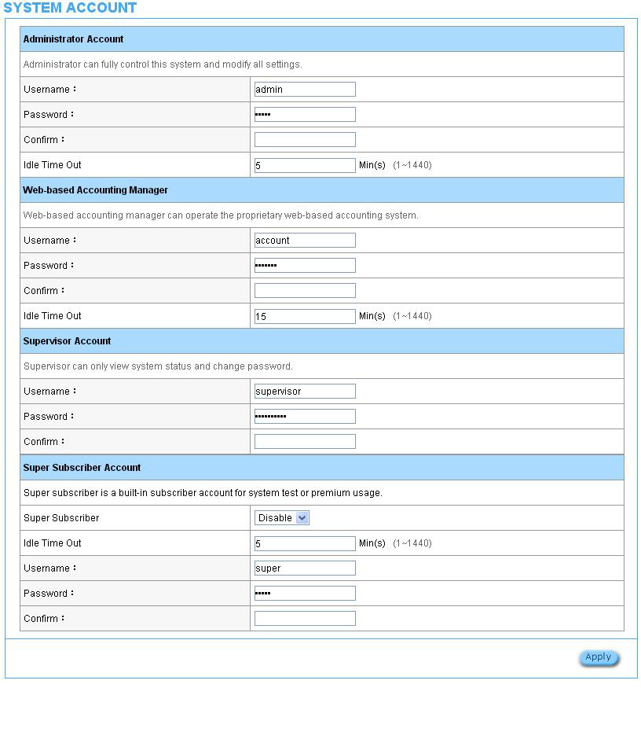

Figure 3‐4‐9 System Account Setting Screen

Item | Description
Username | The username can consist of up to 20 alphanumeric characters and is sensitive.
Password | The password can consist of up to 20 alphanumeric characters and is sensitive.
Confirm | The password for confirmation
Super Subscriber | Disables or enables the super account function.
Idle Time Out | The user idle time out valid is 1 to 1440 minutes. If the idle time out is set as 5 minutes, it  means if the account doesn’t send packet in 5 minutes, the account will logout automatically.

Administrator Account
Step 1: Start your Web browser and enter the factory default IP address 10.59.1.1 in your browser’s location box. Press Enter.

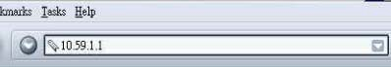

Figure 3‐4‐10 Web Browser Location Field (Factory Default)

Step 2: The HSP500 configuration main menu will appear. Enter admin as the Username and admin as the password and click Login. If you are first time setting the system, the wizard setup screen will appear.

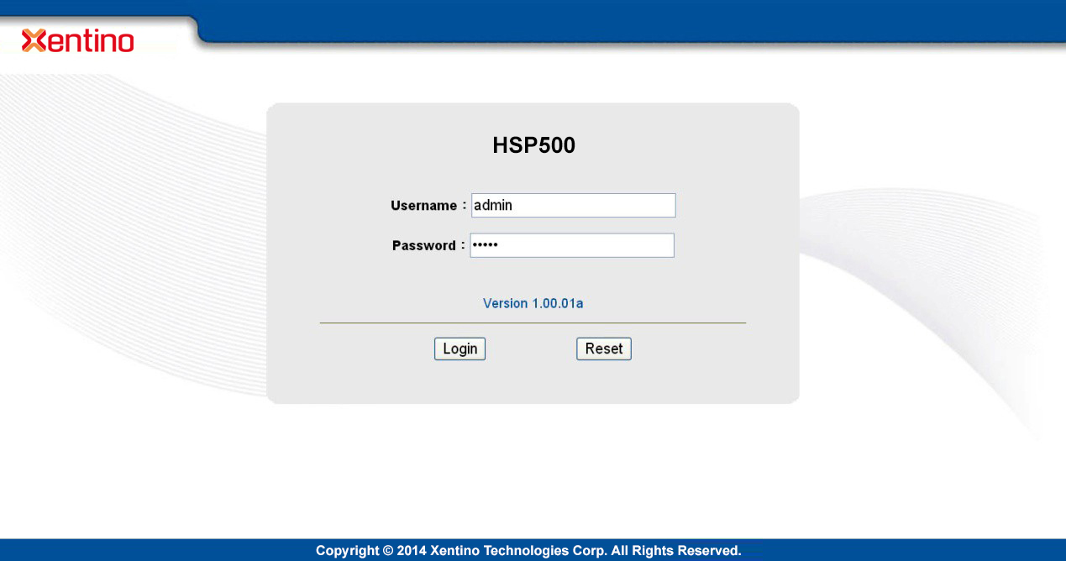

Figure 3‐4‐11 Administrator Account Login Screen (First Time)

Web‐Based Accounting Manager
Step 1: Start your Web browser and enter the factory default IP address 10.59.1.1 in your browser’s location box. Press Enter.

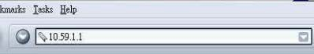

Figure 3‐4‐12 Web Browser Location Field (Factory Default)

Step 2: The HSP500 configuration main menu will appear. Enter account as the
Username and account as the password and click Login.

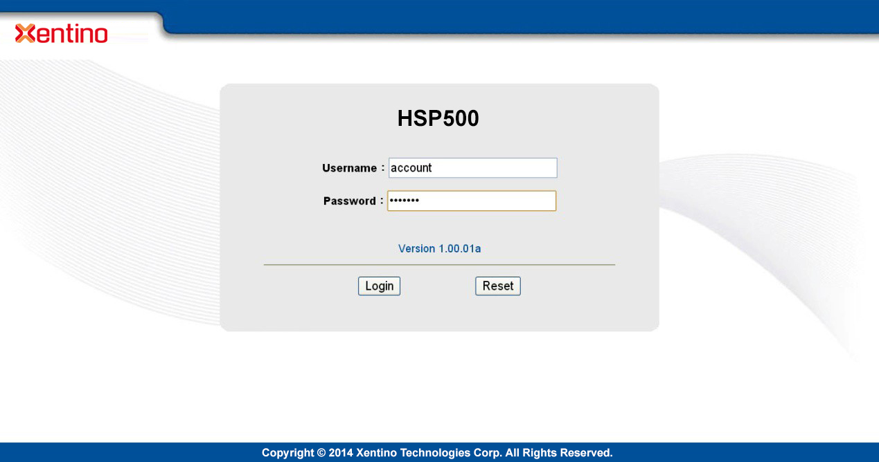

Figure 3‐4‐13 Web‐Based Accounting Manager Login Screen

Supervisor Account
Step 1: Start your Web browser and enter the factory default IP address 10.59.1.1 in your browser’s location box. Press Enter.

Figure 3‐4‐14 Web Browser Location Field (Factory Default)

Step 2: The HSP500 configuration main menu will appear. Enter supervisor as the
Username and supervisor as the password and click Login.

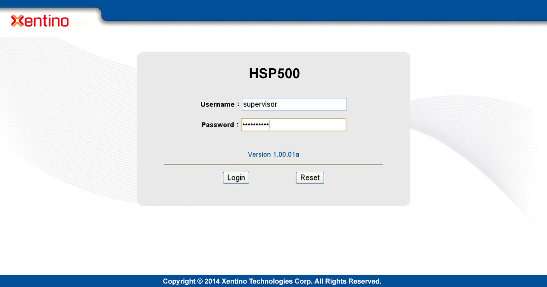

Figure 3‐4‐15 Supervisor Account Login Screen

Step 3: After a valid user name and password have been provided, the HSP500 configuration homepage will appear. “WIZARD SETUP” and “ADVANCED SETUP” are disabled.

Super Subscriber Account
Start your Web Browser; a subscriber login page will appear. Enter super as the
Username and super as the password and click Enter, you can use Internet now.

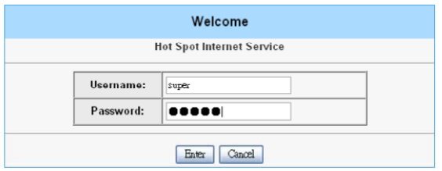

Figure 3‐4‐16 Subscriber Login Page

3­4­6 SSL Certificate

The function allows you to download the registered CA certificate into the HSP500.

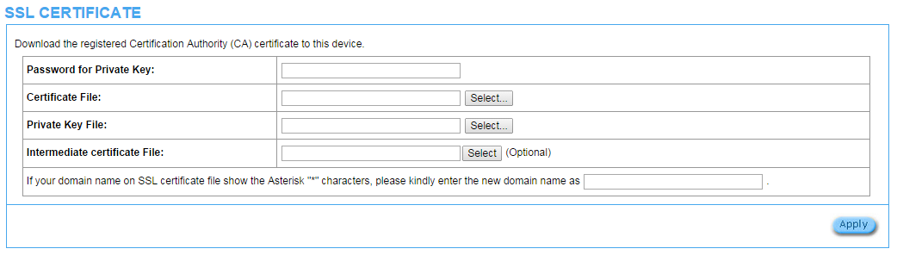

Figure 3‐4‐17 SSL Certificate Download Setting Screen

Note: The password field must the same as the CA’s registered password.

3­4­7 Ping Command

The Ping function can check the HSP500 networking connective or not.

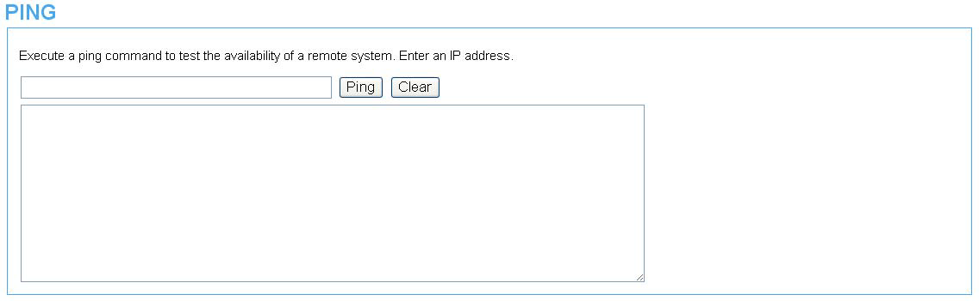

Figure 3‐4‐18 Ping Command Screen

Item | Description
IP or URL | Enter the IP address or the URL link.

3­4­8 Mode Setting
The default setting of HSP500 is a Hotspot with printer but you could set it to be an account generator work with Internet Subscriber Server or Hotspot Gateway such as HSS700 and HSP607. Choose the mode setting you want for your HSP500 then click ”Apply”, the device will re-boot and change the operating mode.
(For detail operating instructions of HSP500 Printer Mode, please refer to HSP500 Printer Mode User’s manual)
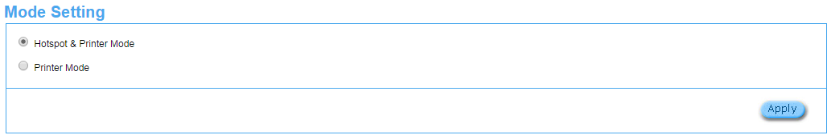
Figure 0-2 Ping Command Screen

3­4­9 Restart
If your HSP500 is not operating correctly, you can choose this option to display the restart HSP500 screen. Clicking the apply button restart the HSP500, with all of your settings remaining intact.

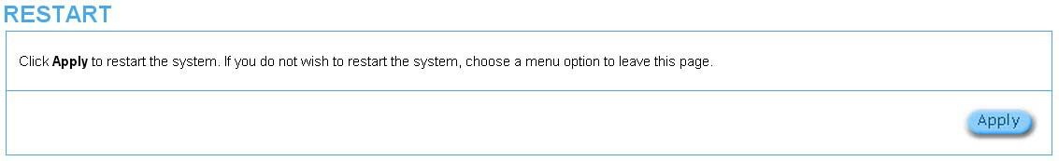

Figure 3‐4‐20 Restart Screen

3­4­10 Logout

If you would like to leave the configuration page, please click apply to exit.

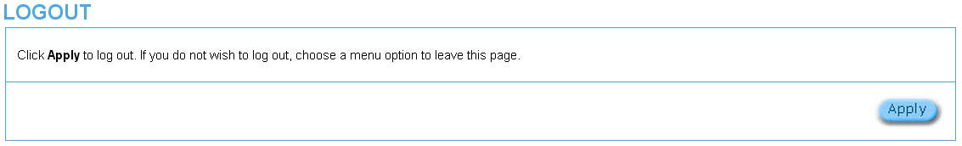

Figure 3‐4‐21 Logout Screen

4. QR Code Service

4­1 QR code setting

Please find Advance setting > Customization > Account Printout >QR code. If you don’t print out the QR Code on the ticket, please disable it and click Apply button.

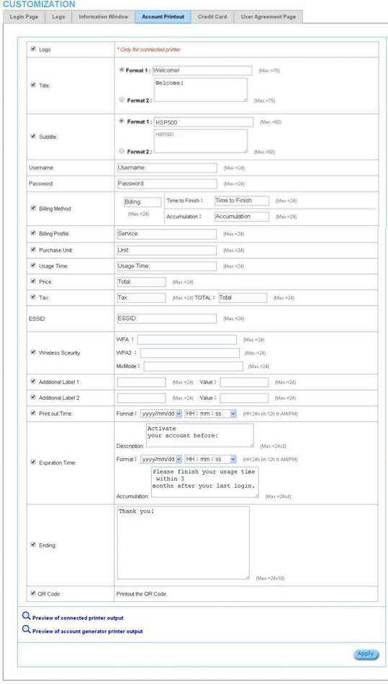
Step 1

Step 2: Enable QR Code

Step 3: Click Apply

Figure 4‐1‐1 QR Coding Setting Screen

4­2 Additional information for QR code use

If you will activate QR code service for APPLE iOS 6 device and later,

1. Please find Advance setting > Security > Pass Through.

2. Choose “Enable”.

3. Add www.apple.com into PASS THROUGH list in HSP500 because iOS6 device and later is required.

4. Click Add to List button.

5. Choose Active on the Pass Through List.

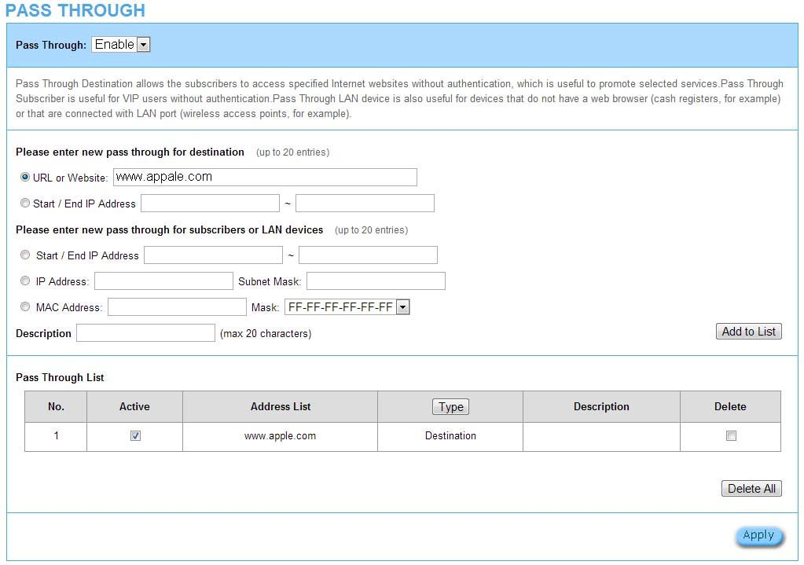
For certain QR code Apps, please add go.redirectingat.com, 54.225.129.12 and 23.23.152.51 (for APP ScanLife) and follow the above steps.

Step 1

Step 2: Choose Enable

Step 3: Add “www.appale.com”

Step 4: Click Add to List

Step 5: Choose Active

Figure 4‐2‐1 Pass Through Setting Screen

4­3 Use QR code to access the Internet

Please follow the steps to access the Internet for clients.

1. Print out the Ticket. You can find the ESSID and WPA/WPA2 printed on the ticket.

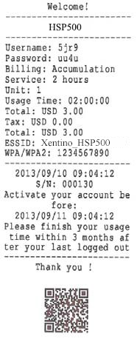

Figure 4‐3‐1 QR Coding Ticket

2. Connect to the ESSID(ex: Xentino_HSP500 ), input WPA/WPA2 password(ex:
1234567890).
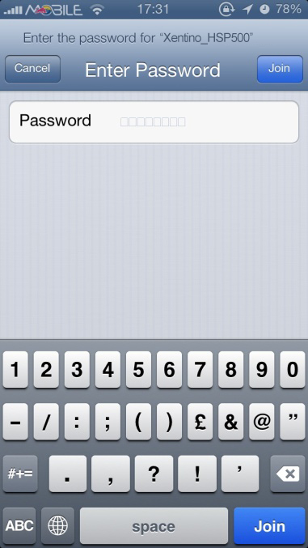
Input the WPA/WPA2 password
Verify to connect the correct ESSID

Figure 4‐3‐2 Password Input Screen

3. Open up QR code APP and Scan.

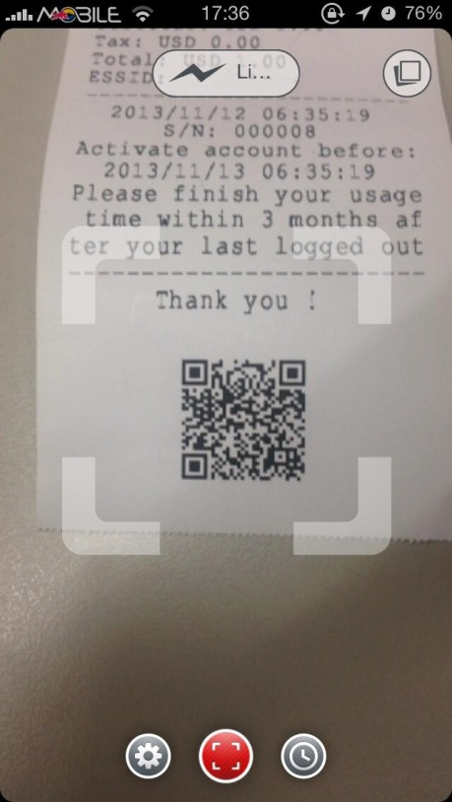
Scan QR code
Figure 4‐3‐3 Scan 1 Screen

4. Some Apps may require user to click "Go to URL".
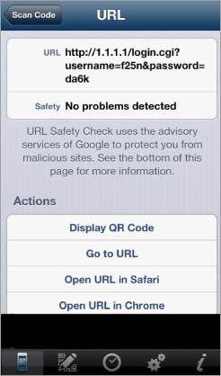

Click “Go to URL”

Figure 4‐3‐3 Scan 2 Screen

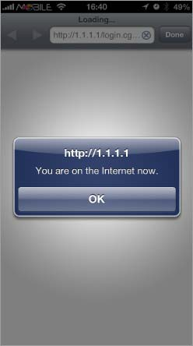
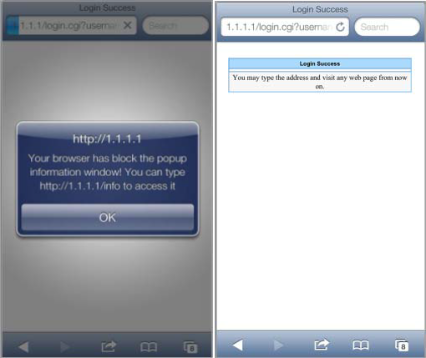
5. Client can use the Internet now.

Figure 4‐3‐4 Scan Finish Screen

5. Personal ID Recognition
Some countries or areas would ask users to show their personal identification when accessing Wi-Fi service according to laws for the cybercrime investigation.
HSP500 provides the function Personal Identification Recognition. The default is disabled. Subscribers need to activate it by the following steps.

5.1 Personal ID Recognition Setting
Step1. Active the function: Go to Advanced Setup -> Authentication -> Authentication. Enable the Personal ID Recognition Mode. Please refer to Chapter Error! Reference source not found. Error! Reference source not found..
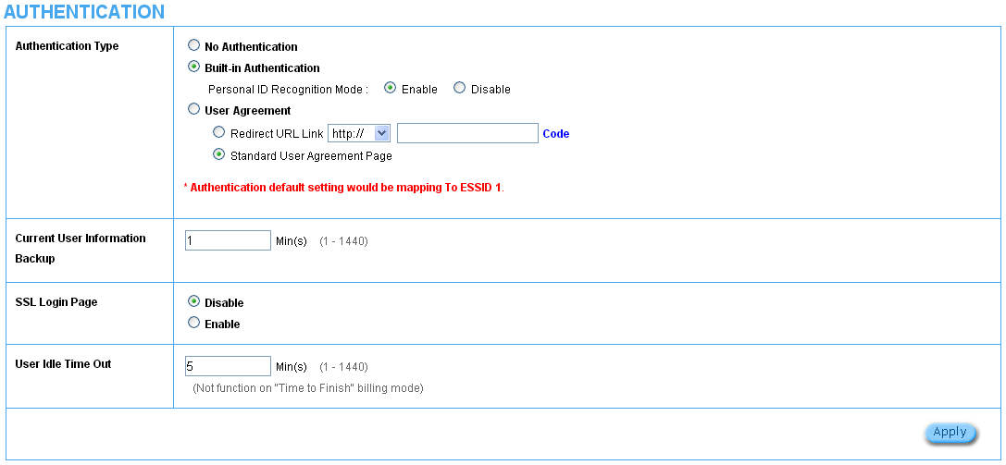

Figure 0-1 System Setting
Step2. The FIRST billing profile you activate is the Personal ID Recognition selection. There is ONLY ONE billing profile in the Personal ID Recognition mode.
Please refer to Chapter Error! Reference source not found. Error! Reference source not found. to modify your first billing profile.
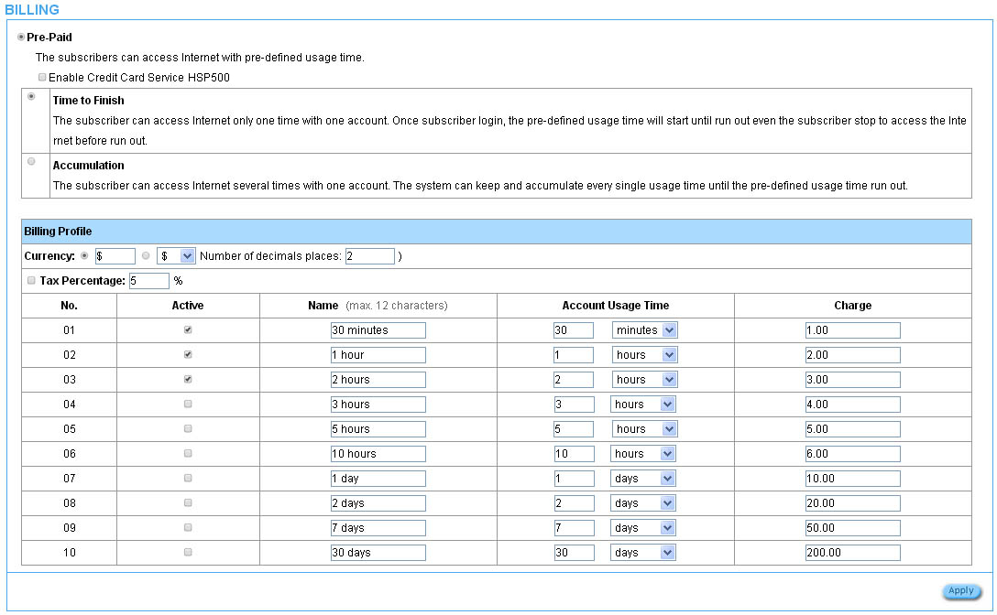

Figure 0-2 Billing Setting Screen
Step 3: Start your browser, and then enter the factory default IP address 10.59.1.1 in your browser’s location box. Press Enter.
Figure 0-3 Web Browser Location Field (Factory Default)

Step 4: The HSP500 configuration tools menu will appear. In the Username and Password field, type the factory default user name “account” and password “account” and click Login.
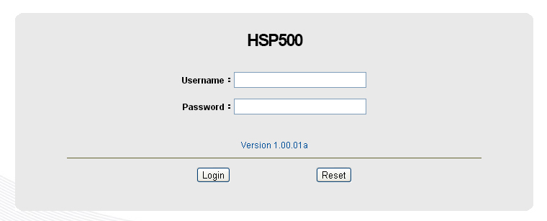
Figure 0-4 Configuration Tools Menu
Step 5: ONLY account manager can operate PIR and printout the ticket. There are 3 types for the account manager to choose, including Driver License NO., Passport No. and Identify card No. Fill in numbers and click “+” or “-” for usage time.
Click the Print button to printout the ticket.
Click View Account List to see all accounts which are printed out.
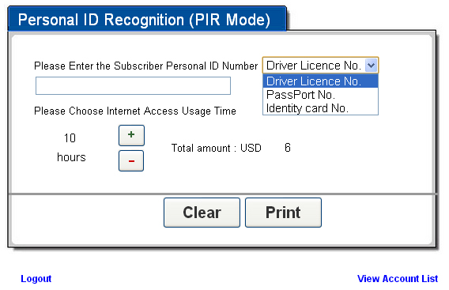
Figure 0-5 PIR

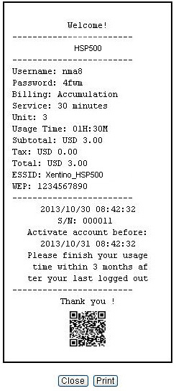
Figure 0-6 PIR Ticket
Step 6: Click Logout and then click the Apply button to finish it.
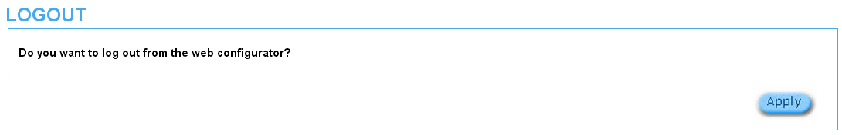
Figure 0-7 Logout

Appendix A Signal Connection Arrangements

RJ‐45 Ethernet Port

The HSP500 RJ‐45 Ethernet port can connect to any networking devices that use a standard LAN interface, such as a Hub/Switch Hub or Router. Use unshielded twisted‐pair (UTP) or shield twisted‐pair (STP) cable to connect the networking device to the RJ‐45 Ethernet port.

Depending on the type of connection, 10Mbps or 100Mbps, use the following Ethernet cable, as prescribed.

10Mbps: Use EIA/TIA‐568‐100‐Category 3, 4 or 5 cables. 100Mbps: Use EIA/TIA‐568‐100‐Category 5 cable.

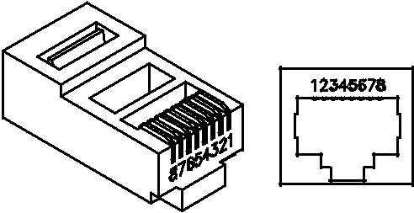

Figure RJ-45 Connector and Cable Pins

Note: To prevent loss of signal, make sure that the length of any twisted‐pair connection does not exceed 100 meters.

Appendix B Regulations/EMI Compliance

FCC Regulatory Statement

Part 15‐Class B compliant device

This device complies with Part 15 of the FCC Rules. Operation is subject to the following conditions:

1. This device may not cause harmful interference, and

2. This device must accept any interference received, including that which may cause undesired operation.

This equipment has been test and found to comply with the limits for a computing device, pursuant to Part 15 of the FCC Rules. These limits are designed to provide reasonable protection against harmful interference when the equipment is operated in a commercial environment. This equipment generates, uses, and can radiate radio frequency energy and, if not installed and used in accordance with the instructions, may cause harmful interference to radio communications. However, there is no guarantee that interference will not occur in a particular installation. If this equipment does cause harmful interference to radio or television reception, which can be determined by turning the equipment off and on, the user is encouraged to try to correct the interference by one or more of the following measures:

1. Reorient or relocate the receiving antenna.

2. Increase the separation between the equipment and receiver.

3. The equipment and the receiver should be connected the outlets on separate circuits.

4. Consult the dealer or an experienced radio/television technician for help.

Changes or modification not expressly approved be the party responsible for compliance could void the user’s authority to operate the equipment.

FCC RF Radiation Exposure Statement
- This Transmitter must not be co‐located or operating in conjunction with any other antenna or transmitter.
- This equipment complies with FCC RF radiation exposure limits set forth for an uncontrolled environment. This equipment should be installed and operated with a minimum distance of 20 centimeters between the radiator and your body.

NCC Statement

根據NCC低功率電波輻射性電機管理辦法規定:
第十二條 | 經型式認證合格之低功率射頻電機，非經許可，公司、商號或使用者均不得擅自變更頻率、加大功率或變更原設計之特性及功能。
第十四條 | 低功率射頻電機之使用不得影響飛航安全及干擾合法通信；經發現有干擾現象時，應立即停用，並改善至無干擾時方得繼續使用。  前項合法通信，指依電信法規定作業之無線電通信。  低功率射頻電機須忍受合法通信或工業、科學及醫療用電波輻射性電機設備之干擾。

LIMITED WARRANTY

HSP500

What the warranty covers:

We warrant its products to be free from defects in material and workmanship during the warranty period. If a product proves to be defective in material or workmanship during the warranty period, we will at its sole option repair or replace the product with a like product with a like product. Replacement product or parts may include remanufactured or refurbished parts or components.
How long the warranty is effective:
The HSP500 is warranted for one year for all parts and one year for all labor from the date of the first consumer purchase.
Who the warranty protects:
This warranty is valid only for the first consumer purchaser.

What the warranty does not cover:

1. Any product, on which the serial number has been defaced, modified or removed.

2. Damage, deterioration or malfunction resulting from:

a. Accident, misuse, neglect, fire, water, lightning, or other acts of nature, unauthorized product modification, or failure to follow instructions supplied with the product.
b. Repair or attempted repair by anyone not authorized by us. c. Any damage of the product due to shipment.
d. Removal or installation of the product.

e. Causes external to the product, such as electric power fluctuations or failure. f. Use of supplies or parts not meeting our specifications.
g. Normal wears and tears.

h. Any other cause that does not relate to a product defect.

3. Removal, installation, and set‐up service charges.

How to get service:

1. For information about receiving service under warranty, contact our Customer Support.

2. To obtain warranted service, you will be required to provide (a) the original dated sales slip, (b) your name, (c) your address (d) a description of the problem and (e) the serial number of the product.
3. Take or ship the product prepaid in the original container to your dealer, and our service center.

4. For additional information, contact your dealer or our Customer Service Center.

Limitation of implied warranties:

THERE ARE NOWARRANTIED, EXPRESSED OR IMPLIED, WHICH EXTEND BEYOND THE DESCRIPTION CONTAINED HEREIN INCLUDING THE IMPLIED WARRANTY OF MERCHANTABILITY AND FITNESS FOR A PARTICULAR PURPOSE.
Exclusion of damages:
Our LIABILITY IS LIMITED TO THE COST OF REPAIR OR REPLACEMENT OF THE PRODUCT. We SHALL NOT BE LIABLE FOR:

1. DAMAGE TO OTHER PROPERTY CAUSED BY ANY DEFECTS IN THE PRODUCT, DAMAGES BASED UPON INCONVENCE, LOSS OF USE OF THE PRODUCT, LOSS OF TIME, LOSS OF PROFITS, LOSS OF BUSINESS OPPORTUNITY, LOSS OF GOODWILL, INTERFERENCE WITH BUSINESS RELATIONSHIPS, OR OTHER COMMERCIAL LOSS, EVEN IF ADVISED OF THE POSSIBLITY OF SUCH DAMAGES.
2. ANY OTHER DAMAGES, WHETHER INCIDENTAL, CONSEQUENTIAL OR OTHERWISE.

3. ANY CLAIM AGAINST THE CUSOMER BY ANY OTHER PARTY.

